**BCA PROJECT REPORT (BCSP-064)**

**e – Recruitment Management System (e-RMS)**

**Submitted By:**

**Name: Debanil Roy**

**Enrollment No.: 2106469395**

**Programme Code: BCA**

**CONTENTS**

1. INTRODUCTION 1
2. OBJECTIVES 4
3. TOOLS / ENVIRONMENT USED 5
4. ANALYSIS 6
5. DESIGN DOCUMENT 16
6. PROGRAMME CODE 22
7. TESTING 59
8. INPUT / OUTPUT SCREENS 84
9. SECURITY 101
10. LIMITATIONS 103
11. FUTURE APPLICATION OF THE PROJECT 105
12. REFERENCES 106

# INTRODUCTION

The recruitment process in India is a continuous endeavor, with various government departments conducting annual drives to fill vacant positions. Managing the applications of millions of candidates participating in these recruitment exercises presents a significant administrative challenge.

As of 2025, the demand for government jobs remains exceptionally high. For instance, the Railway Recruitment Board's Non-Technical Popular Categories (RRB NTPC) 2025 recruitment attracted over 1.21 crore applicants competing for 11,558 vacancies, highlighting the intense competition for limited positions.**1** Similarly, the Staff Selection Commission's General Duty (SSC GD) Constable recruitment for 2025 announced 53,690 vacancies, marking it as one of the largest in recent years.**2**

Despite the overwhelming interest, a significant number of positions remain unfilled across various government sectors. For example, in Andhra Pradesh, the District Selection Committee (DSC) 2025 teacher recruitment saw 3.35 lakh candidates applying for 16,347 teaching posts, averaging about 35 applicants per post.**3**

Many government institutions continue to rely on traditional methods for handling recruitment notices physically. While some have transitioned to semi-digital application processes, tasks such as processing results and issuing appointment letters are still carried out manually. This reliance on physical processing leads to challenges and losses for all parties involved. For instance, once a provisional appointment letter is issued, it typically takes 10-15 days to reach the recipient. In some cases, the letter may be lost in transit, potentially resulting in the cancellation of the appointment.

India has a significant unemployed population actively seeking job opportunities, yet many positions in government agencies remain unfilled. This issue arises partly due to the lack of a structured waiting list for qualified candidates who missed appointments due to intense competition. The offline recruitment management system further exacerbates the problem by lacking the efficiency and transparency needed to address such gaps effectively.

The e-Recruitment Management System aims to address the limitations of the traditional, physical recruitment process. It will feature modules for receiving applications, processing results, and automating the allotment of vacancies based on the specific criteria outlined in each recruitment notice.

This system benefits both key stakeholders in the recruitment process: the appointee and the appointer. Candidates can register on the system to view all open recruitment notices and apply directly. Recruiters, on the other hand, can create recruitment notices, enter candidates' results, and let the system automatically sort and generate a rank list. Once the rank list is prepared, recruiters can send appointment letters to selected candidates. Candidates can then accept or reject the offer through the system. If an offer is rejected, the recruiter can seamlessly issue an appointment letter to the next eligible candidate on the rank list.

By streamlining the recruitment process, the e-Recruitment Management System aims to significantly reduce delays and inefficiencies. Addressing the issue of repeated vacancies in certain offices enhances the effectiveness of the recruitment cycle. Additionally, the system promotes the judicious use of resources while improving operational efficiency and ensuring greater transparency in the hiring process.

# OBJECTIVES

* **Digitize and Streamline Recruitment Process**

To replace traditional, paper-based recruitment methods with an end-to-end digital system that handles everything from application submission to result processing and appointment letter issuance.

* **Reduce Delays and Prevent Appointment Failures**

To minimize delays in communication (e.g., postal appointment letters) and reduce the risk of offer cancellations by enabling instant, trackable offer acceptance or rejection within the system.

* **Optimize Vacancy Utilization**

To ensure efficient use of available vacancies by automatically maintaining a ranked waiting list of eligible candidates, enabling quick reallocation if an offer is declined.

* **Improve Transparency and Efficiency**

To enhance the transparency and accountability of government recruitment by providing both recruiters and applicants real-time access to recruitment statuses, result rankings, and appointment decisions.

# TOOLS / ENVIRONMENT USED

**Software**

* Front End: HTML / CSS / Bootstrap / JavaScript (React.js)
* Back End: PHP
* Database: MySQL
* Testing: Python

**Development**

* Visual Studio Code (Integrated Development Environment)
* MySQL Workbench 8.0 CE (MySQL GUI Tool)
* Node Package Manager (npm) (JavaScript Package Manager for React)
* GitHub Codespace (Remote IDE)
* Git (Version control)
* GitHub (Remote repository hosting)

**Other Tools**

* Figma (UI Design)
* Lucidchart (Diagram)

# ANALYSIS

**System Requirements Specification**

**1. Introduction**

**1.1 Purpose**

This document outlines the software requirements for the e-Recruitment Management System (e-RMS). The system is designed to streamline the recruitment process by facilitating recruitment creation, application handling, result processing with subject prioritization, application verification, and appointment issuance.

**1.2 Scope**

The e-RMS is a web-based application that enables recruiters to manage the entire recruitment lifecycle. Key functionalities include:

* Recruitment creation with subject priority settings
* Online application submission by candidates
* Result entry with subject-wise marks and priority considerations
* Automatic ranking based on aggregate scores, subject priorities, and date of birth
* Application verification before appointment issuance
* Secure document management

*Note: Features such as multi-location support, applicant location preferences, hierarchical recruiter roles, and third-party recruitment agency integration are planned for future versions.*

**1.3 Definitions, Acronyms, and Abbreviations**

* **SRS**: Software Requirements Specification.
* **e-RMS**: e-Recruitment Management System.
* **Recruiter**: Authorized user responsible for managing recruitment processes.
* **Applicant**: Individual applying for a recruitment opportunity.
* **Recruitment ID**: Unique identifier for each recruitment.
* **Application ID**: Unique identifier for each application submitted by a applicant.

**1.4 References**

* IEEE Std 830-1998, IEEE Recommended Practice for Software Requirements Specifications.
* IEEE Software Requirements Specification Template

**1.5 Overview**

This document is structured to provide a comprehensive overview of the e-RMS, including its general description, specific requirements, external interface requirements, and other relevant information.

**2. Overall Description**

**2.1 Product Perspective**

The e-RMS is a standalone web application developed using PHP (with PDO) and MySQL. It features a responsive frontend (e.g., React-based), RESTful APIs, and secure document access mechanisms.

**2.2 Product Functions**

* **Recruitment Management**: Create and manage recruitment notices with subject priorities.
* **Application Handling**: Allow applicants to submit applications and upload necessary documents.
* **Result Processing**: Enter and manage subject-wise marks with priority considerations.
* **Ranking Generation**: Automatically generate applicant rankings based on aggregate scores, subject priorities, and date of birth.
* **Application Verification**: Verify applications before issuing appointment letters.
* **Appointment Issuance**: Generate and dispatch appointment letters to selected candidates.

**2.3 User Classes and Characteristics**

* **Recruiter**: Manages recruitment processes, including creation, result entry, application verification, and appointment issuance.
* **Applicant**: Applies for recruitment opportunities and tracks application status.

**2.4 Operating Environment**

* **Server**: PHP 8.x, MySQL 8.x
* **Client**: Modern web browsers (e.g., Chrome, Firefox, Edge)
* **Platform**: Web-based application accessible via internet

**2.5 Design and Implementation Constraints**

* Use of PHP and MySQL for backend development.
* Secure document storage with hashed filenames.
* Role-based access control for different user types.

**2.6 User Documentation**

User manuals and help guides will be provided for both recruiters and applicants, detailing system functionalities and usage instructions.

**2.7 Assumptions and Dependencies**

* Users have access to the internet and compatible web browsers.
* The system will be hosted on a secure server with regular backups.

**3. Specific Requirements**

**3.1 Functional Requirements**

**3.1.1 User Authentication**

* The system shall provide secure login functionality for recruiters and applicants.
* Passwords shall be stored using secure hashing algorithms.

**3.1.2 Recruitment Management**

* Recruiters shall be able to create recruitment notices with details such as position title, requirements, deadlines, and subject priorities.
* Each recruitment shall be assigned a unique Recruitment ID.

**3.1.3 Application Submission**

* Applicants shall be able to submit applications online, including uploading required documents.
* Each application shall be assigned a unique Application ID.

**3.1.4 Result Entry**

* Recruiters shall be able to enter subject-wise marks for each application.
* Subject priorities shall influence the weight of each subject during ranking.

**3.1.5 Ranking Generation**

* The system shall generate applicant rankings based on:
  1. Aggregate subject scores
  2. Priority-weighted subject scores
  3. Date of birth (used as a tiebreaker)

**3.1.6 Application Verification**

* Users shall be able to verify applications before issuing appointment letters.

**3.1.7 Appointment Issuance**

Recruiters shall be able to generate and dispatch appointment letters to selected candidates.

**3.2 Performance Requirements**

* The system shall handle high volumes of applications without performance degradation.
* Response times for user actions shall not exceed 2 seconds under normal load.

**3.3 Security Requirements**

* The system shall implement role-based access control.
* All data transmissions shall be encrypted using HTTPS.
* Regular security audits shall be conducted to identify and mitigate vulnerabilities.

**3.4 Software Quality Attributes**

* **Reliability**: The system shall have 99.9% uptime.
* **Maintainability**: The system shall be modular to facilitate easy updates and maintenance.
* **Usability**: The user interface shall be intuitive and user-friendly.
* **Portability**: The system shall be compatible with major web browsers.

**4. External Interface Requirements**

**4.1 User Interfaces**

* Responsive web interface accessible via modern web browsers.
* Separate dashboards for recruiters and applicants.

**4.2 Hardware Interfaces**

* The system shall be hosted on a server with the following minimum specifications:
  + CPU: Quad-core processor
  + RAM: 16 GB
  + Storage: 500 GB SSD

**4.3 Software Interfaces**

* Backend: PHP 8.x with PDO
* Database: MySQL 8.x
* Frontend: React.js or equivalent

**4.4 Communication Interfaces**

* RESTful APIs for communication between frontend and backend.
* Secure email notifications for application status updates.

**5. Other Requirements**

**5.1 Backup and Recovery**

* Daily backups of the database and uploaded documents.
* Recovery procedures shall be documented and tested regularly.

**5.2 Future Enhancements**

* Multi-location office support for recruiters.
* Location preference handling for applicants.
* Hierarchical recruiter role model (e.g., sub-offices).
* Third-party recruitment agency integration.
* Notification system (SMS/email).
* Analytics and reporting dashboards.

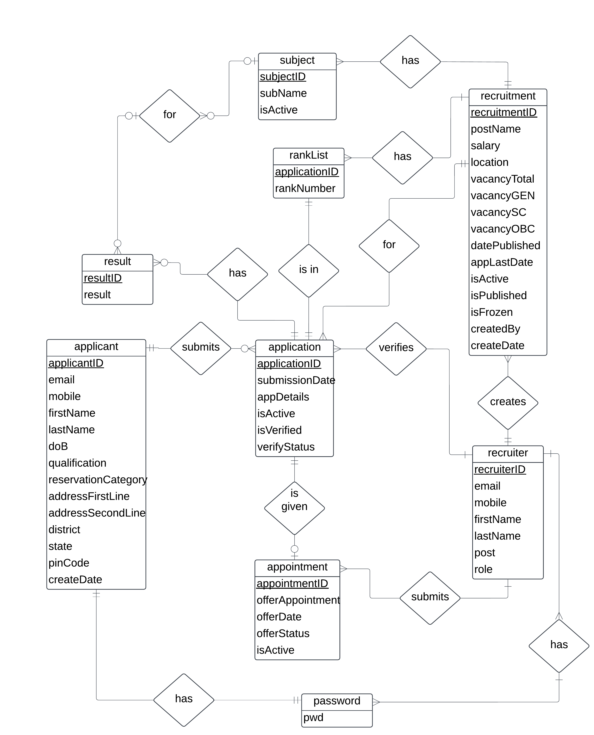**Entity Relationship Diagram**

**Data Flow Diagram**

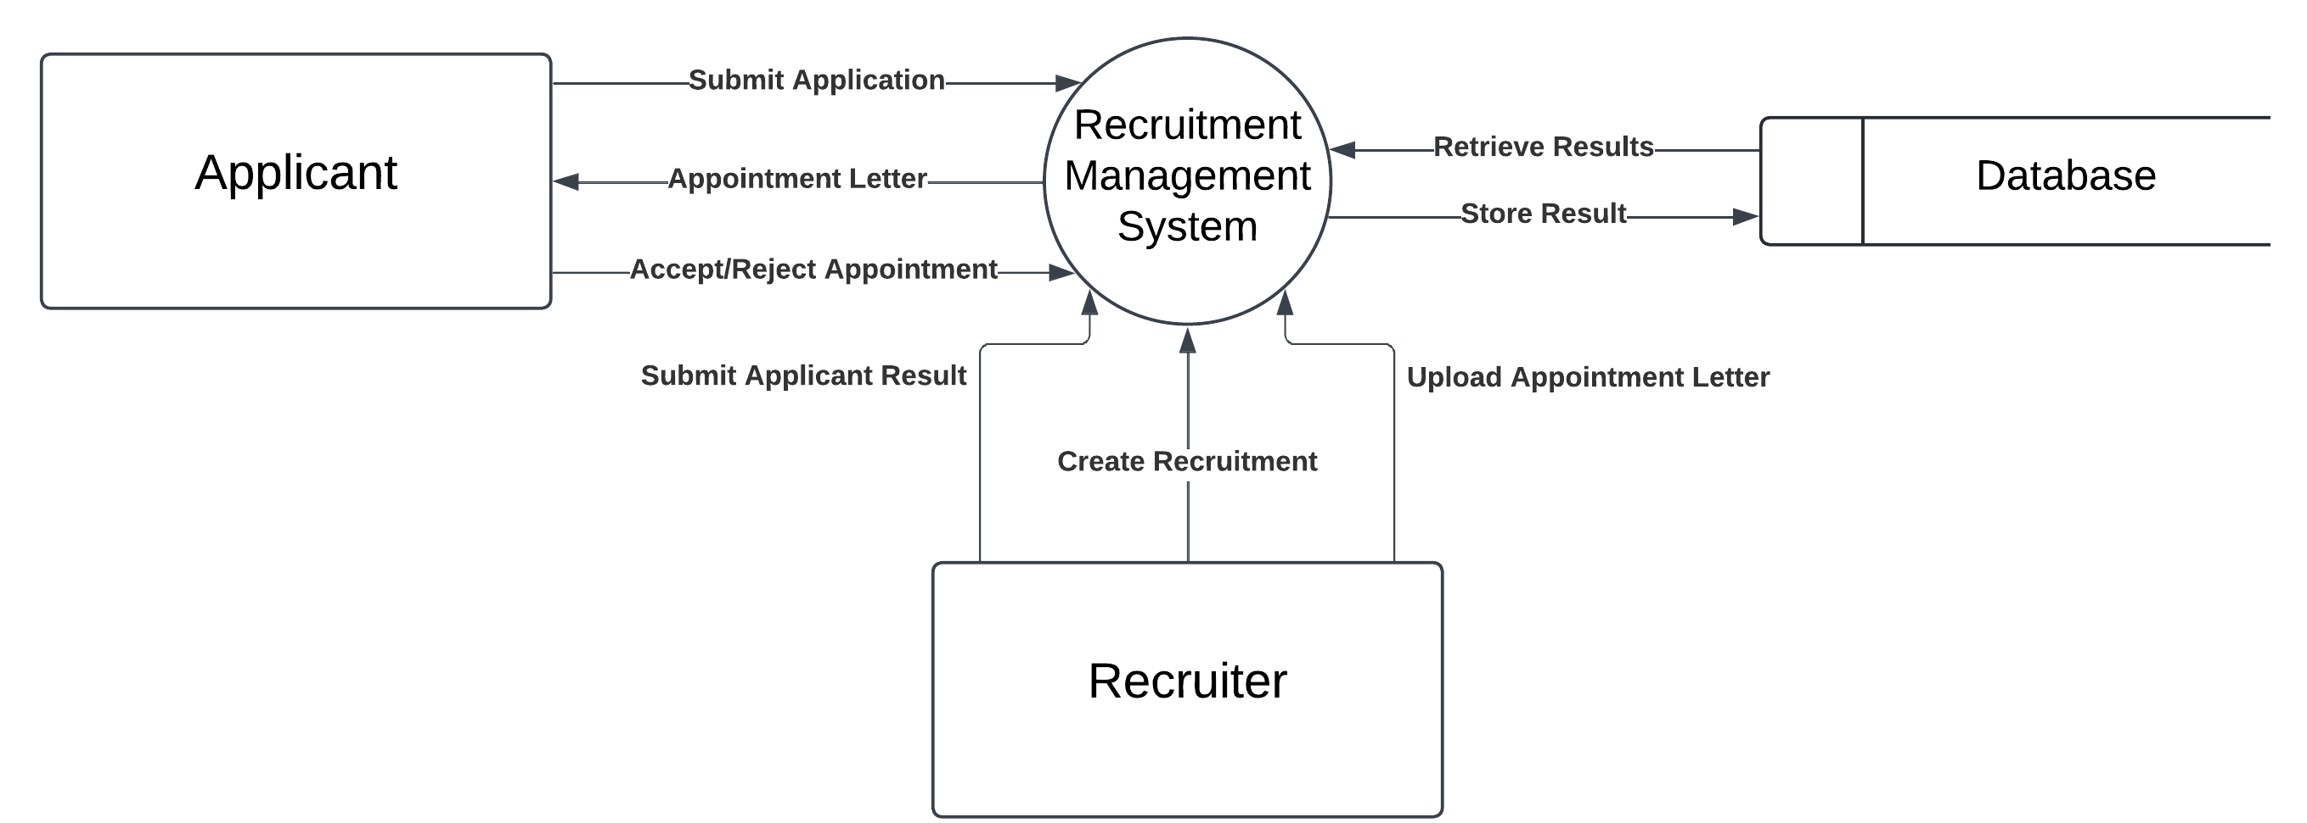

**Level 0 Data Flow Diagram – e-RMS**

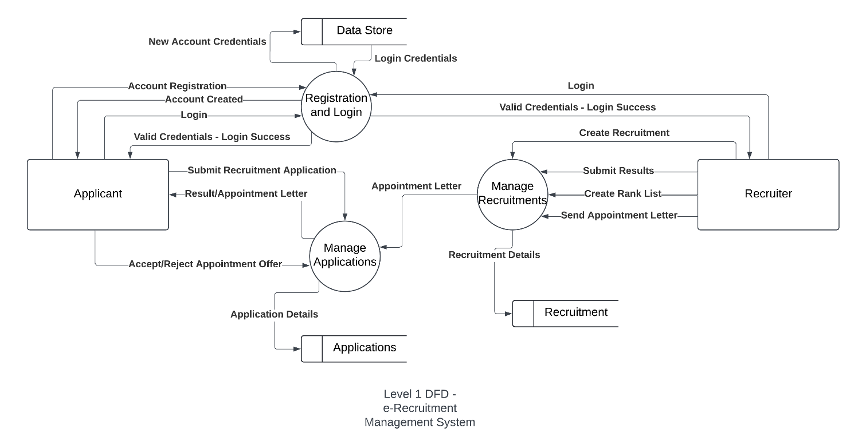

**Level 1 Data Flow Diagram – e-RMS**

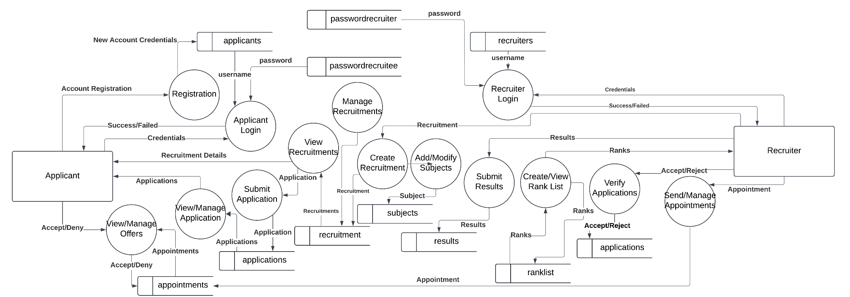

**Level 2 Data Flow Diagram – e-RMS**

# DESIGN DOCUMENT

**Database Design**

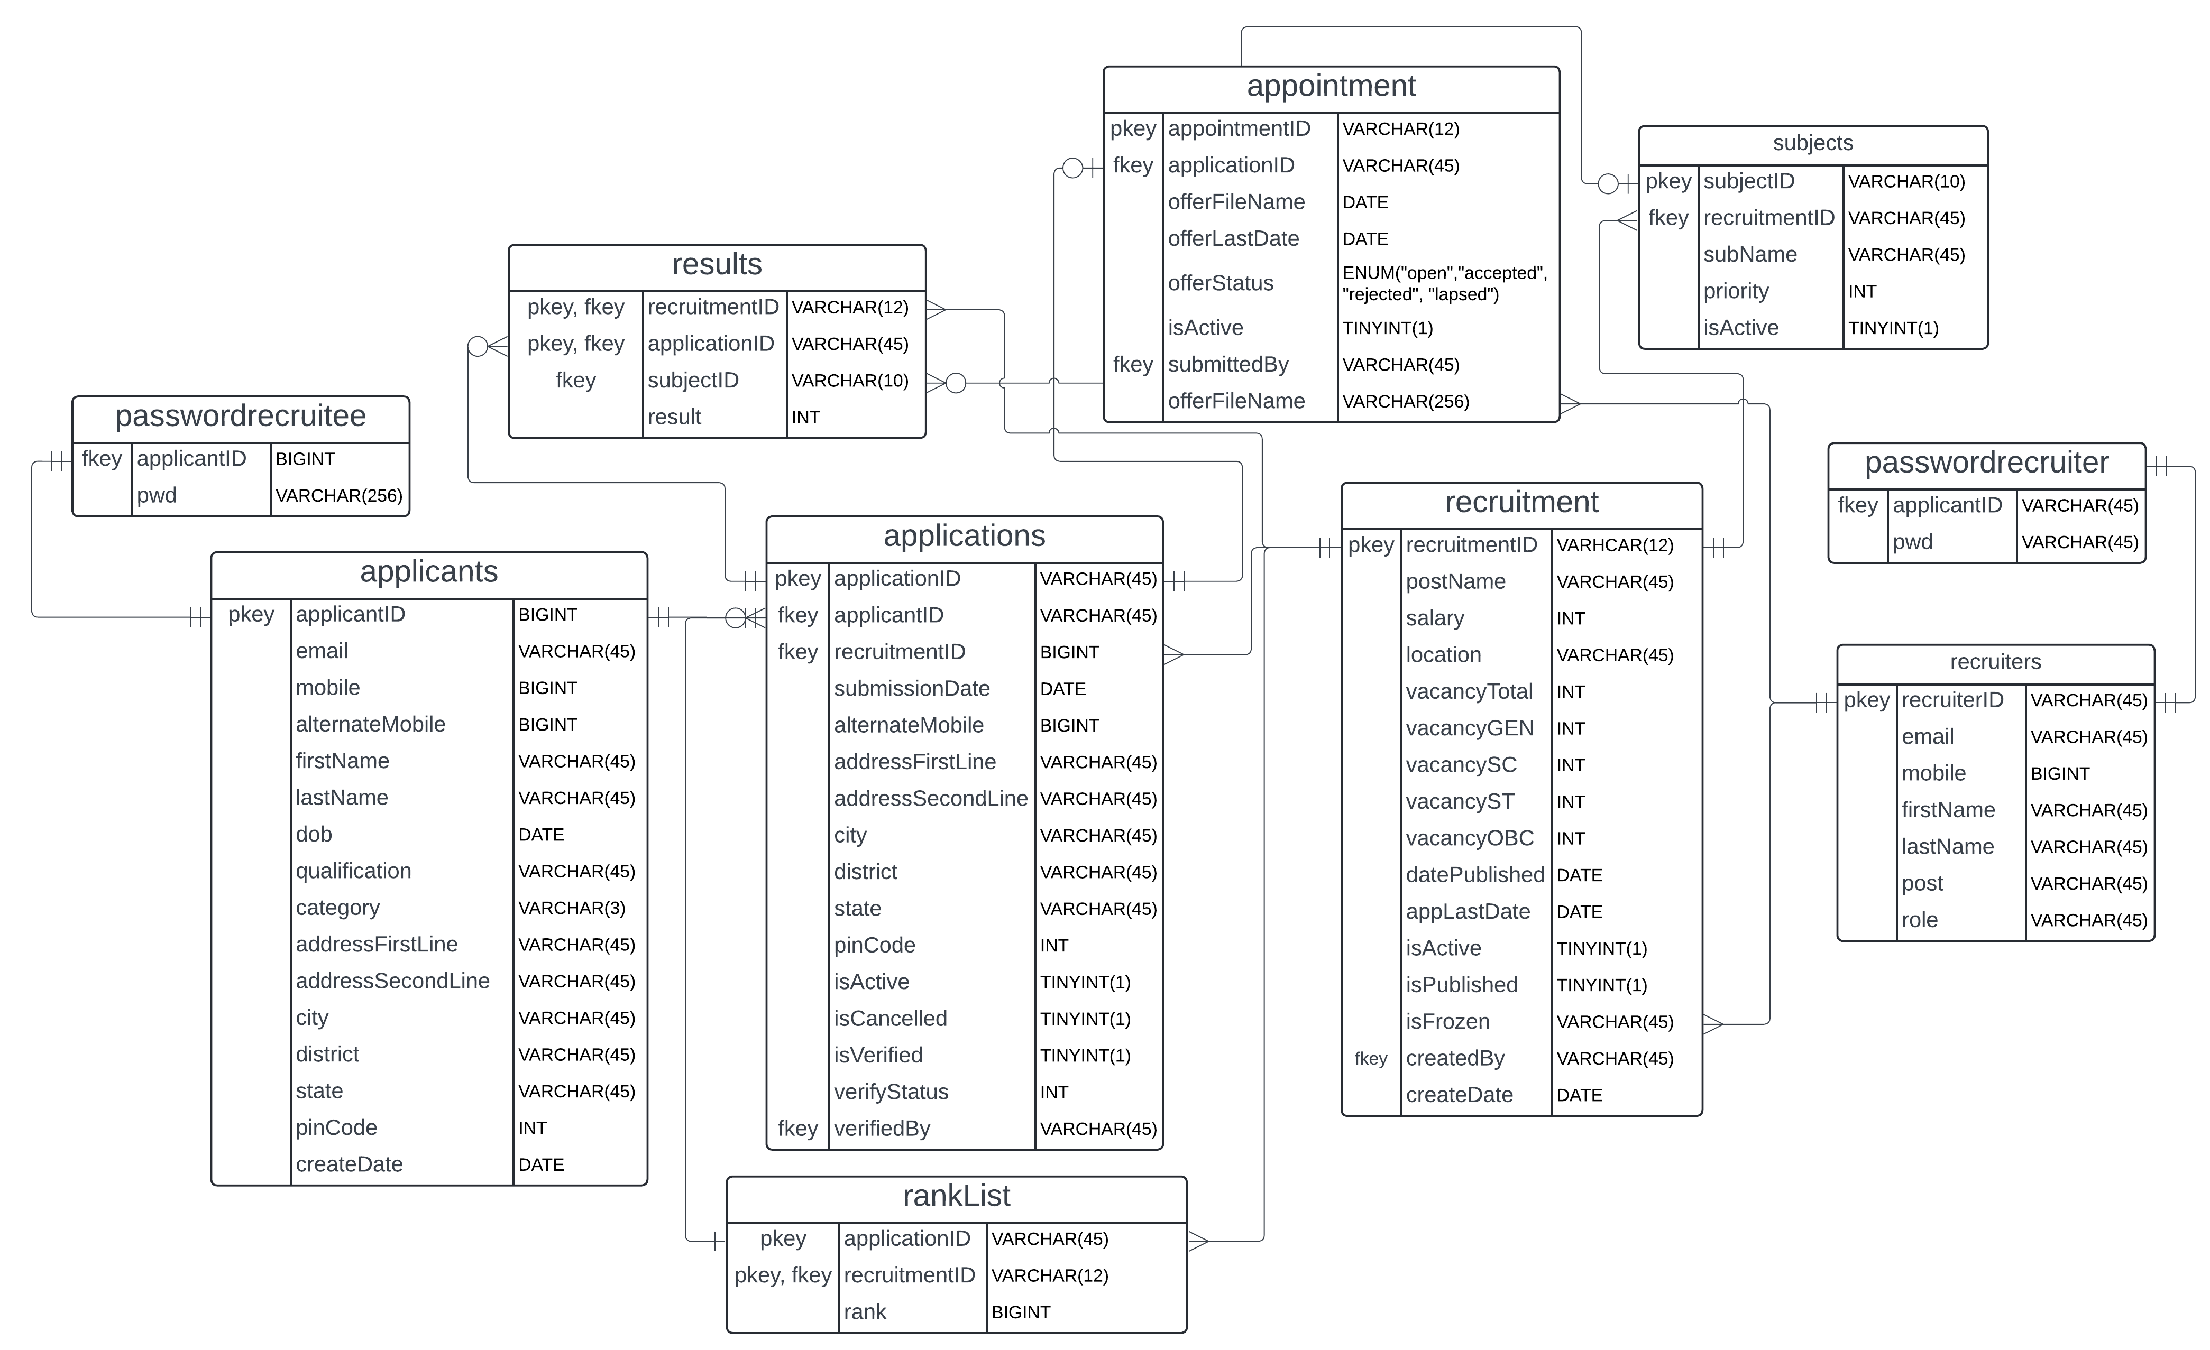

**Data Integrity and Constraints**

**1. Primary Keys**

* Each table has a well-defined **PRIMARY KEY**, ensuring entity uniqueness:
  + applicants(applicantID)
  + applications(applicationID)
  + appointments(appointmentID)
  + recruitment(recruitmentID)
  + recruiters(recruiterID)
  + subjects(subjectID)
  + results(recruitmentID, applicationID, subjectID) *(composite PK)*
  + ranklist(applicationID, recruitmentID) *(composite PK)*

**2. Foreign Key Constraints**

* Enforce **referential integrity** across modules:
  + applications.applicantID → applicants.applicantID
  + applications.recruitmentID → recruitment.recruitmentID
  + applications.verifiedBy → recruiters.recruiterID
  + appointments.applicationID → applications.applicationID
  + recruitment.createdBy → recruiters.recruiterID
  + results.applicationID + recruitmentID → applications.applicationID + recruitmentID
  + results.subjectID → subjects.subjectID
  + subjects.recruitmentID → recruitment.recruitmentID
  + passwordrecruitee.applicantID → applicants.applicantID

**3. NOT NULL Constraints**

* Enforced on key fields to avoid incomplete records:
  + Almost all primary fields like email, firstName, mobile, dob, qualification, category, etc.
  + Enum offerStatus and isActive flags in appointments.

**4. UNIQUE Constraints**

* Uniqueness enforced on:
  + applicants.email
  + applicants.mobile
  + applications.applicationID *(implied by PK)*
  + appointments.applicationID *(only one appointment per application)*
  + passwordrecruitee.applicantID
  + passwordrecruiter.recruiterID

**5. DEFAULT Values & Triggers**

* Many defaults are controlled using **triggers**:
  + applicants.createDate → NOW()
  + applications.submissionDate, isActive, isVerified → set in trigger
  + appointments.offerDate, offerLastDate, offerStatus, isActive → default set in trigger
  + recruitment.isActive, isPublished, isFrozen, createDate → default via trigger
  + subjects.subjectID → LEFT(REPLACE(UUID(), '-', ''), 6) (auto-generated)

**6. ENUM & Boolean Constraints**

* appointments.offerStatus uses:

ENUM ('open', 'accepted', 'rejected', 'lapsed')

* Boolean flags:
  + isActive, isCancelled, isVerified, isPublished, isFrozen

**7. Data Types & Length Enforcement**

* Strings: Mostly VARCHAR(45) or VARCHAR(256) (for documents/passwords).
* IDs:
  + applicantID and recruiterID are unique; mostly BIGINT or VARCHAR(45)
  + subjectID, recruitmentID, applicationID, etc. have specific lengths (for consistency).
* Numbers:
  + pinCode, mobile, salary, vacancy* fields use INT or BIGINT

**8. Composite Keys**

* Used for multi-entity linkage and to avoid redundancy:
  + results(recruitmentID, applicationID, subjectID)
  + ranklist(applicationID, recruitmentID)

**9. Date Constraints**

* dob, submissionDate, datePublished, createDate, offerDate enforce real-world chronological consistency.
* Some are auto-populated using NOW() or CURDATE() in triggers.

**User Interface Design**

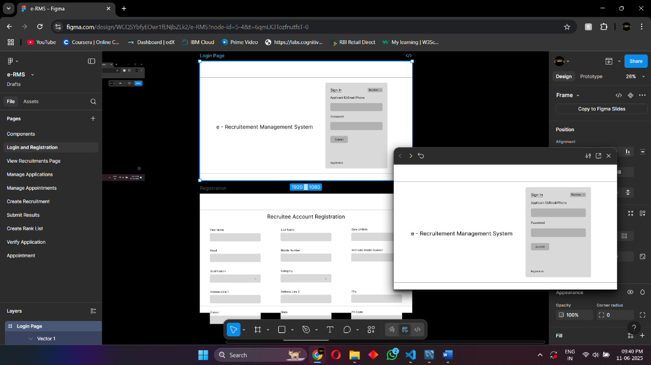The initial user interface designs for the e-Recruitment Management System were created using Figma, a collaborative design tool. These wireframes served as blueprints for the layout and structure of various screens within the application. A wireframe is a low-fidelity visual guide that outlines the skeletal framework of an interface, focusing on functionality, placement of elements, and user flow rather than detailed styling. Based on these wireframes, the final designs were developed and refined, ensuring that user experience principles were preserved throughout the implementation. Screenshots of the original wireframes are included below.

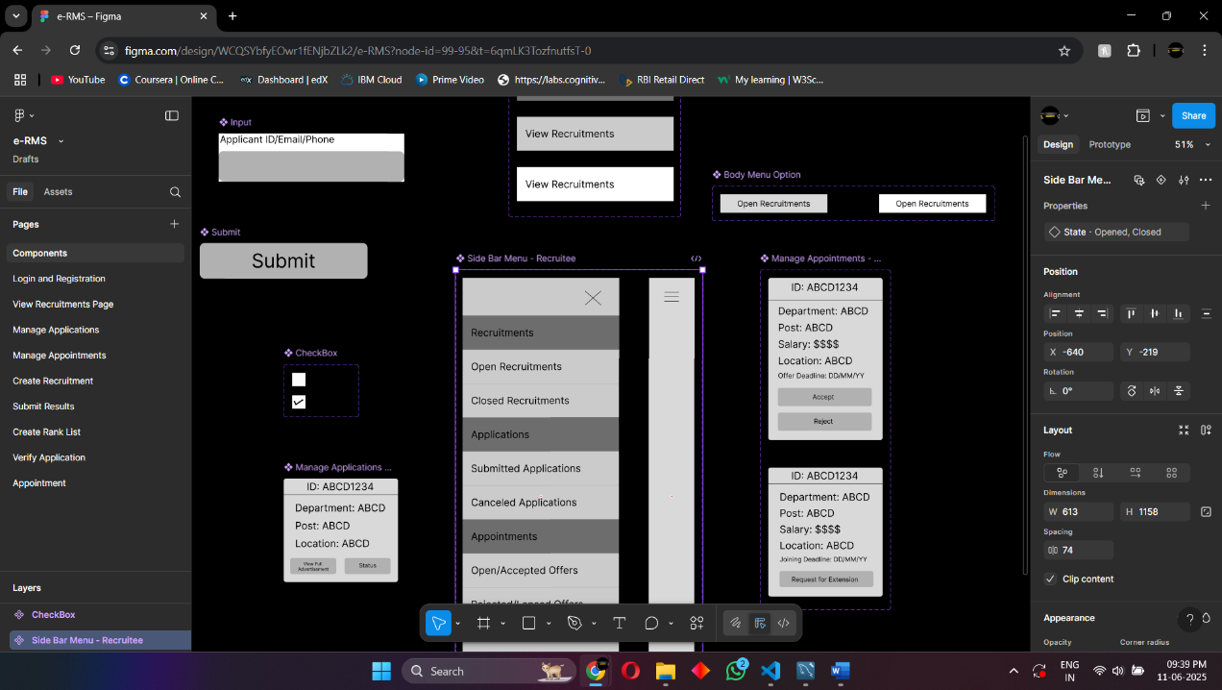

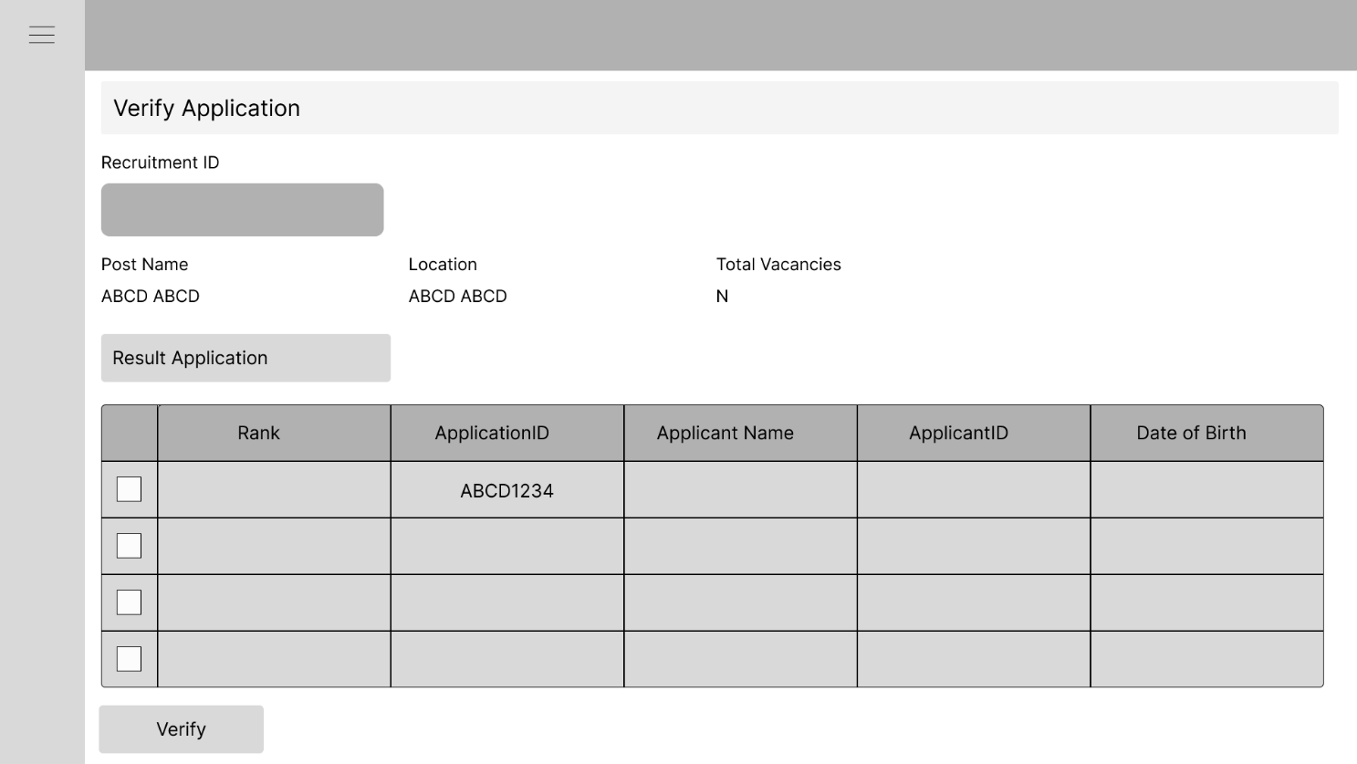

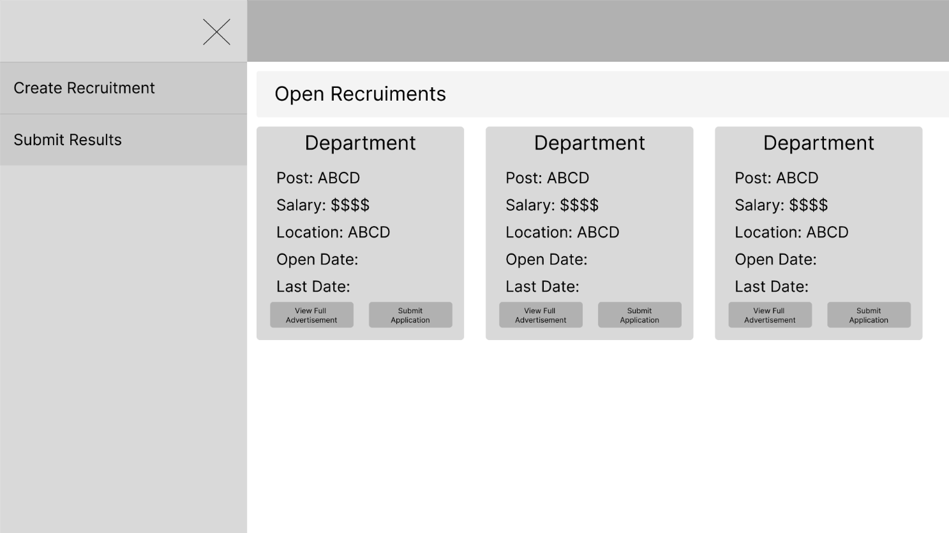

# PROGRAMME CODE

Due to the extensive nature of the complete codebase, only select snippets and functional blocks relevant to key operations and logic have been included in this document for clarity and brevity. These snippets are representative of the implementation and are intended to illustrate core features and workflows. The full source code, including all components, utility files, and configuration details, can be accessed in the project's GitHub repository.

**Front End (JavaScript (React.js / JSX) / CSS)**

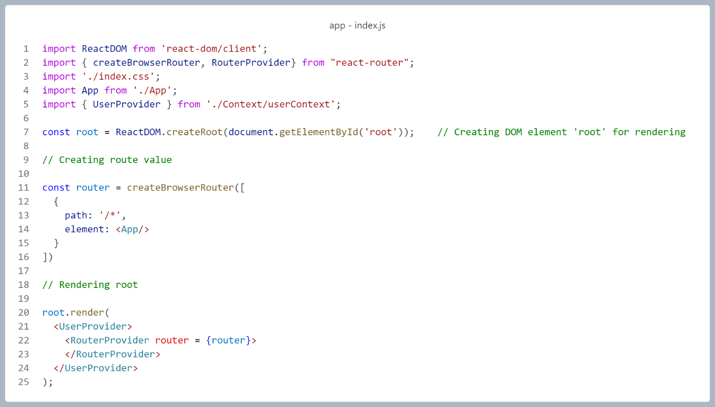

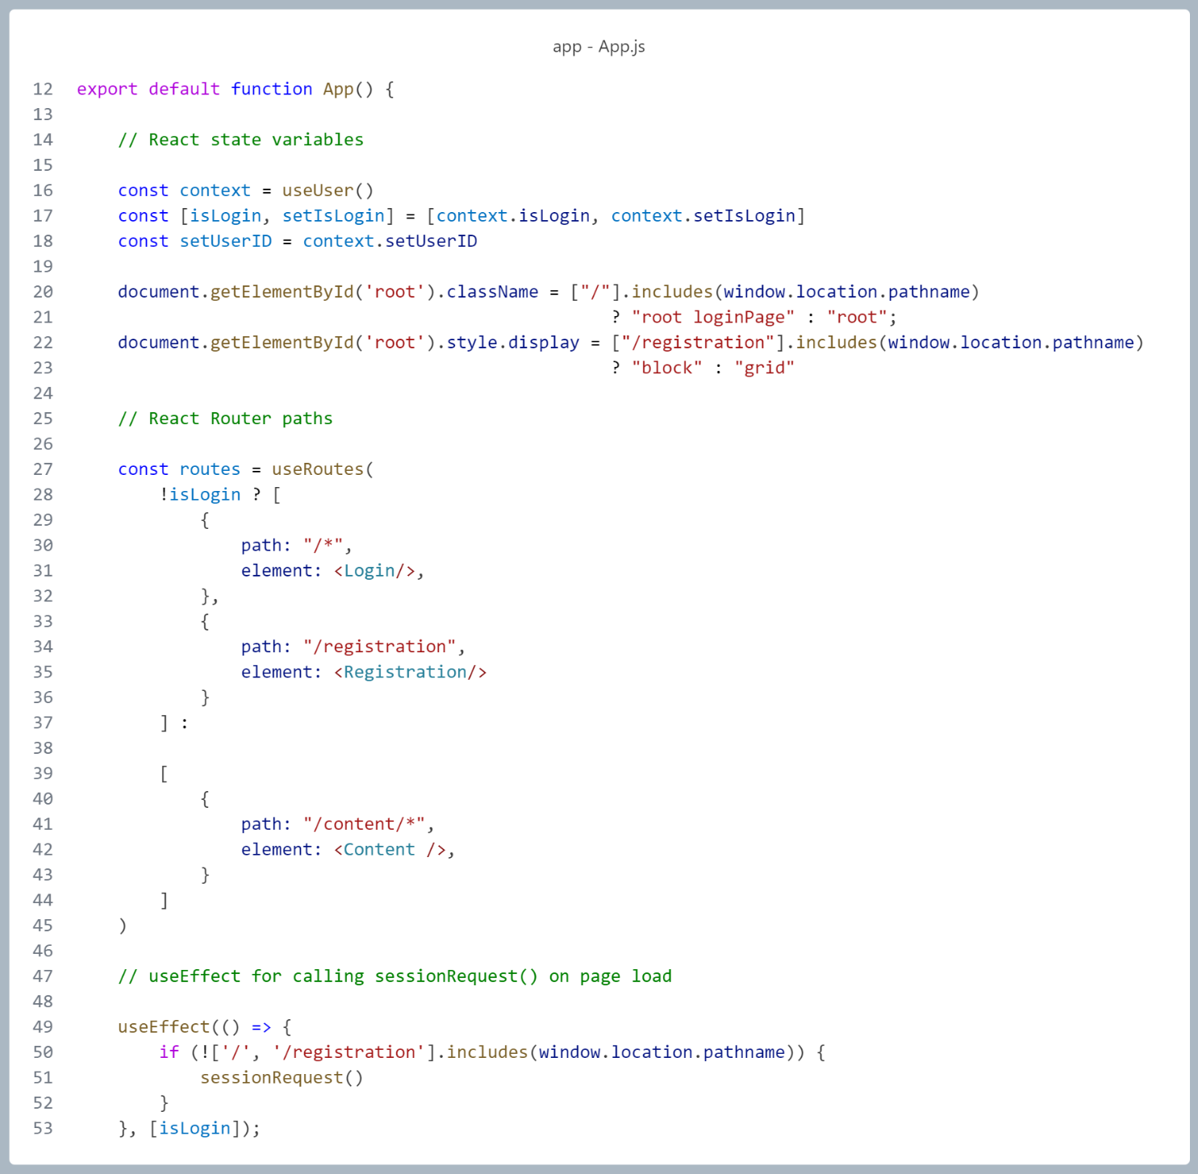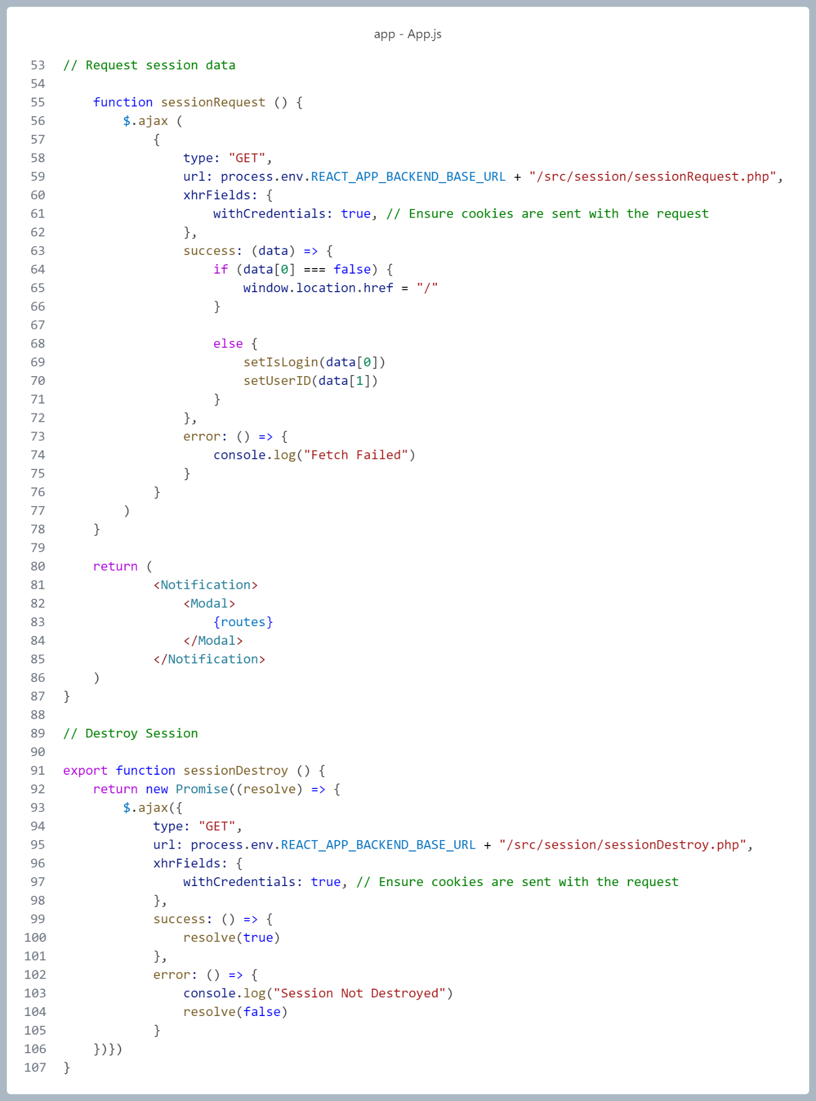

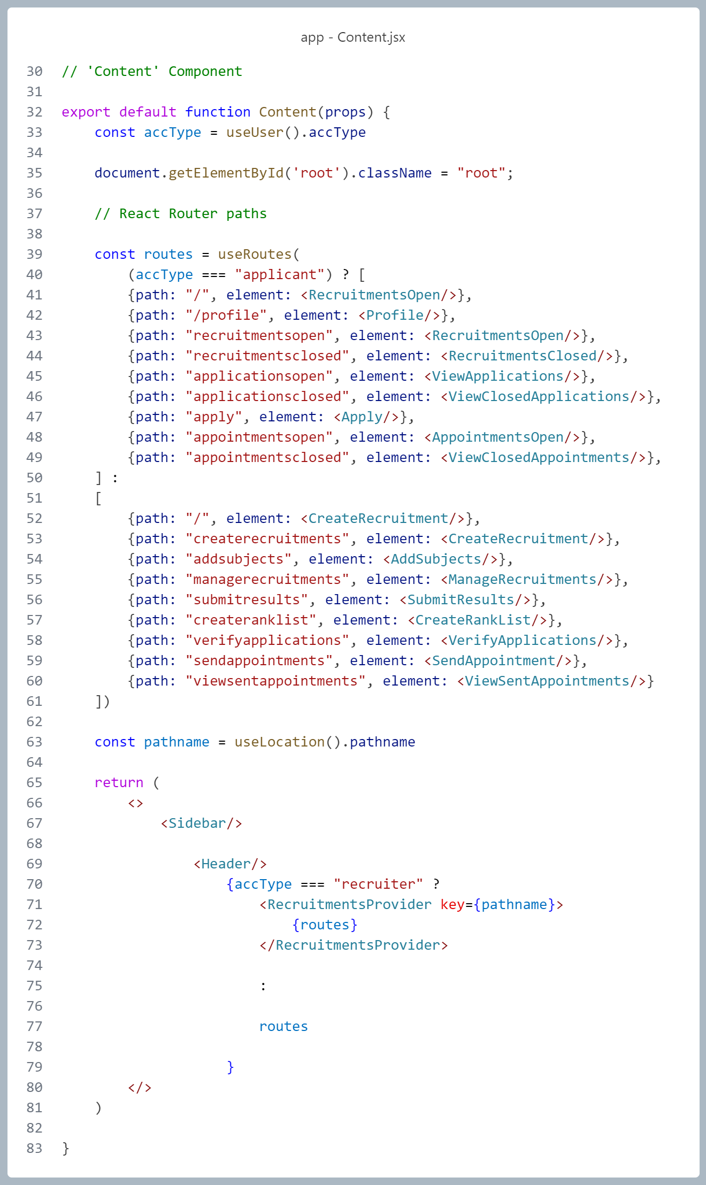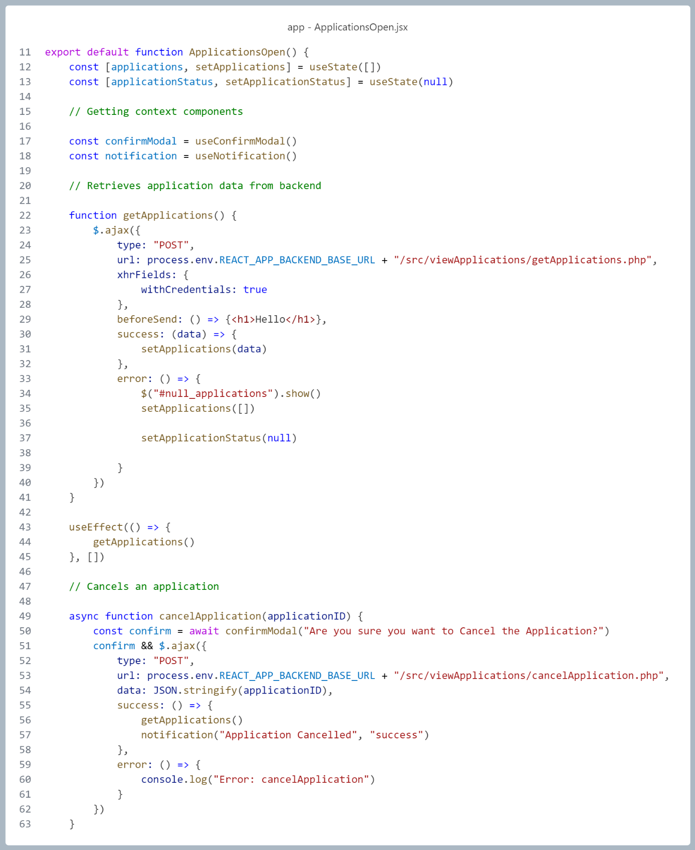

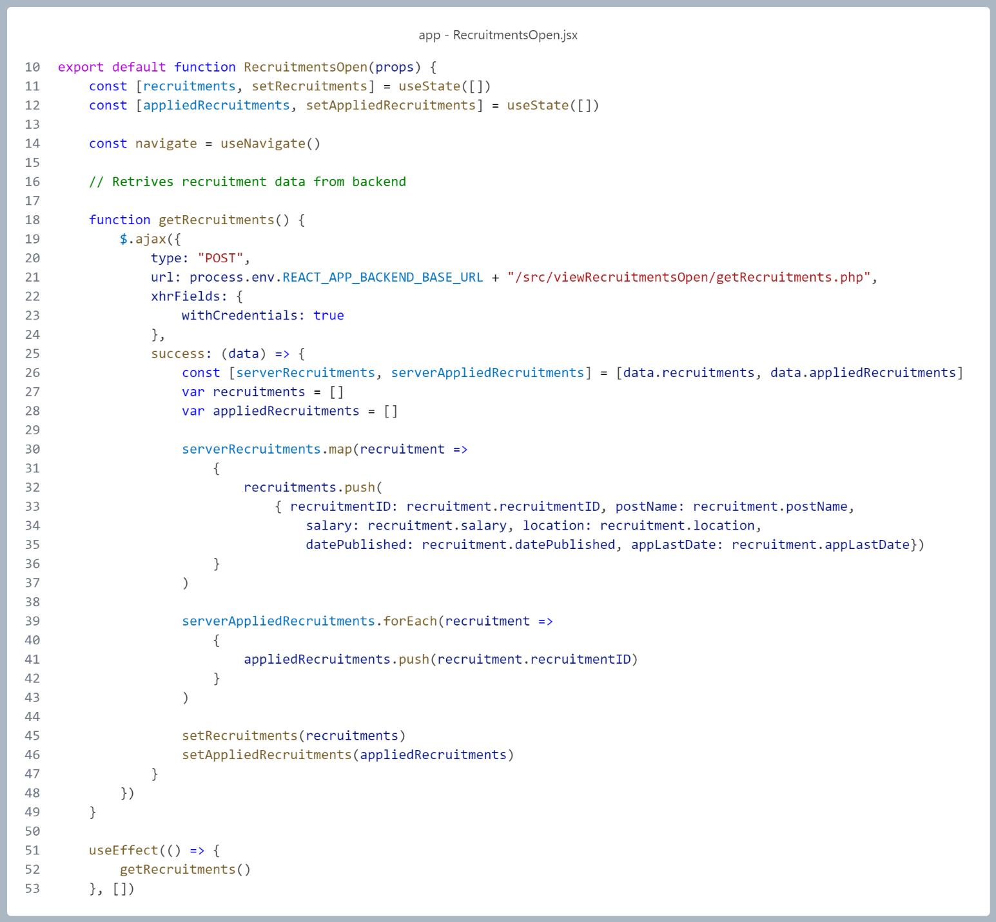

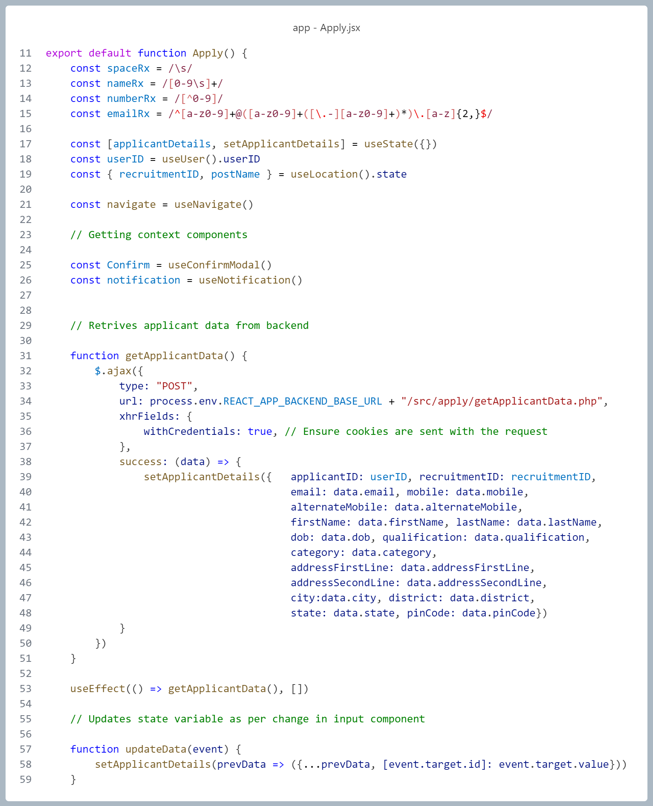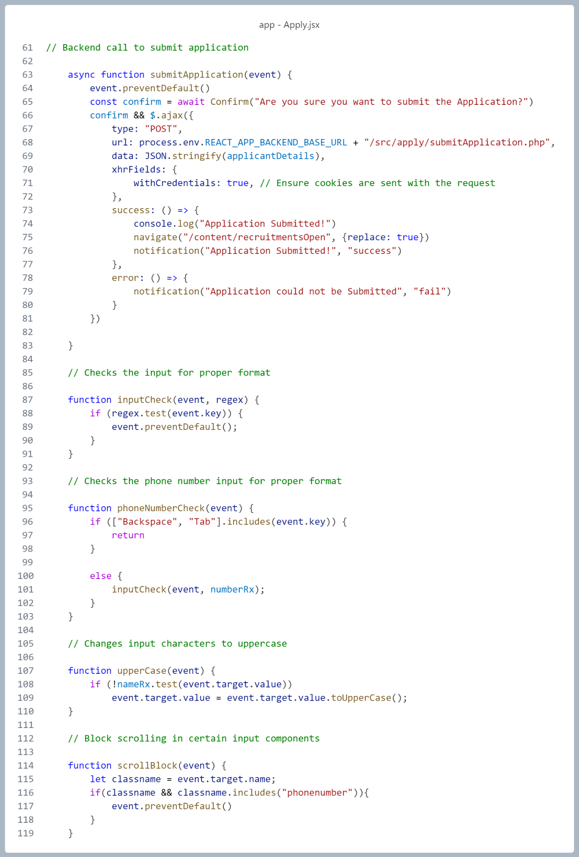

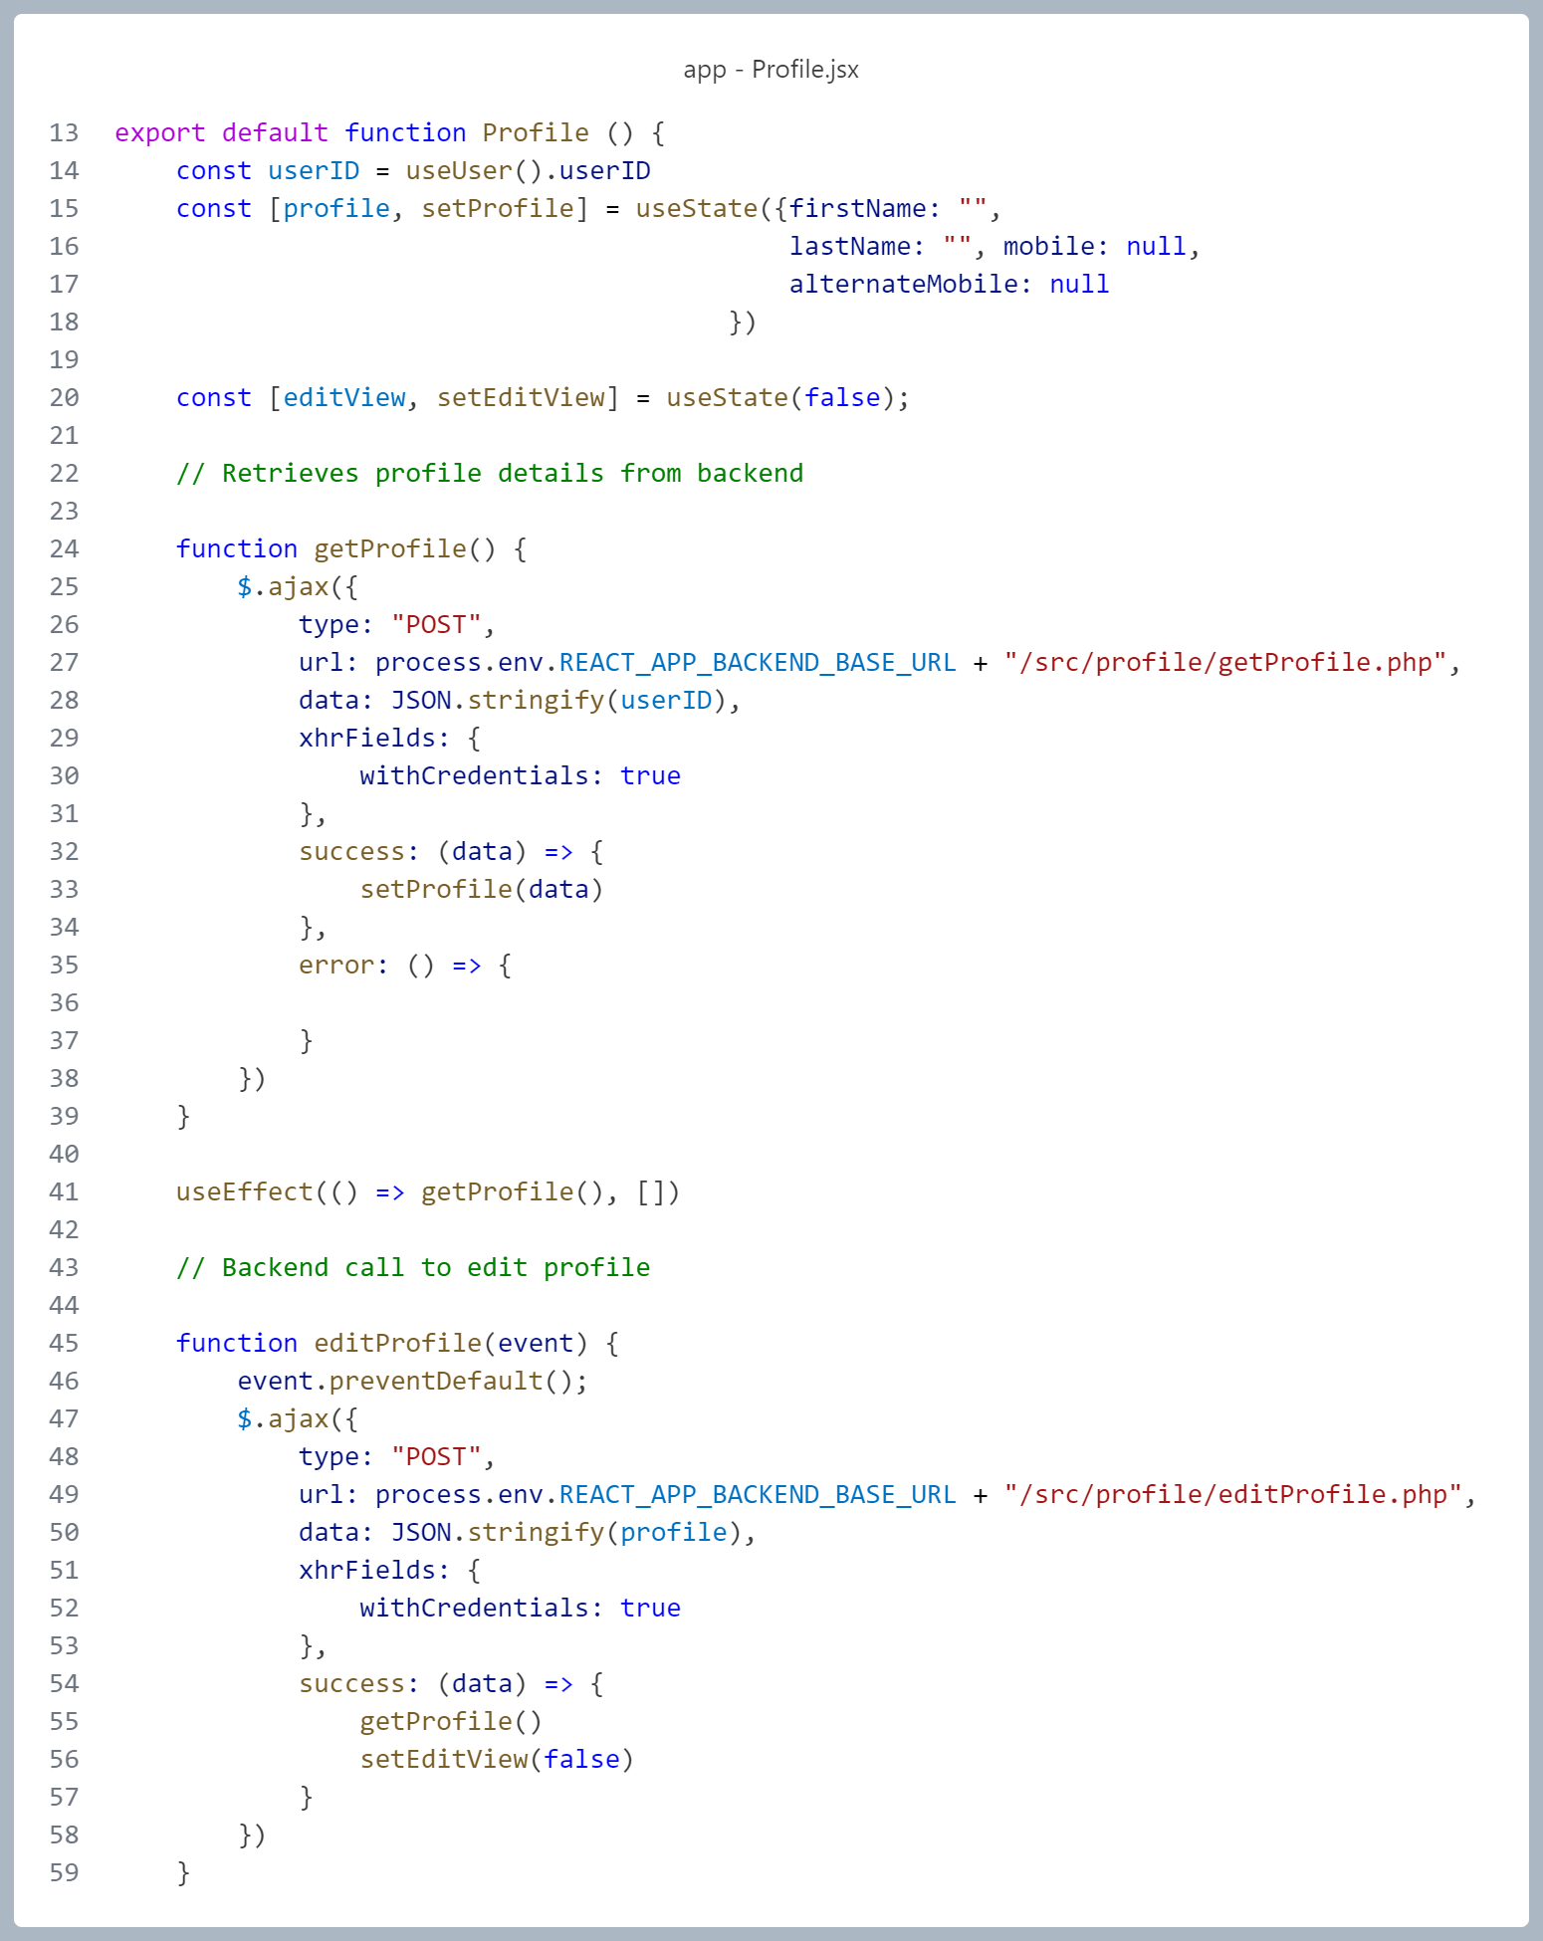

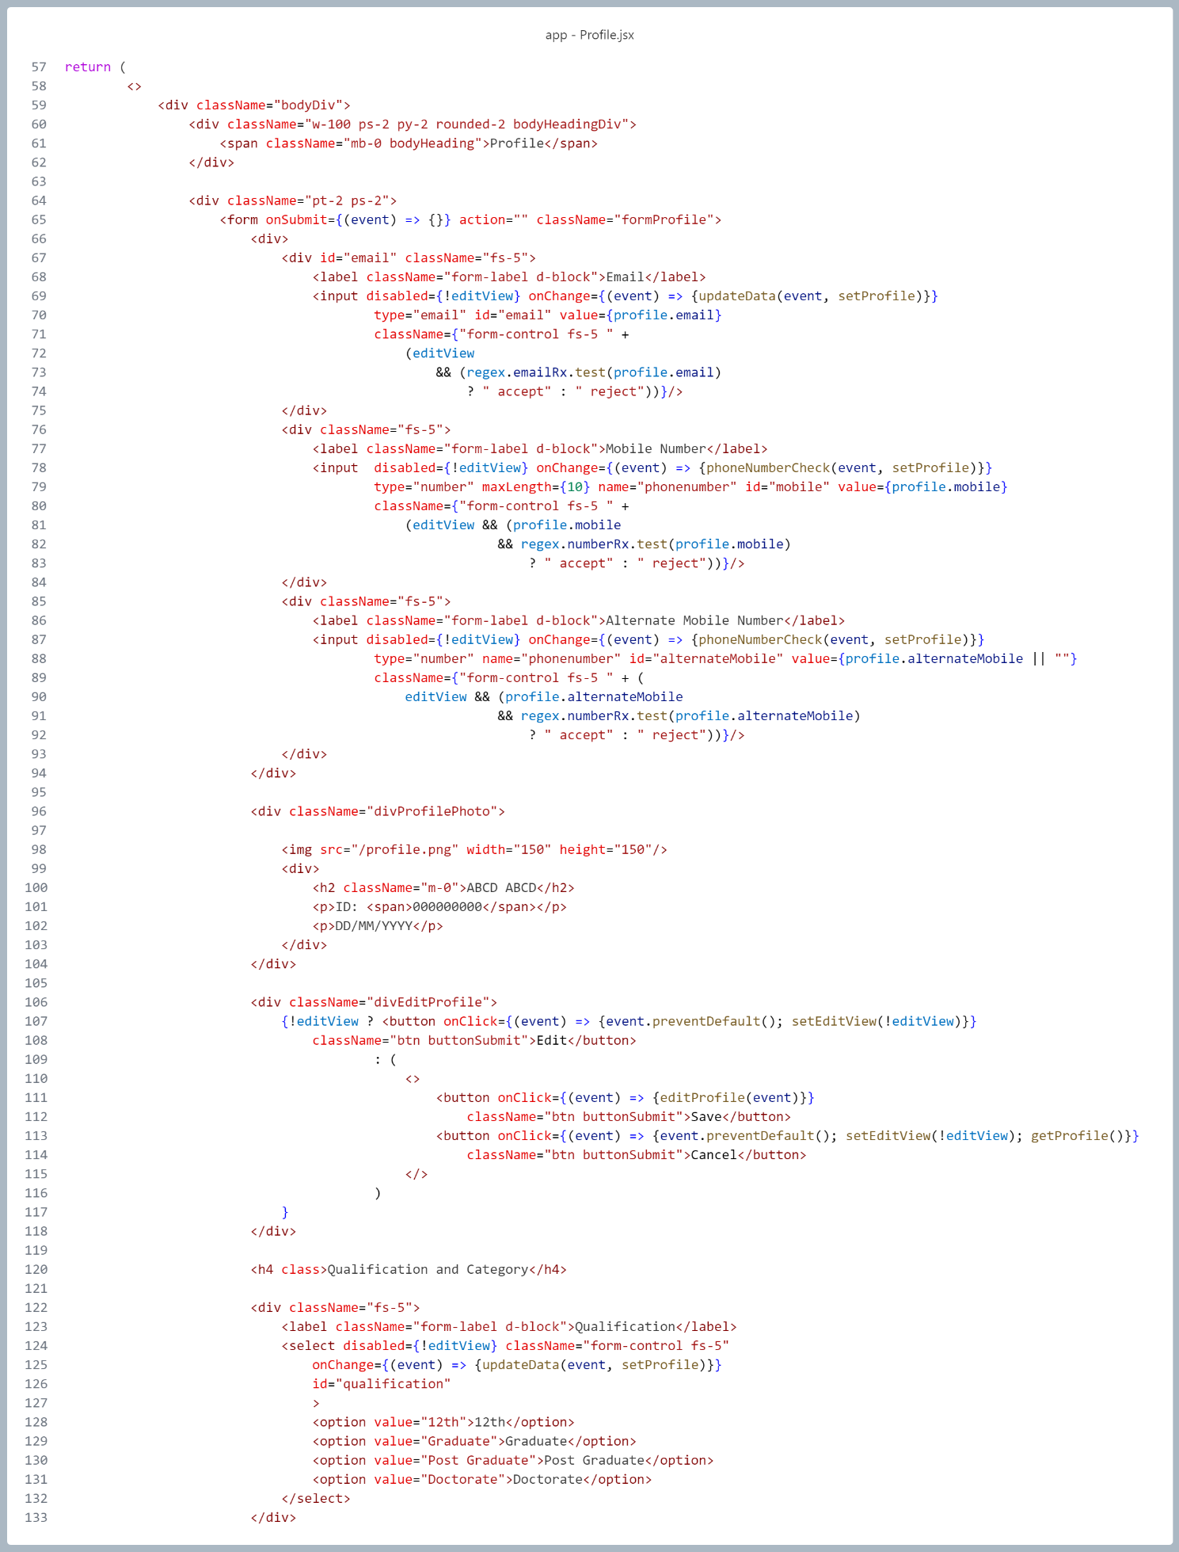

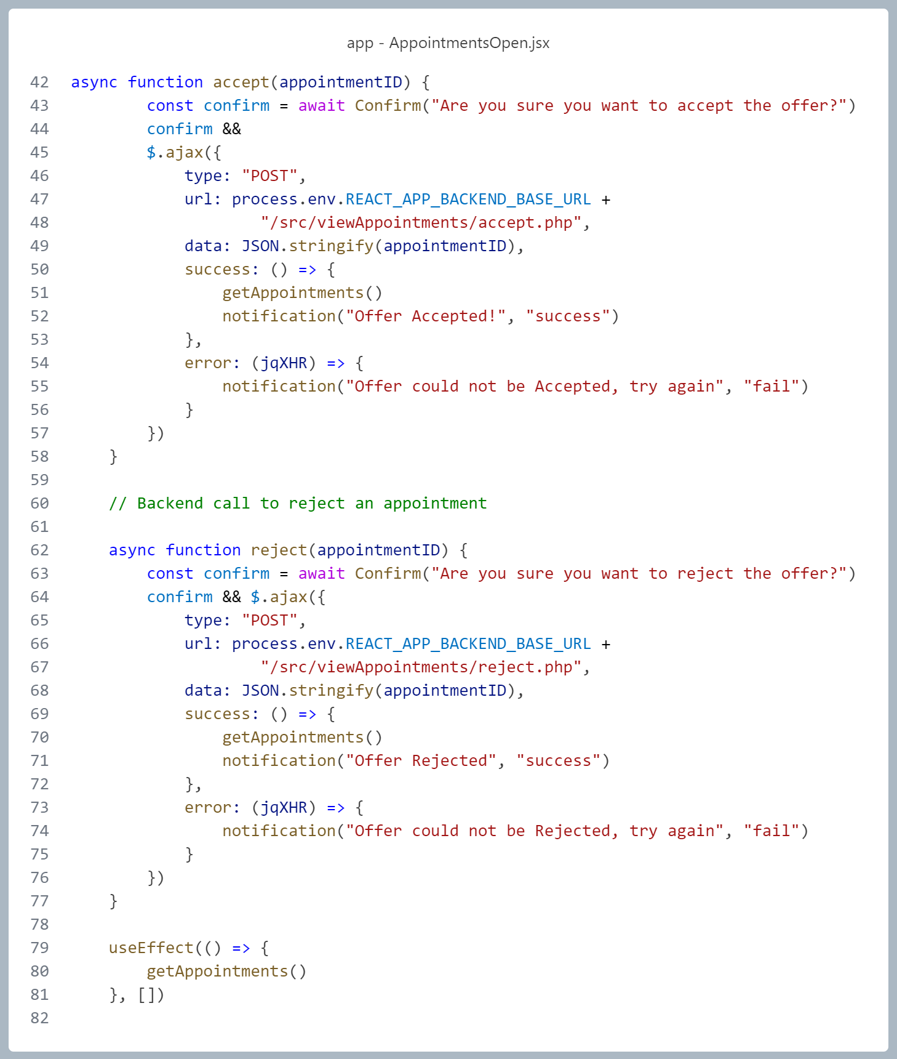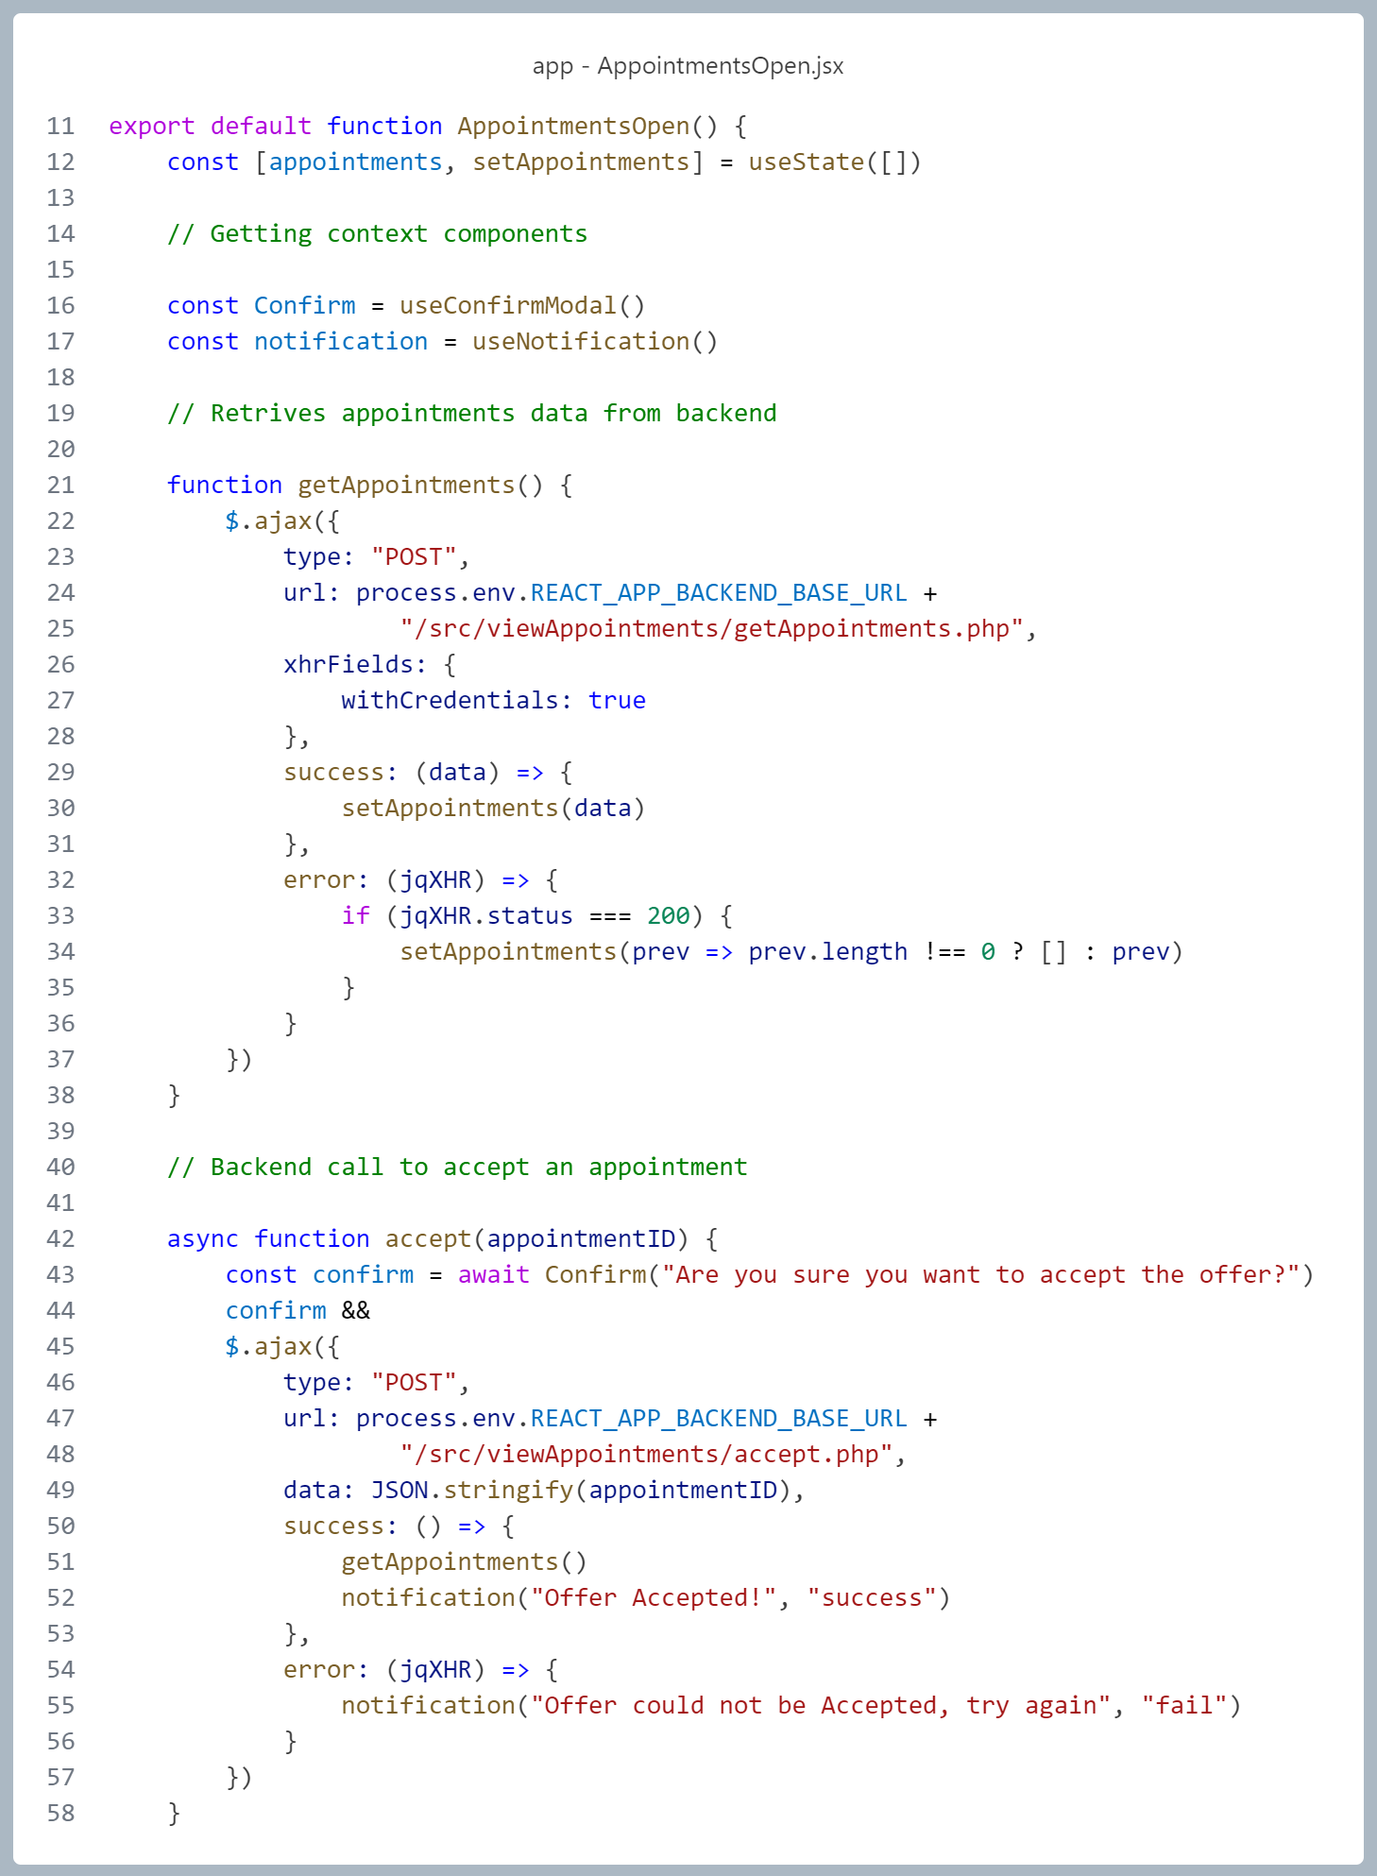

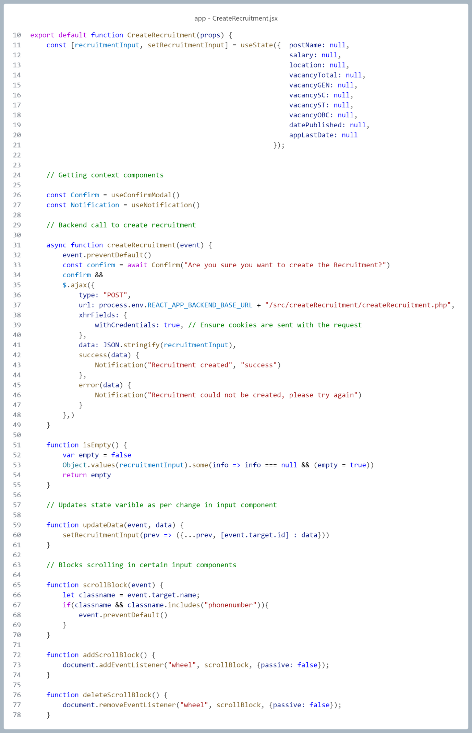

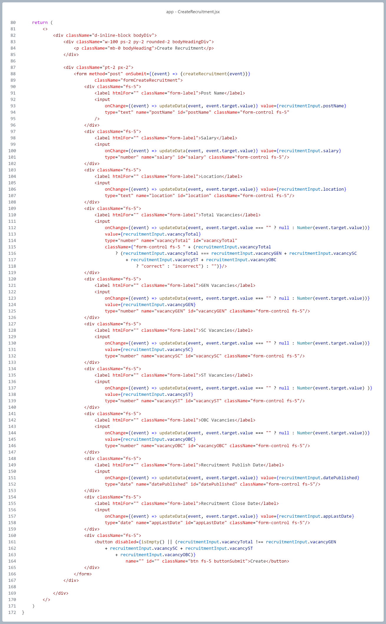

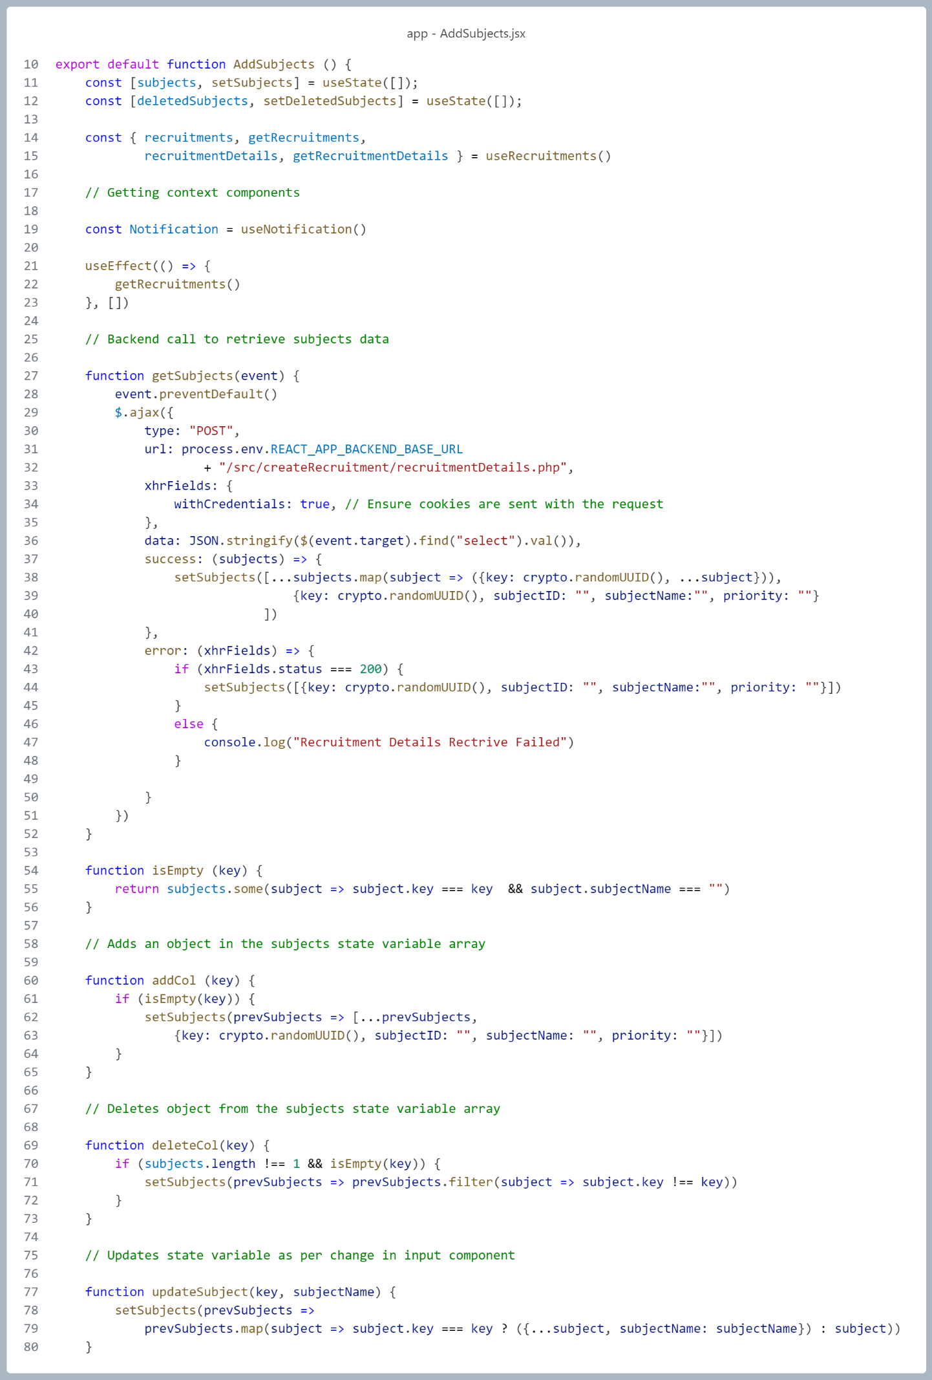

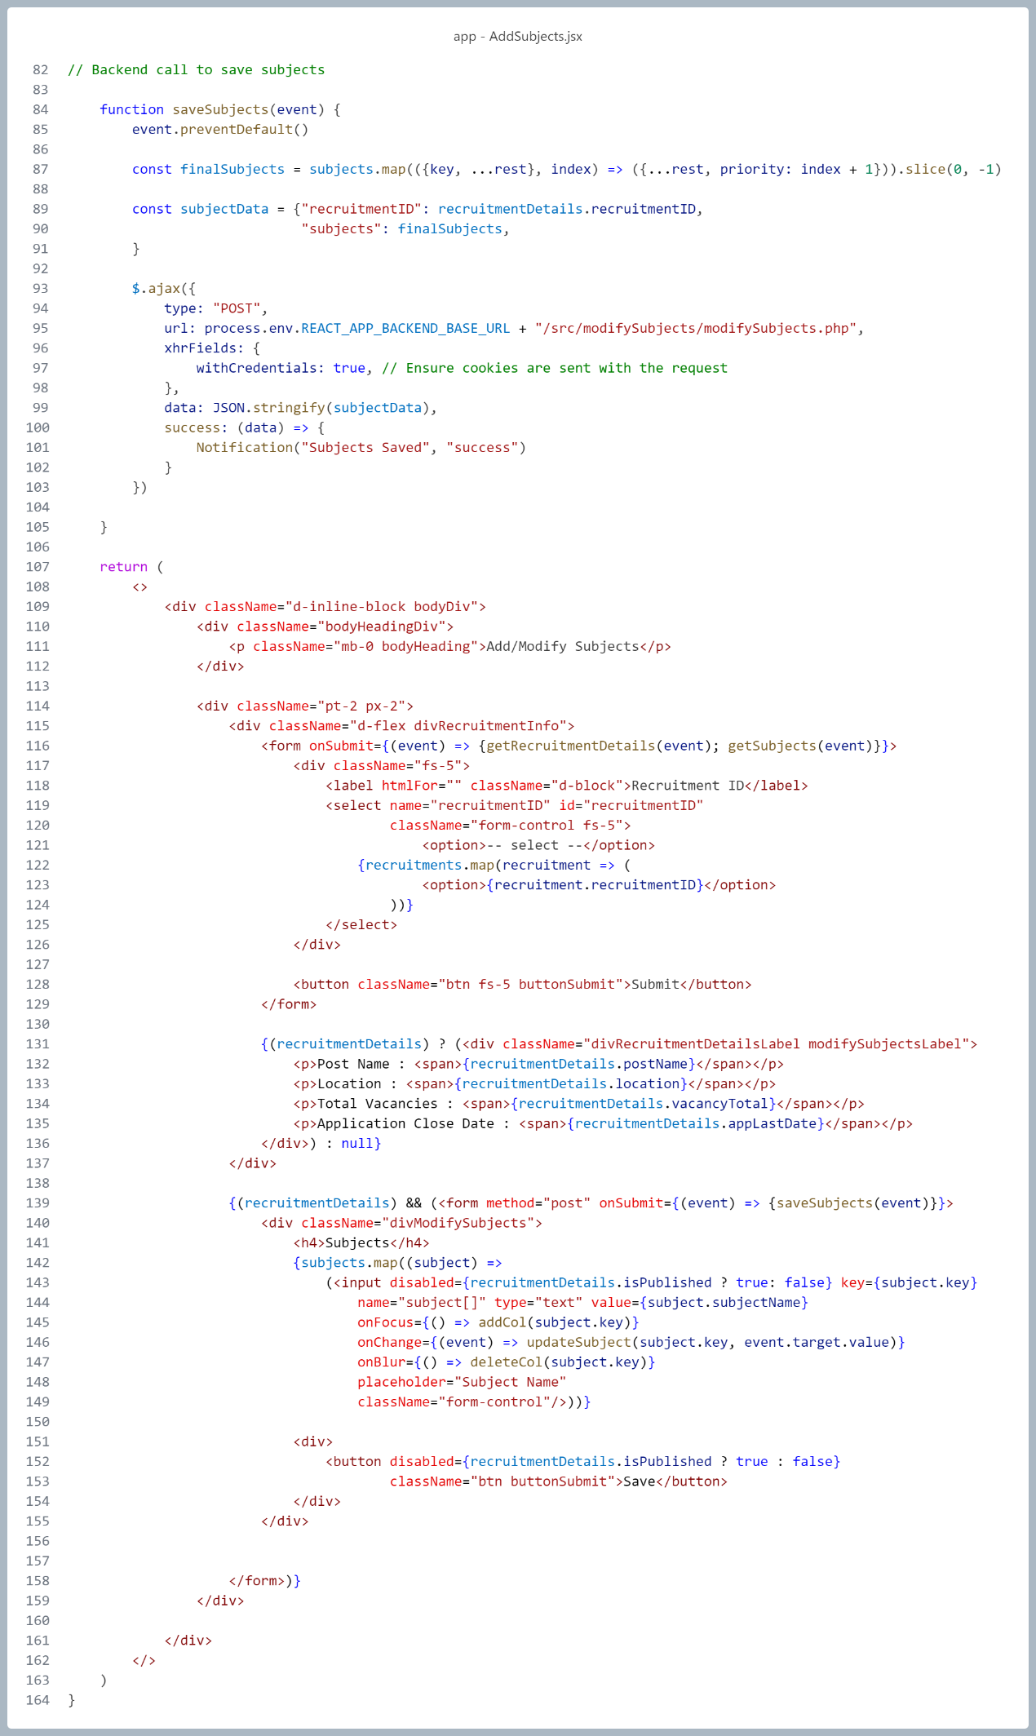

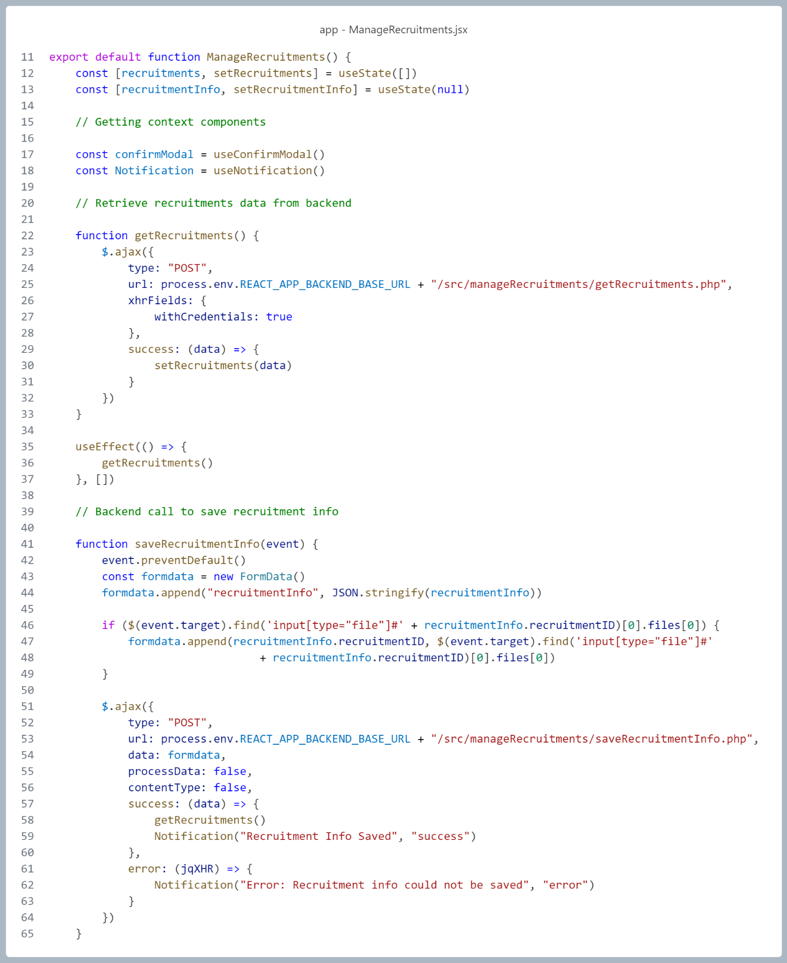

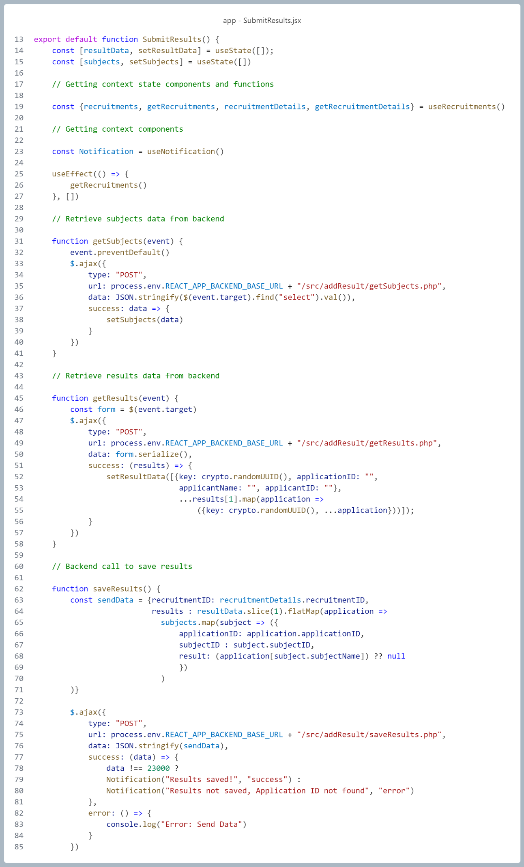

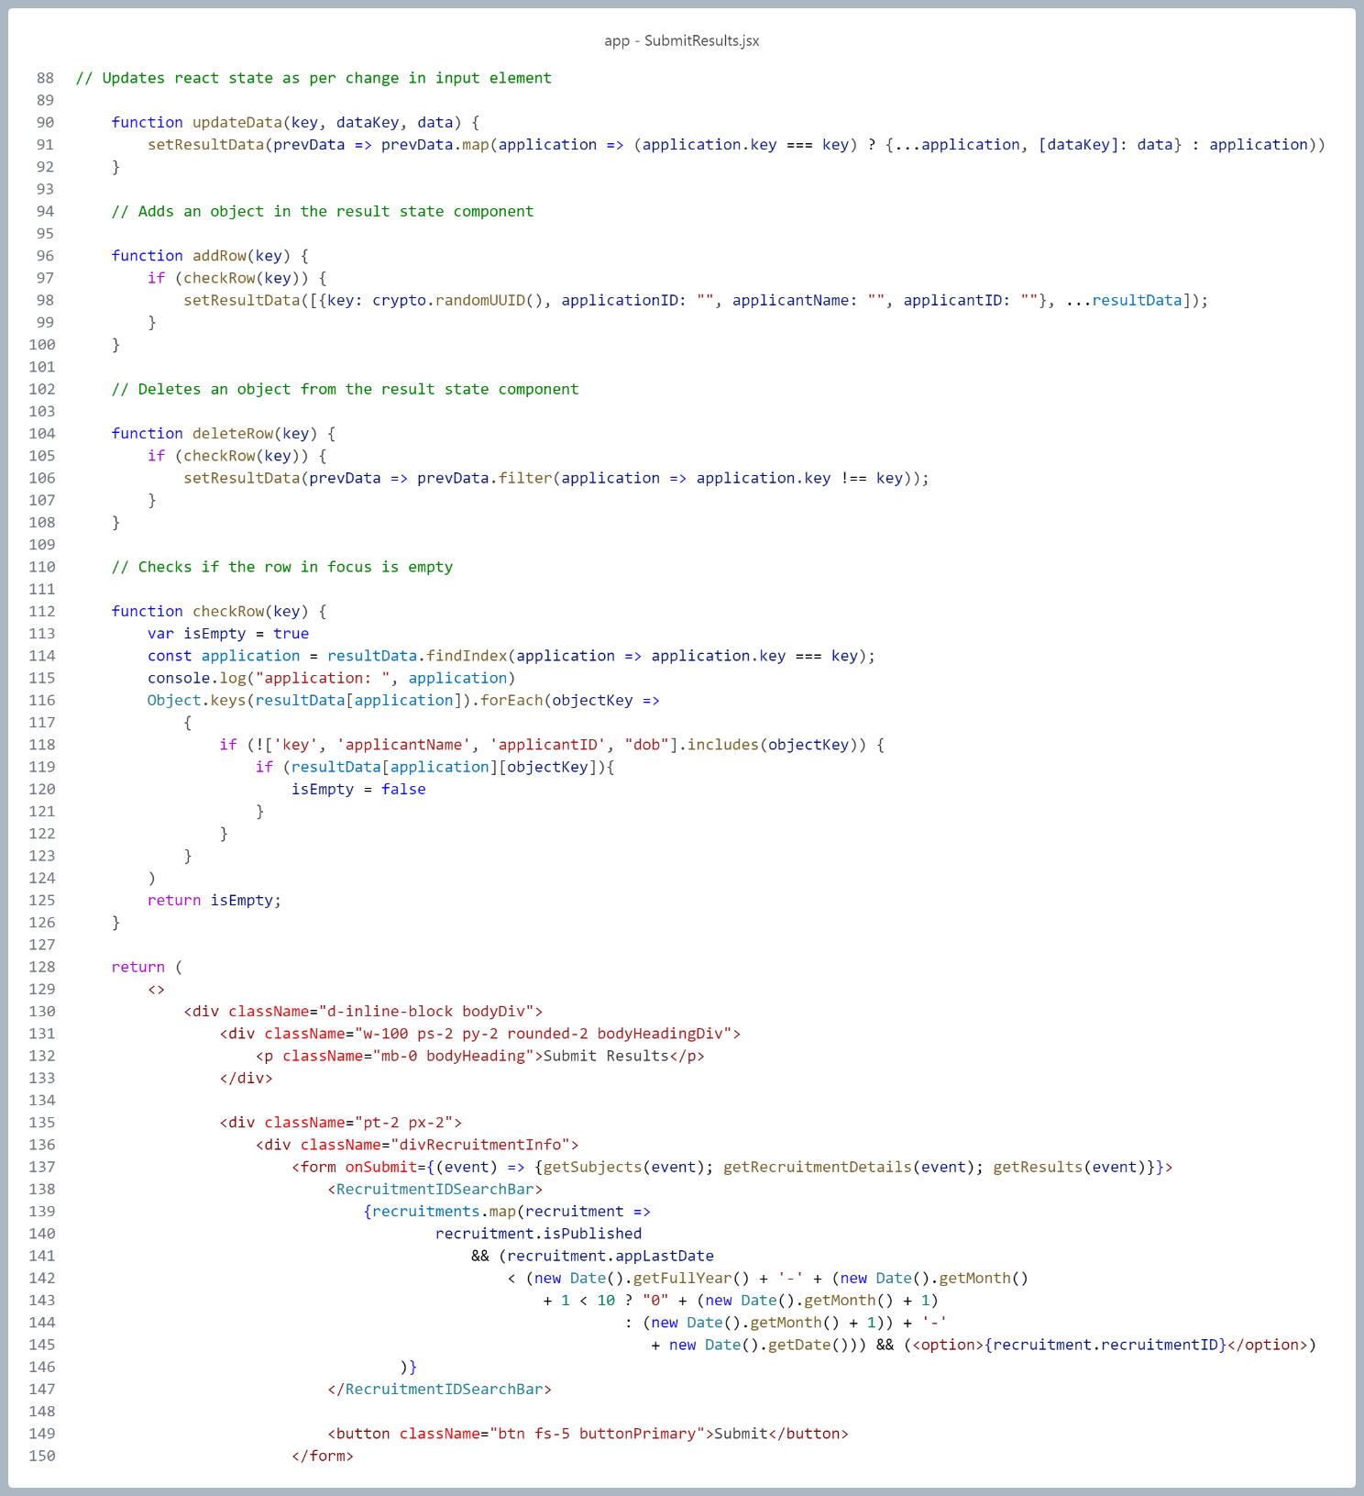

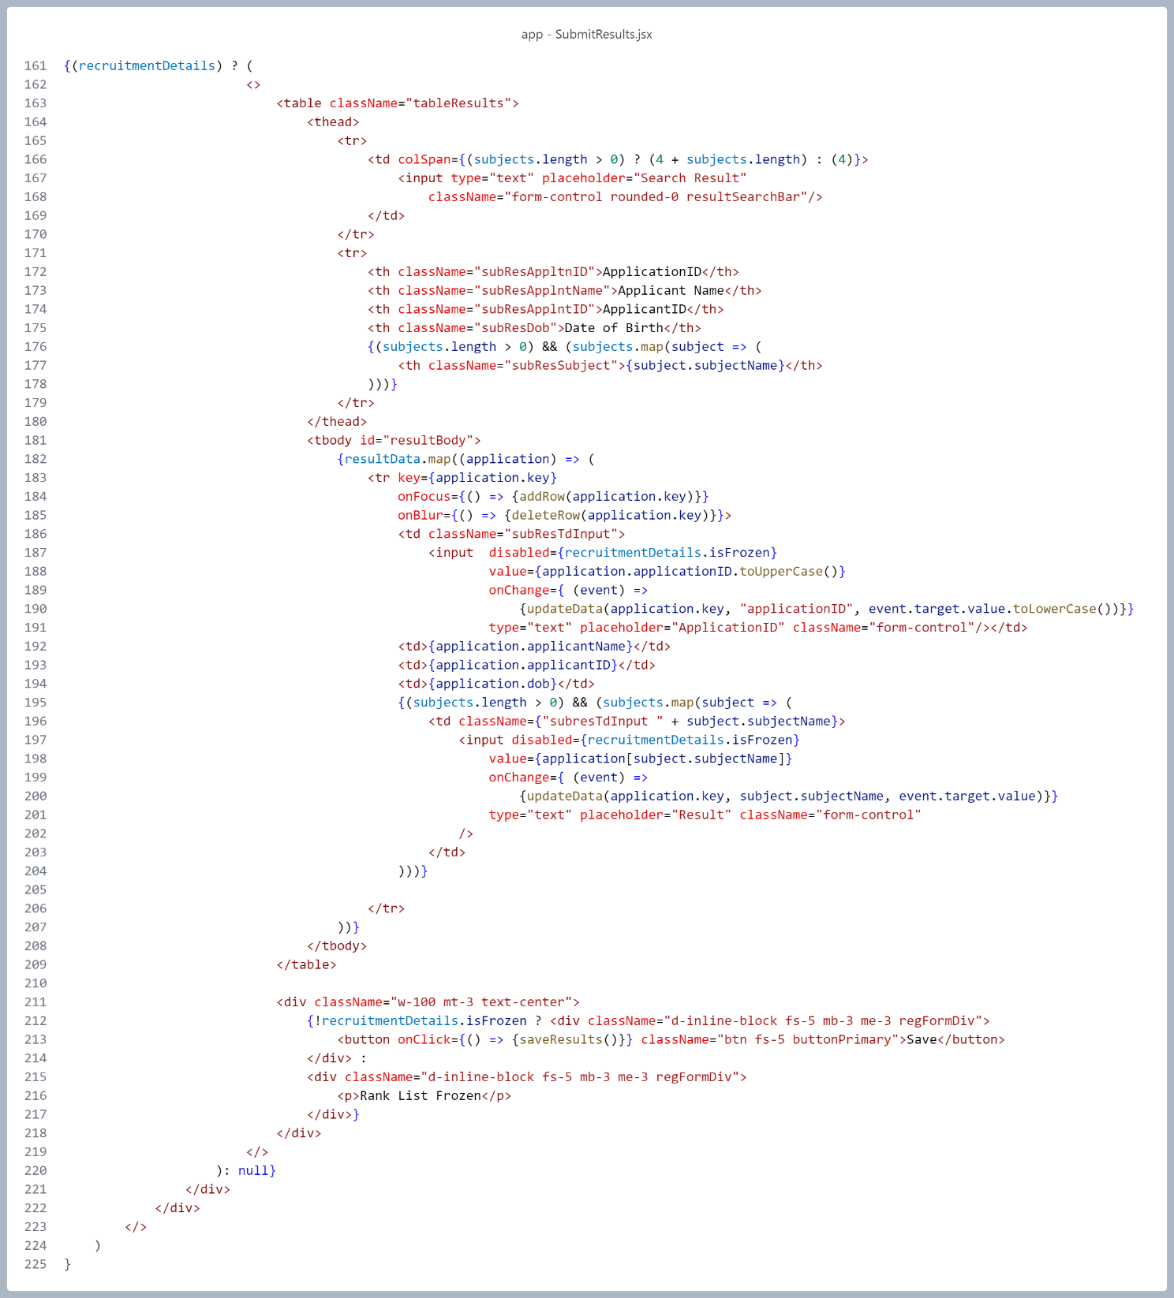

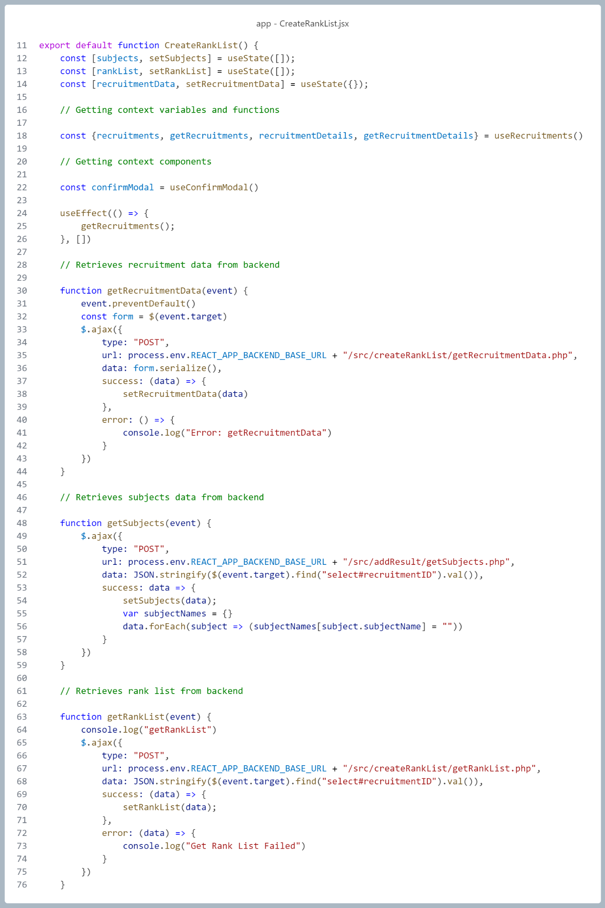

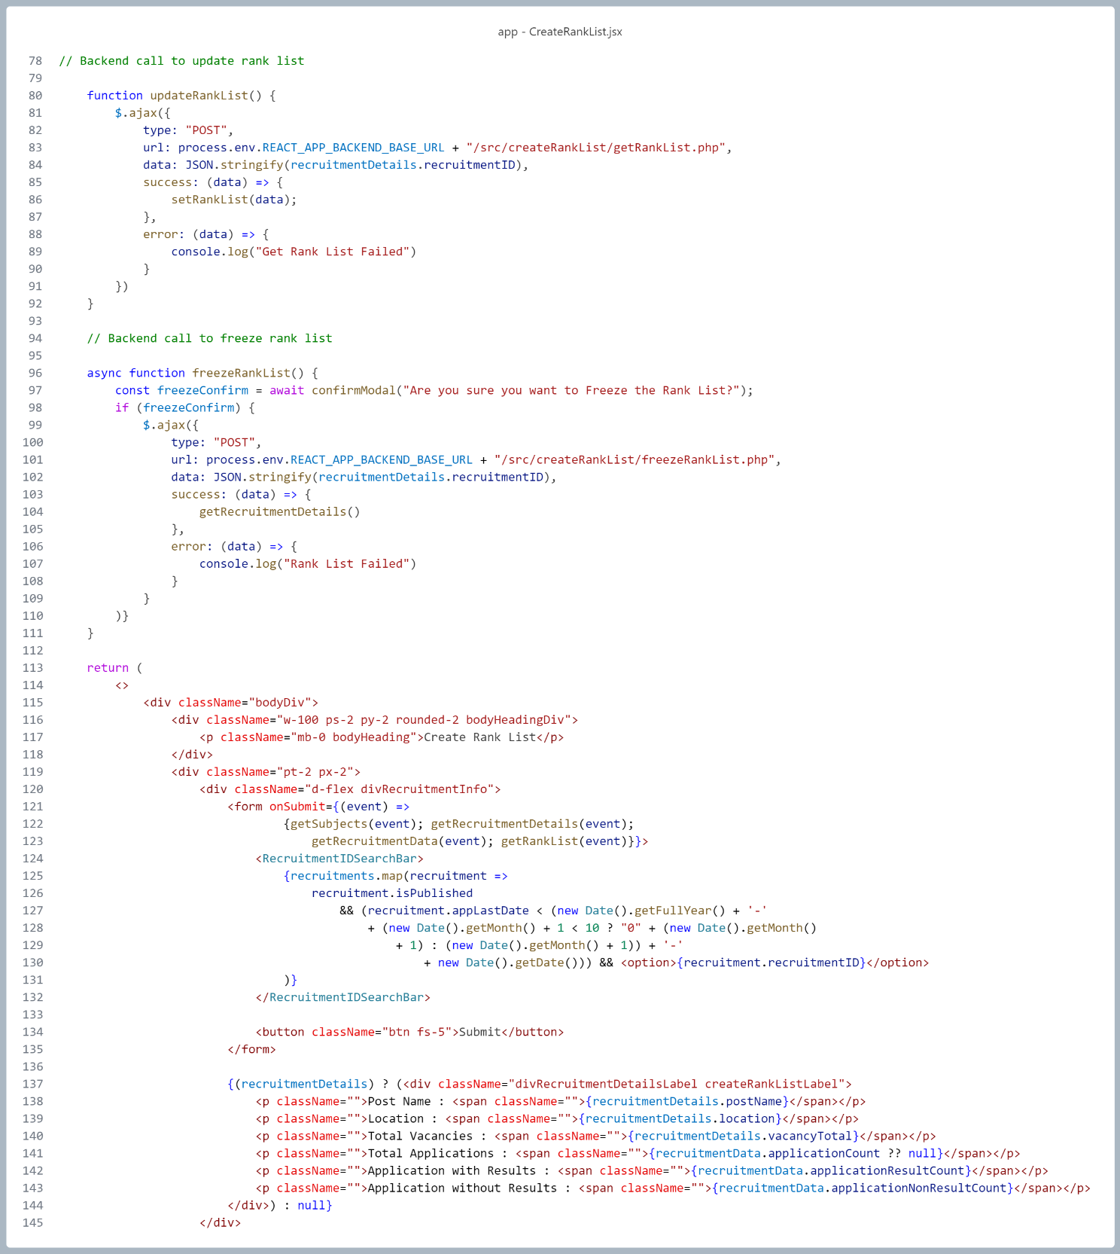

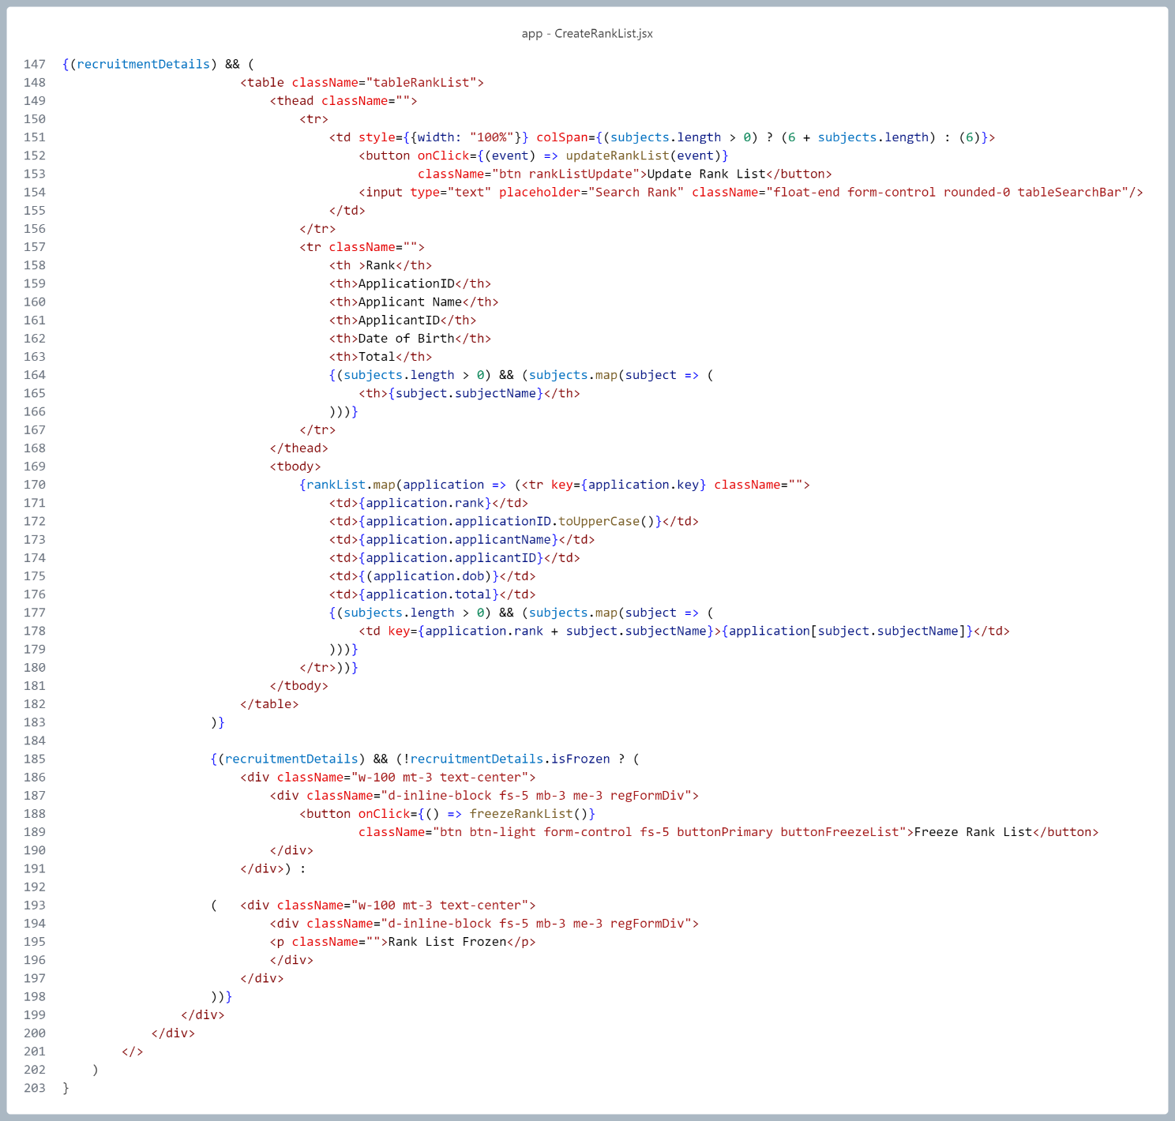

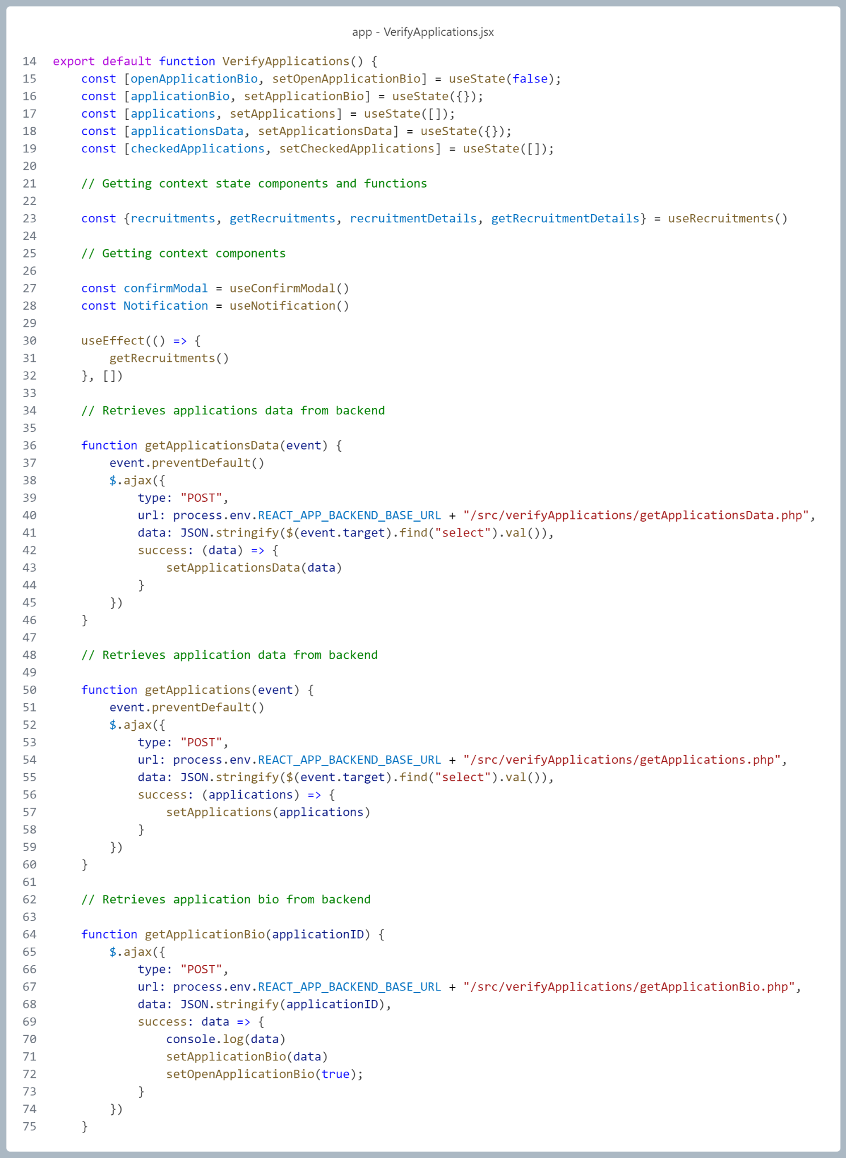

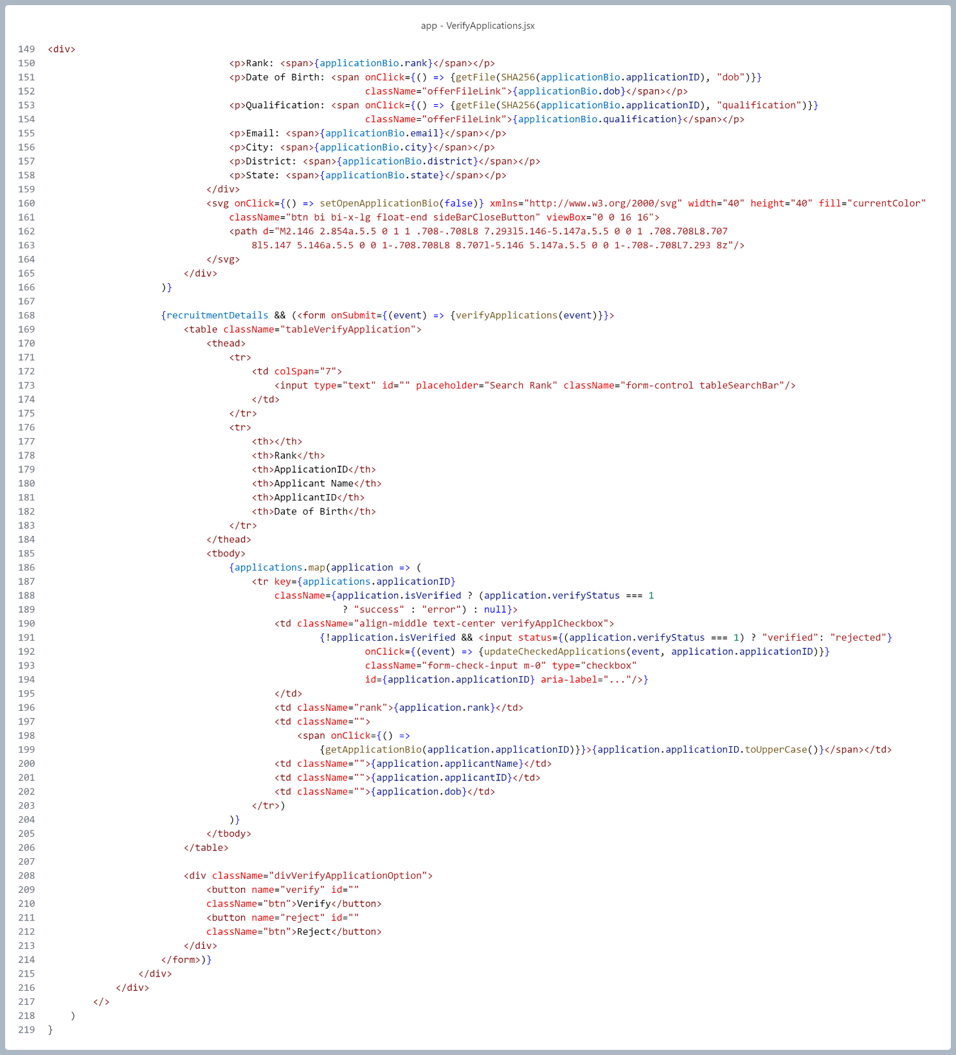

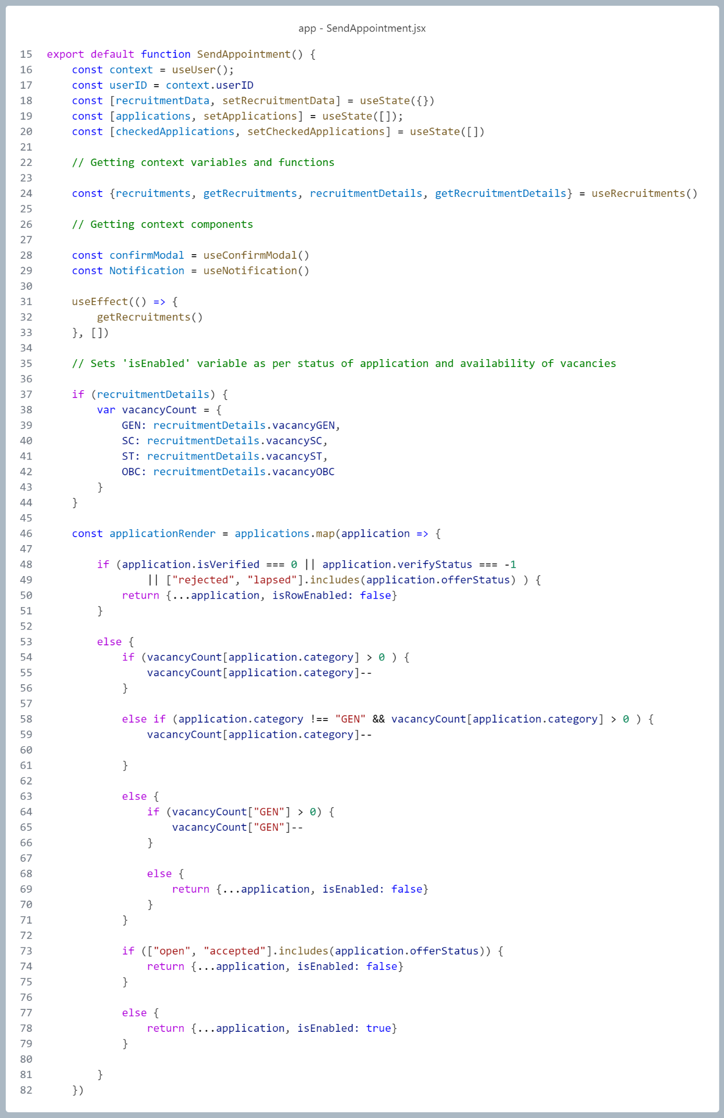

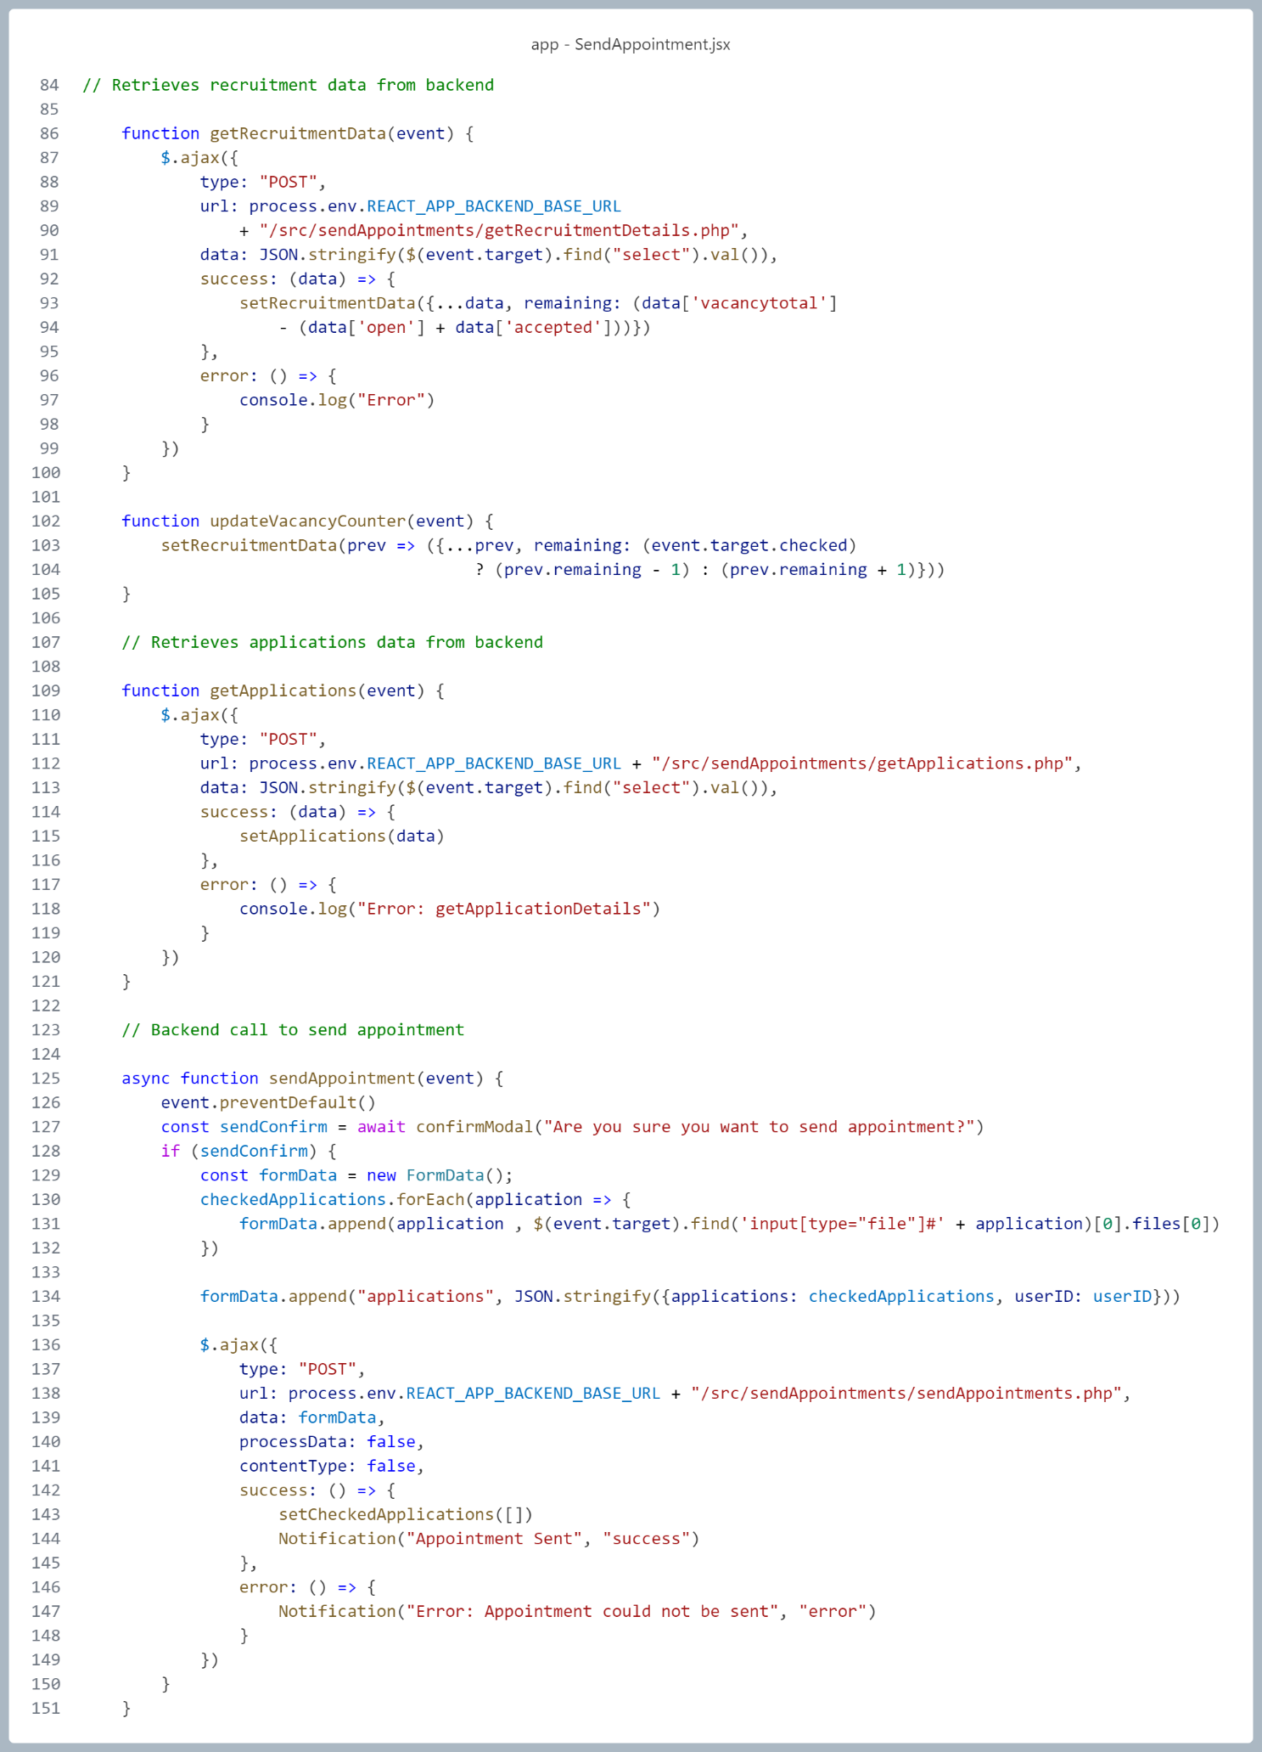

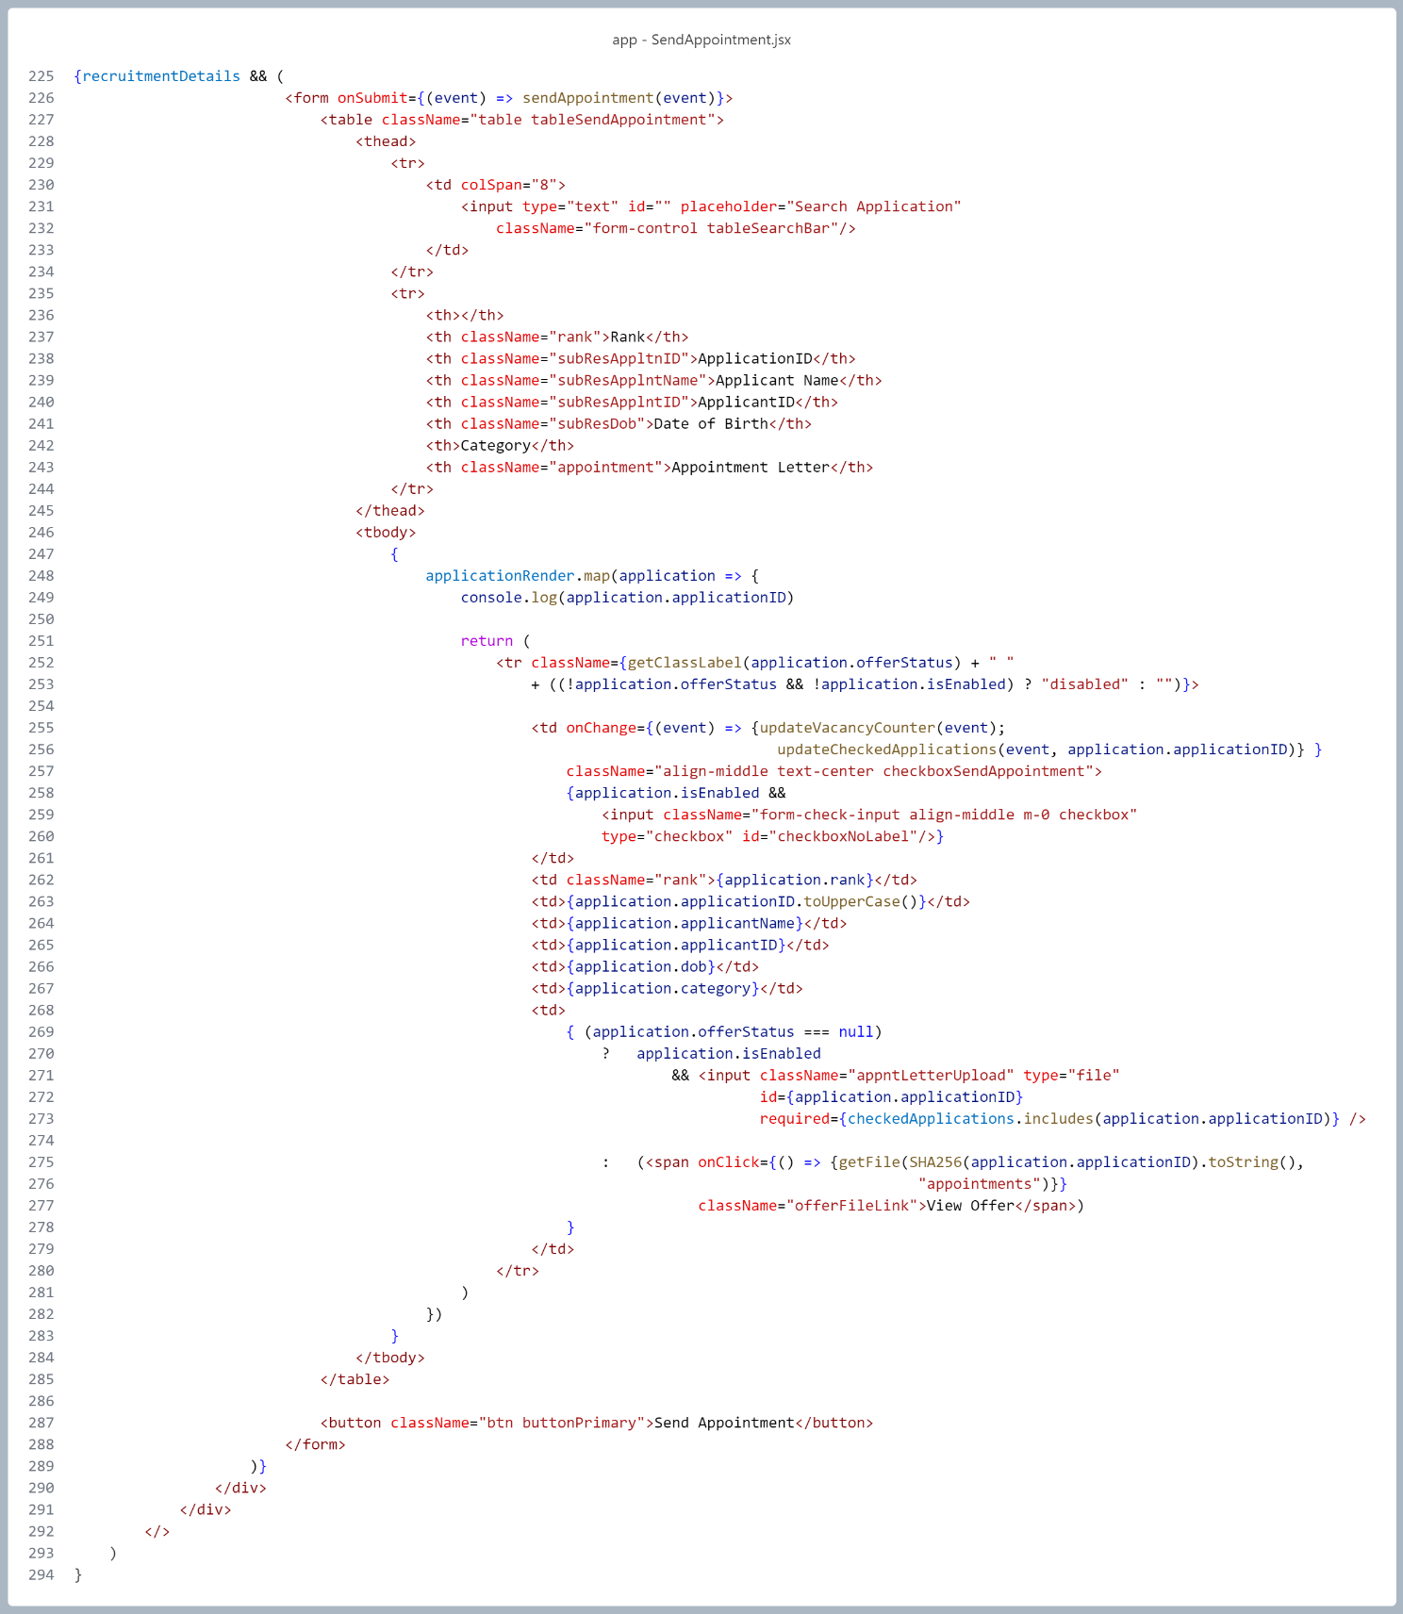

**Backend (PHP)**

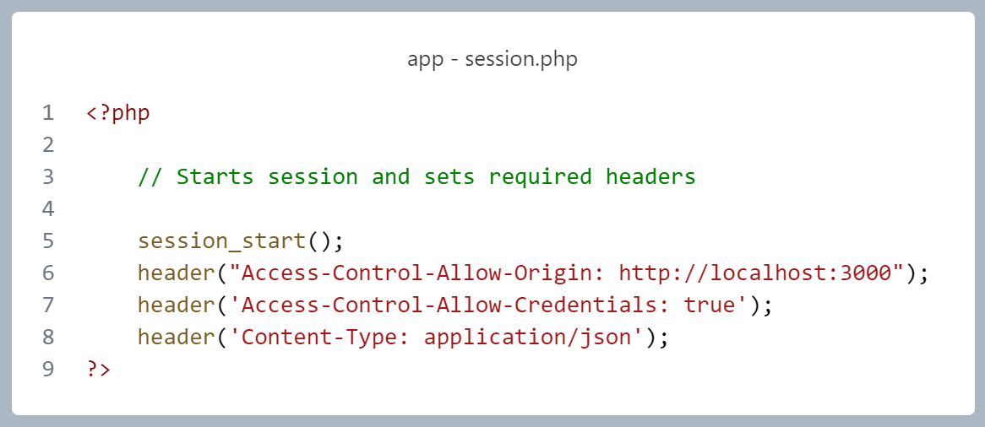

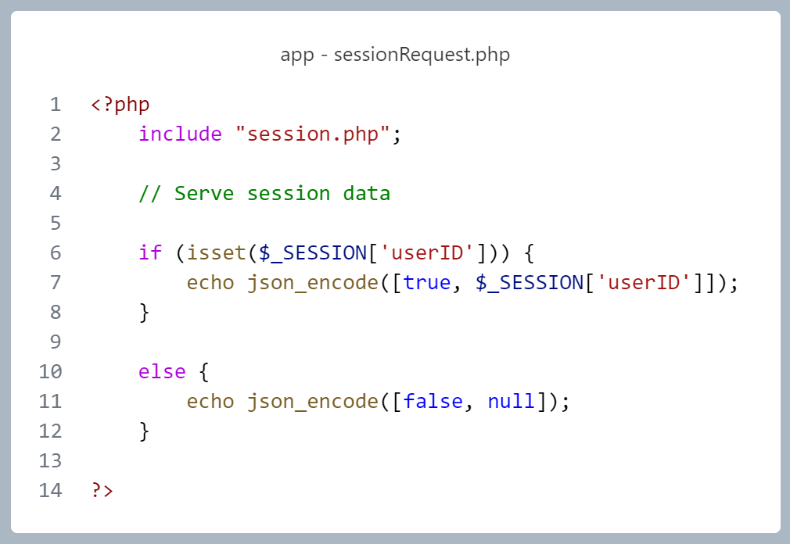

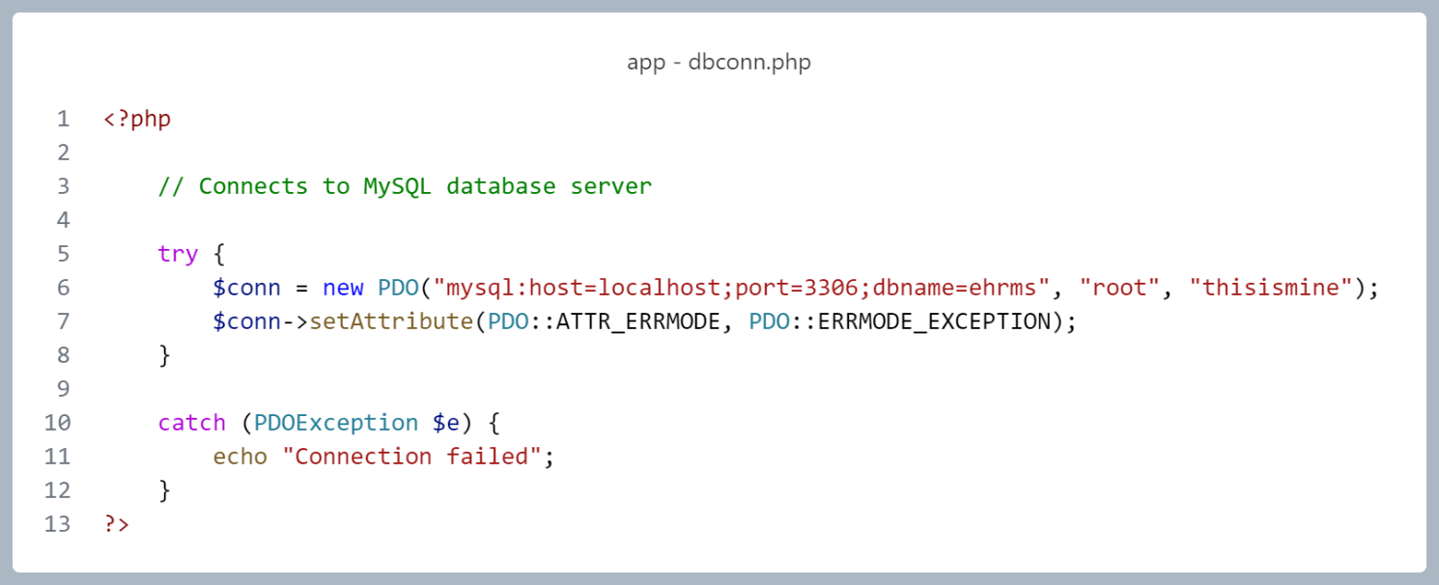

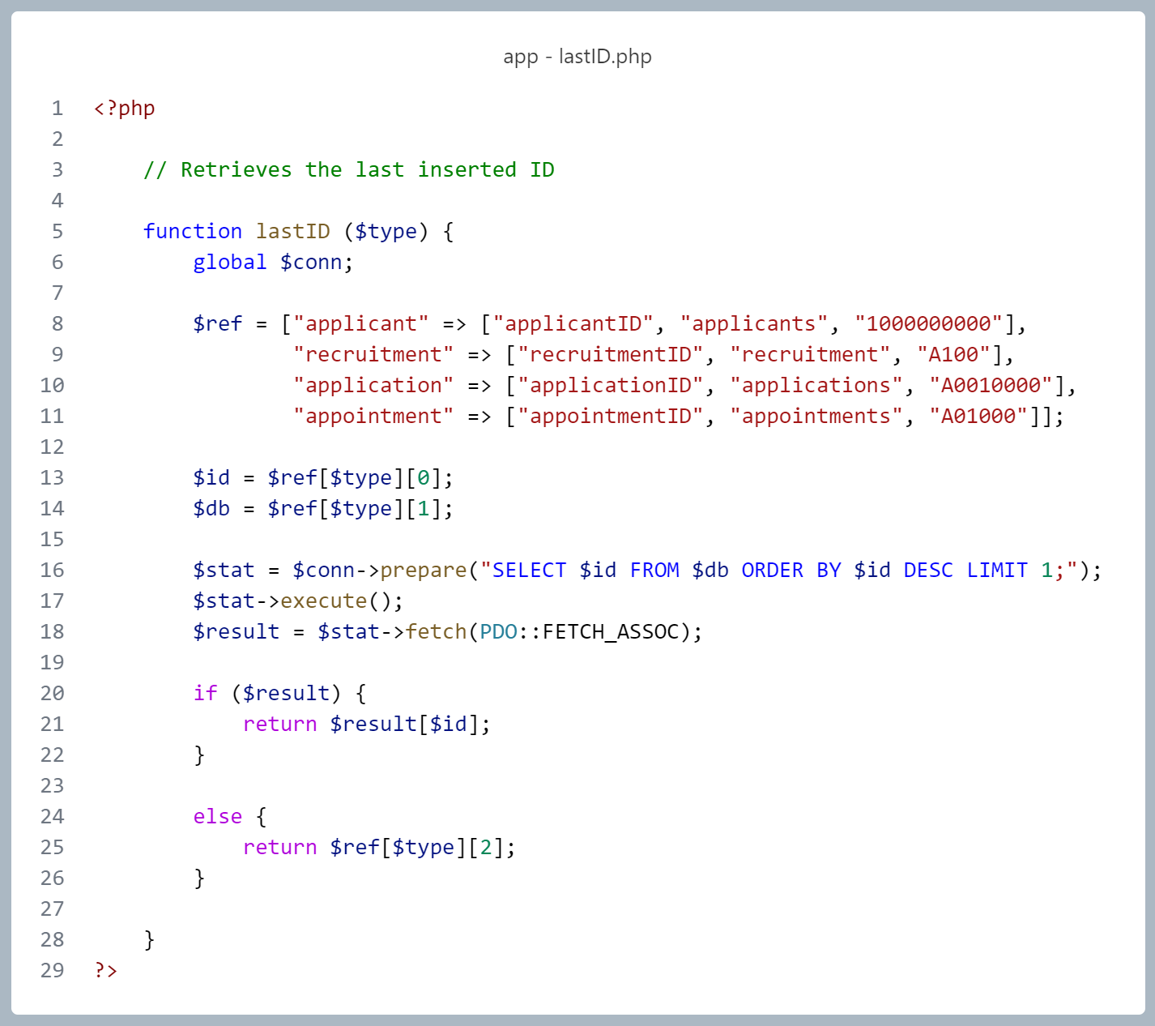

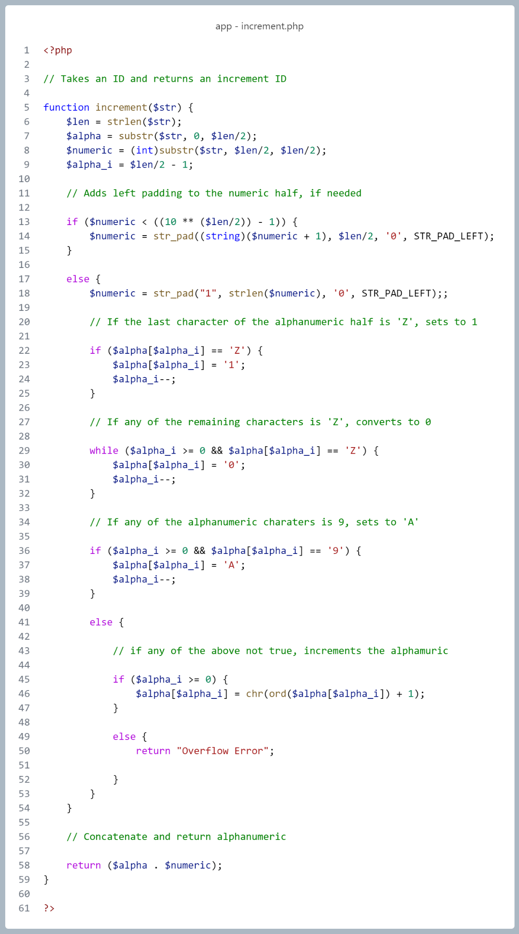

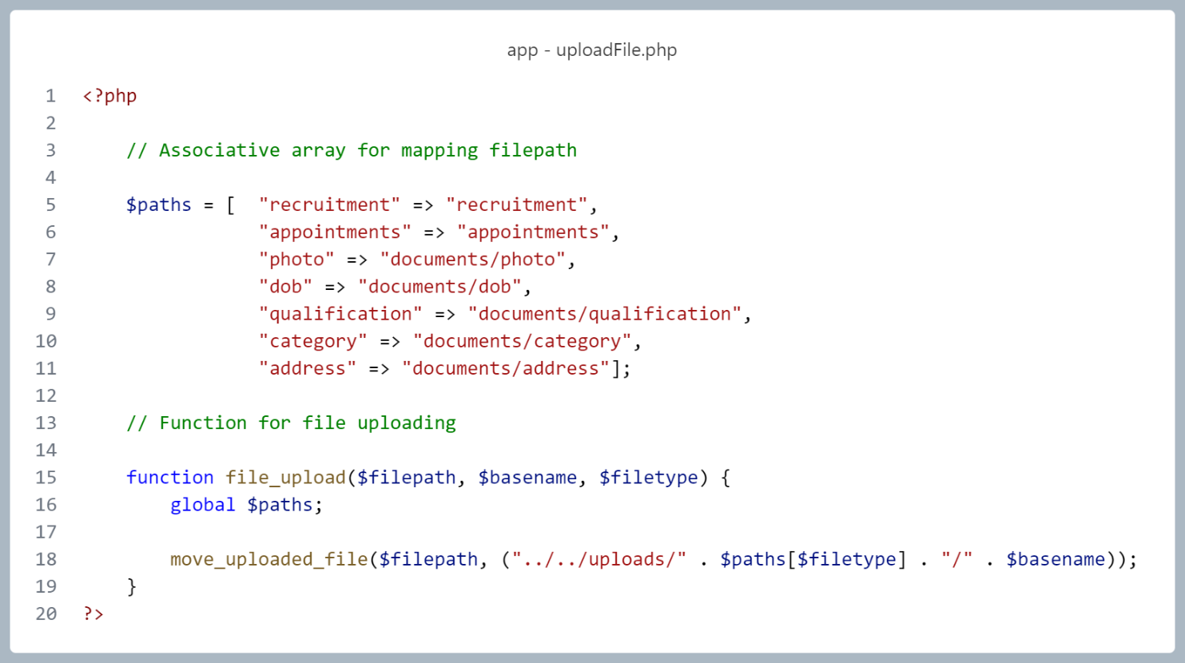

**Database (MySQL)**

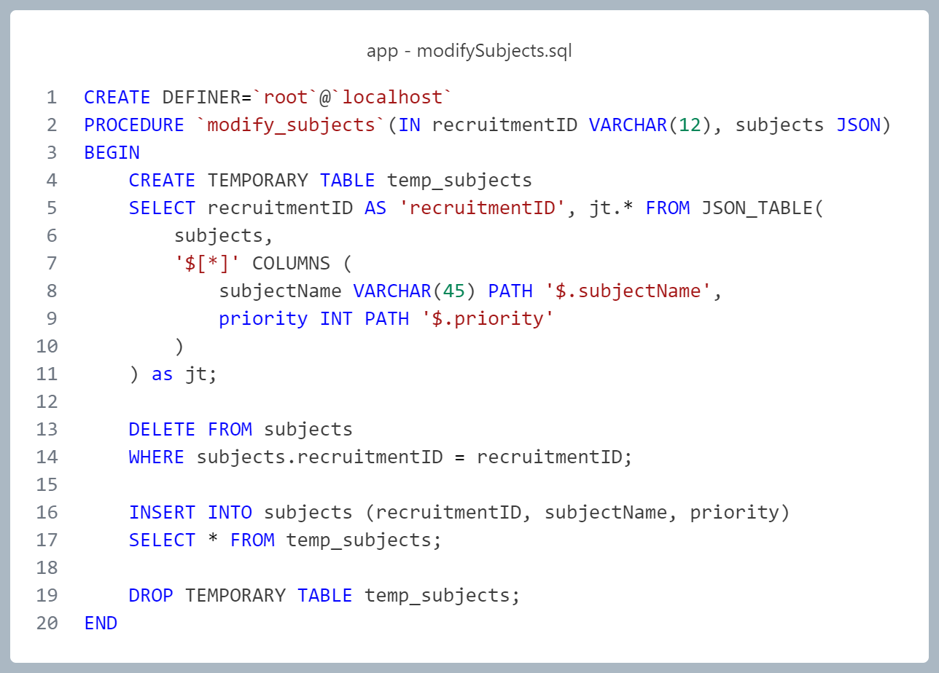

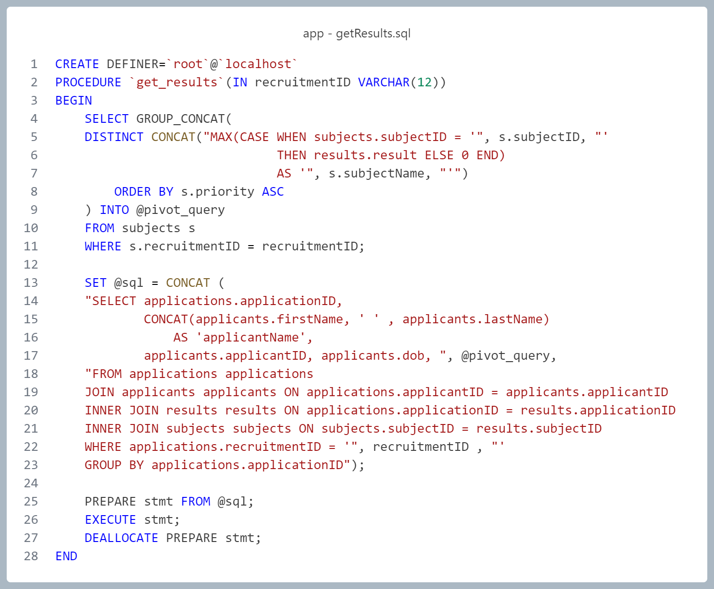

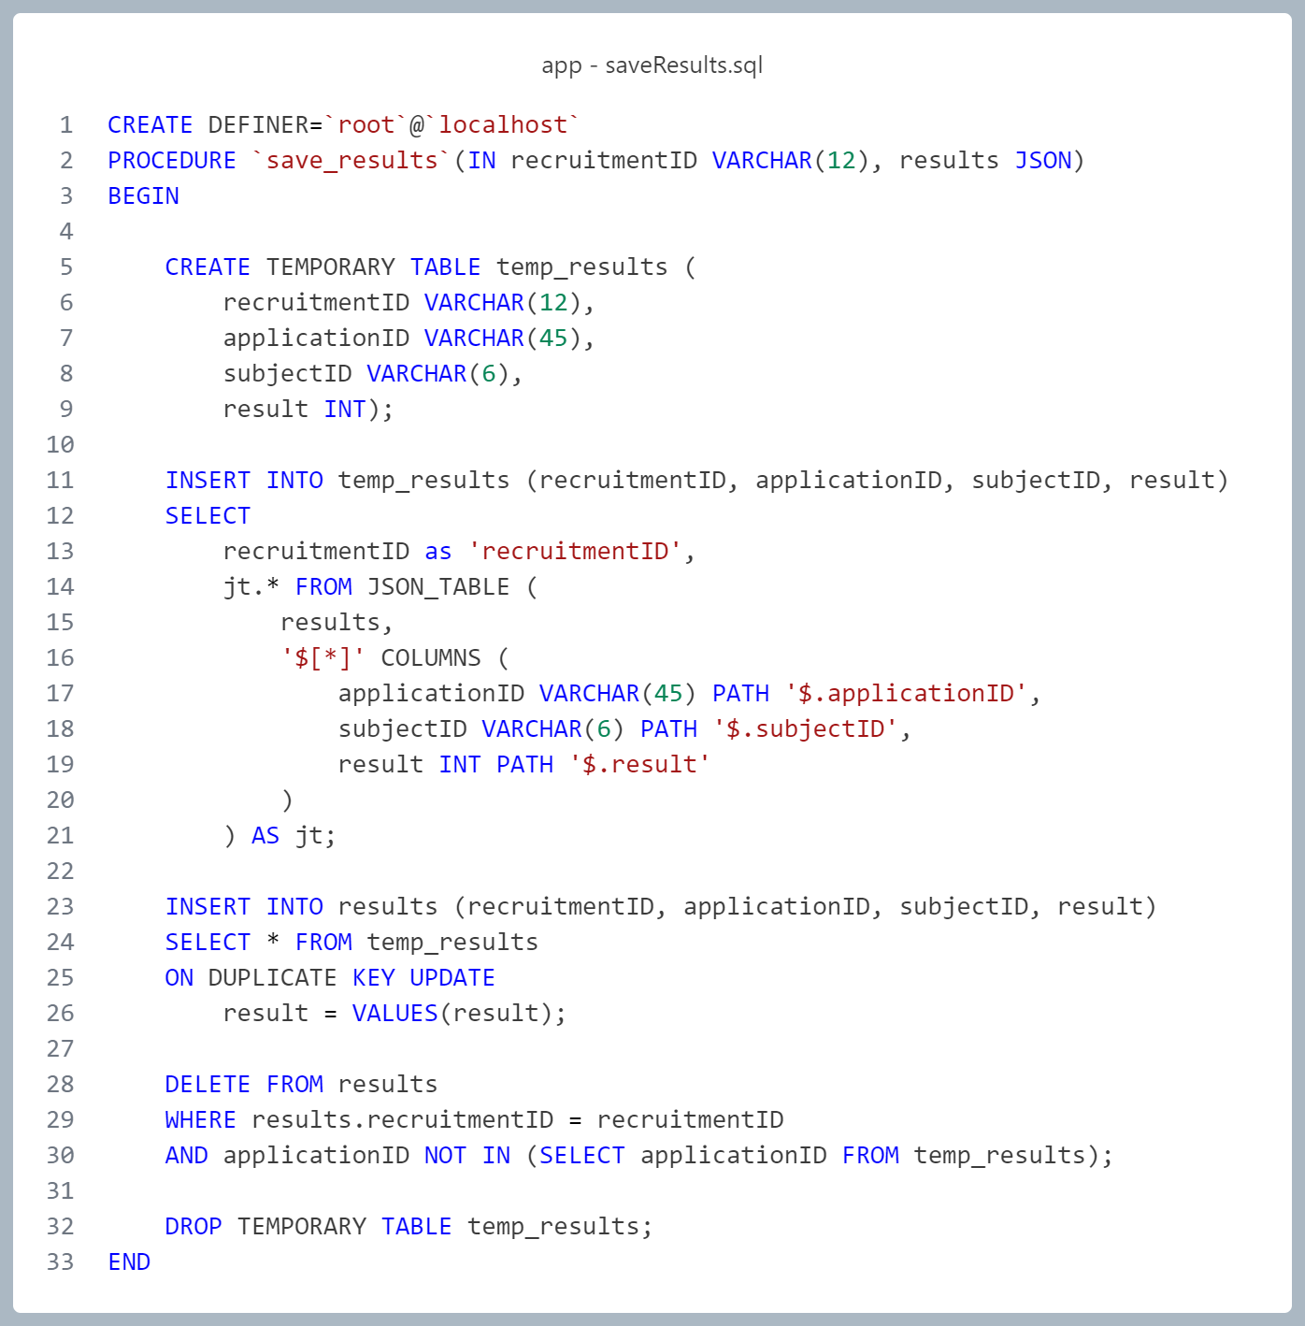

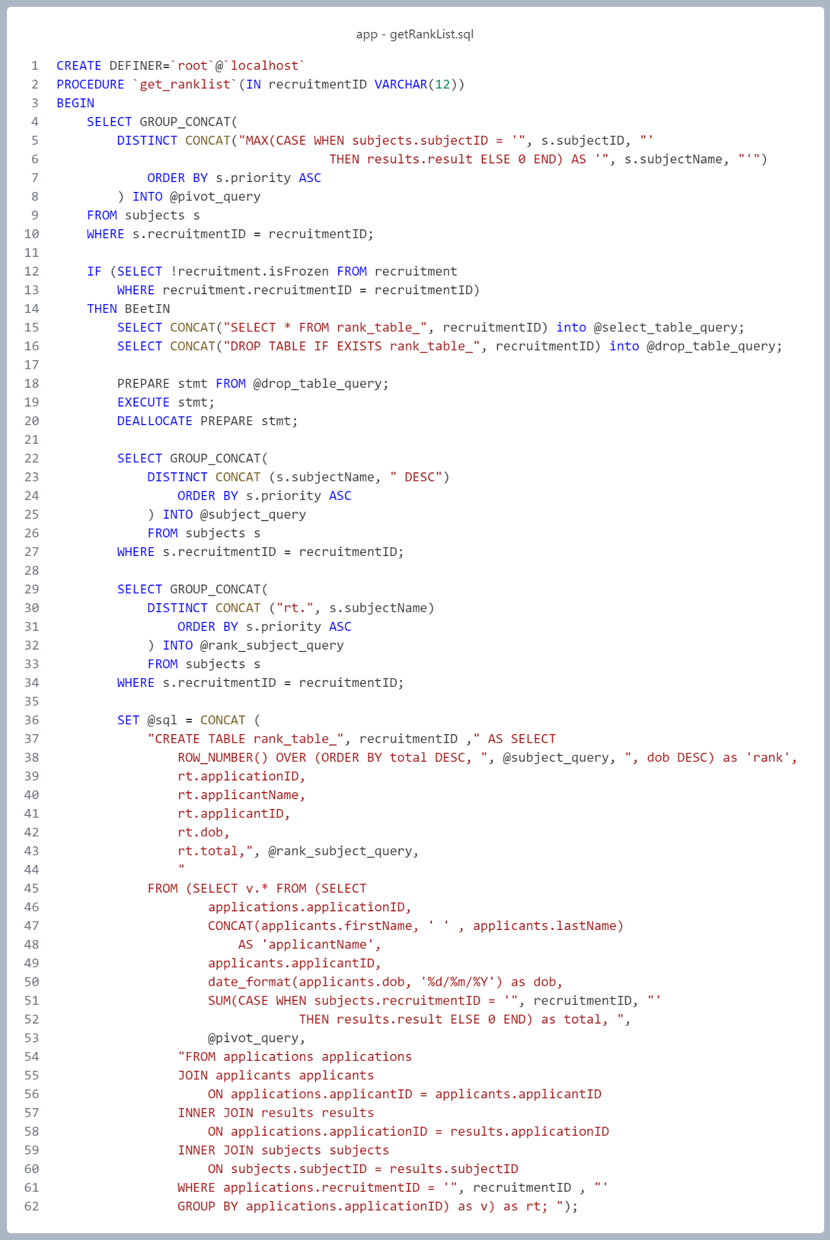

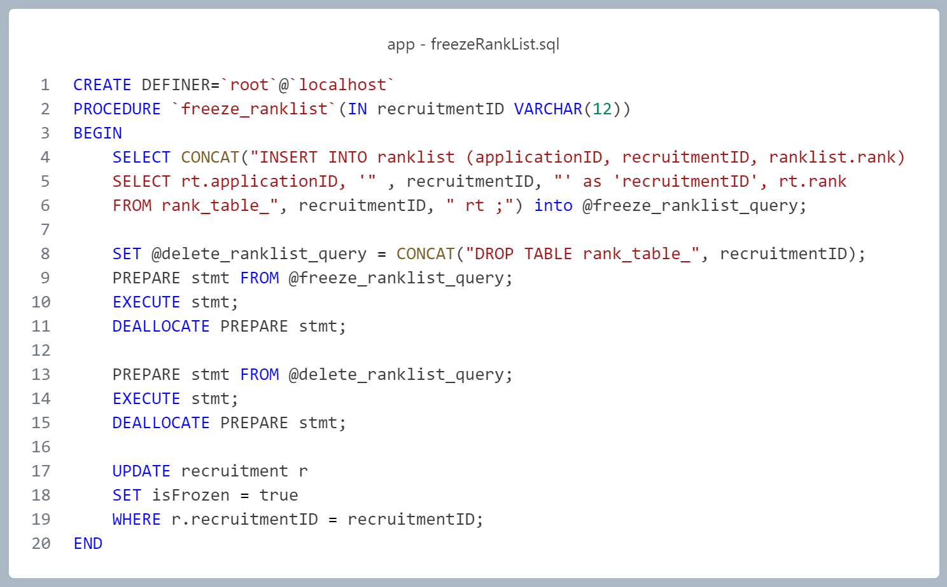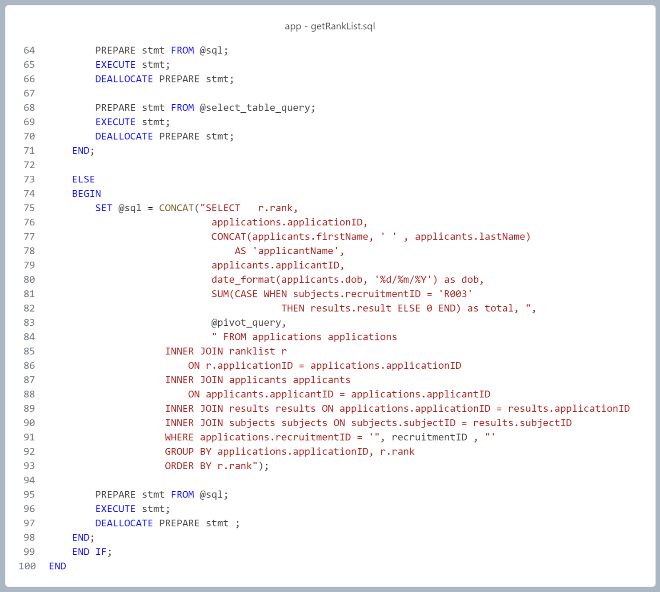

# TESTING

The test cases for the e-Recruitment Management System were designed and executed using automated scripts written in Python with the Selenium WebDriver framework. Automation was chosen to efficiently validate user interface behavior and input validation logic across various scenarios, such as login errors, incorrect credentials, successful authentication, application submission, and modal confirmations. All tests were executed on the Google Chrome browser, ensuring compatibility with a commonly used environment and realistic simulation of user actions.

One of the test scripts is included for reference, while the remaining scripts — due to their repetitive nature and length — are available on the project’s GitHub repository.

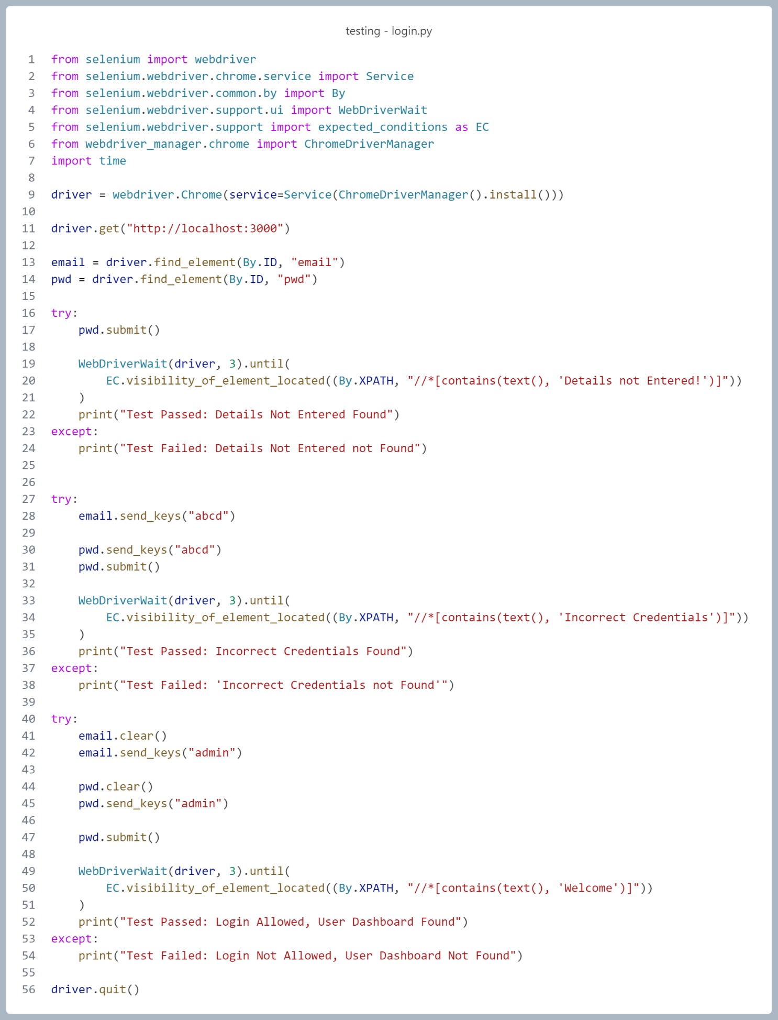

**Registration**

**Test Case 1: Name Fields Validation**

* **Tested Inputs**: " ABCD222" (firstName), " ABCD222 323BCD" (lastName)
* **Expected Output**: Numbers and leading/trailing/multiple spaces are filtered out.
* **Test Result**: Pass/Fail based on whether the input cleans up to valid alphabetic names.

**Test Case 2: Email Pattern Validation**

* **Tested Inputs**: invalid@@email!! (invalid), email2@email.com (valid)
* **Expected Output**: Invalid formats apply reject class and disable the submit button. Valid format applies accept class and enables form progression.
* **Test Result**: Proper visual and functional feedback for both valid and invalid formats.

**Test Case 3: Mobile Number Validation**

* **Tested Input**: " 0123ABC4 56789"
* **Expected Output**: Only digits remain; all letters and spaces are stripped.
* **Test Result**: Field correctly stores "0123456789".

**Test Case 4: Dropdown Selection**

* **Fields Tested**: qualification, category
* **Tested Method**: Selection via select_by_visible_text() and select_by_value() respectively.
* **Expected Output**: Appropriate dropdown values are registered and retained for submission.

**Test Case 5: Form Submission & Modal Interaction**

* **Action**: Clicks submit button and confirms submission via modal ("Yes").
* **Expected Output**: User is redirected to password creation page after confirmation.
* **Test Result**: Password form loads, confirming the registration form was accepted.

**Test Case 6: Password Field Validations**

* **Tested Inputs**:
  + "itanagar" → missing uppercase, special char, digit
  + "Itanagar@" → missing digit
  + "Itanagar@2" → meets all strength requirements
* **Expected Output**: Weak passwords trigger reject class. Matching strong passwords allow form progression.
* **Test Result**: All strength and mismatch validations correctly applied.

**Test Case 7: Final Submission Check**

* **Action**: Submits valid password and repassword fields.
* **Expected Output**: Redirects user to login page (http://localhost:3000).
* **Test Result**: Redirect is successful, indicating account creation and flow completion.

**Result**

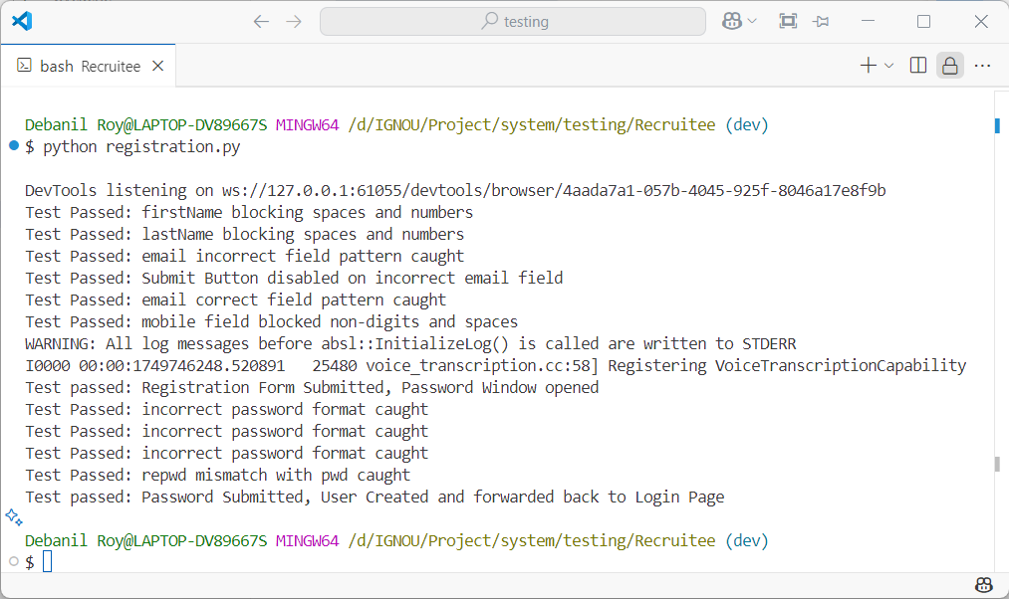

**Login**

**Test Case 1: Submit Empty Fields**

* **Input**: email = "", password = ""
* **Expected Output**: Error message "Details not Entered!" should appear.
* **Purpose**: Ensures form validation prevents submission of empty fields.
* **Expected Result**: Test Passed: Details Not Entered Found (if working correctly)

**Test Case 2: Submit Invalid Credentials**

* **Input**: email = "abcd", password = "abcd"
* **Expected Output**: Error message "Incorrect Credentials" should be displayed.
* **Purpose**: Validates backend credential check and error feedback mechanism.
* **Expected Result**: Test Passed: Incorrect Credentials Found

**Test Case 3: Submit Valid Admin Credentials**

* **Input**: email = "admin", password = "admin"
* **Expected Output**: Dashboard or welcome page loads with "Welcome" text visible.
* **Purpose**: Confirms successful login and page redirection for valid user.
* **Expected Result**: Test Passed: Login Allowed, User Dashboard Found

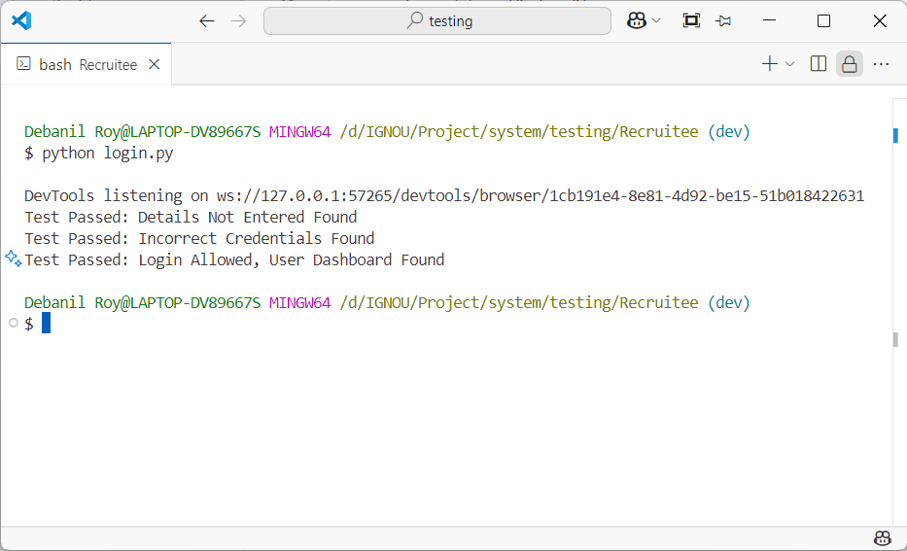**Result**

**Sidebar**

**Purpose:** To ensure that all sidebar navigation links in the applicant dashboard route to their respective pages correctly and consistently.

**Test Case 1: Navigate to 'Open Recruitments'**

* **Action**: Click the sidebar link "Open Recruitments"
* **Expected Output**: Open recruitments page loads successfully
* **Test Result**: Link is accessible and route changes without error

**Test Case 2: Navigate to 'Closed Recruitments'**

* **Action**: Click the sidebar link "Closed Recruitments"
* **Expected Output**: Closed recruitments page is displayed
* **Test Result**: Page changes and content loads properly

**Test Case 3: Navigate to 'Open Applications'**

* **Action**: Click "Open Applications"
* **Expected Output**: List of open applications becomes visible
* **Test Result**: Section loads and updates DOM

**Test Case 4: Navigate to 'Closed Applications'**

* **Action**: Click "Closed Applications"
* **Expected Output**: Closed application records are shown
* **Test Result**: Navigation is functional and content is rendered

**Test Case 5: Navigate to 'Open Offers'**

* **Action**: Click "Open Offers"
* **Expected Output**: Open offers section displays with relevant cards
* **Test Result**: Page transition occurs smoothly

**Test Case 6: Navigate to 'Previous Offers'**

* **Action**: Click "Previous Offers"
* **Expected Output**: Archive of past offers becomes accessible
* **Test Result**: Section opens without issues

**Test Case 7: Return to 'Open Recruitments'**

* **Action**: Re-click "Open Recruitments"
* **Expected Output**: User is brought back to initial view
* **Test Result**: Final navigation works as expected

**Result**

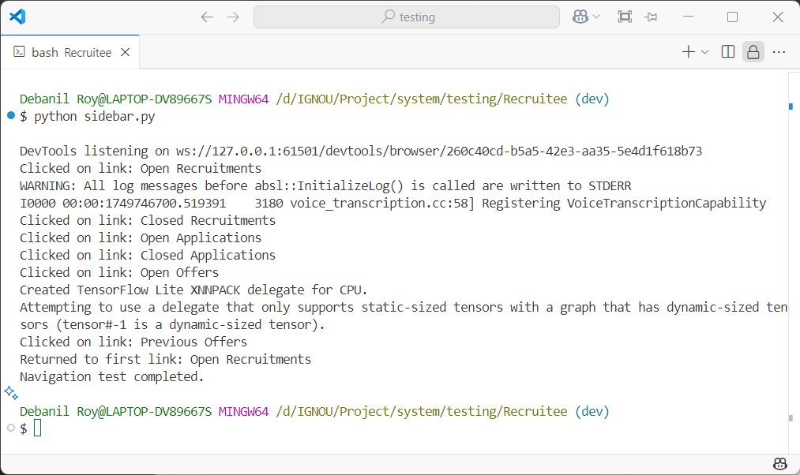

**Apply**

**Test Case 1: Locate Recruitment ID R001**

* **Input**: Class cardViewRecruitments cards
* **Expected Output**: Card with "Recruitment ID: R001" is found
* **Purpose**: Ensure that the correct recruitment card is accessible on the page

**Test Case 2: Submit Application Form and Cancel**

* **Action**: Clicks "Apply" → scrolls to "Submit" → clicks "No" on confirmation modal
* **Expected Result**: Modal closes, user stays on application form
* **Purpose**: Confirms that users can cancel an application before submission

**Test Case 3: Submit Application Form and Confirm**

* **Action**: Re-clicks "Submit" → clicks "Yes" on confirmation modal
* **Expected Result**: Redirected to "Open Recruitments" view
* **Purpose**: Confirms that confirmed applications redirect the user appropriately

**Result**

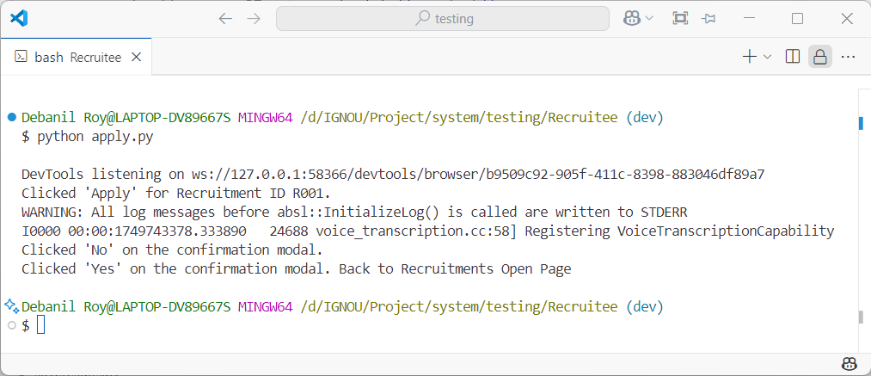

**Open applications**

**Purpose:** To verify that applicants can cancel a submitted application and receive appropriate confirmation via modal and notification.

**Test Case 1: Navigate to Open Applications**

* **Action**: Clicks "Open Applications" from the navigation menu.
* **Expected Result**: Page loads successfully.

**Test Case 2: Locate Application Card**

* **Search Target**: Recruitment post name = "HR Manager".
* **Expected Result**: Card for that application is found.

**Test Case 3: Cancel the Application**

* **Actions**:
  1. Click "Status" on the card.
  2. Click "Cancel Application".
  3. Click "No" on modal → return to status.
  4. Click "Cancel Application" again → click "Yes" on confirmation modal.
* **Expected** **Result**: Cancellation modal works; application is removed or marked cancelled.

**Test Case 4: Confirmation via Notification**

* **Check**: Notification with text "APPLICATION CANCELLED" appears.
* **Expected** **Result**: Test Passed: Application was cancelled successfully...

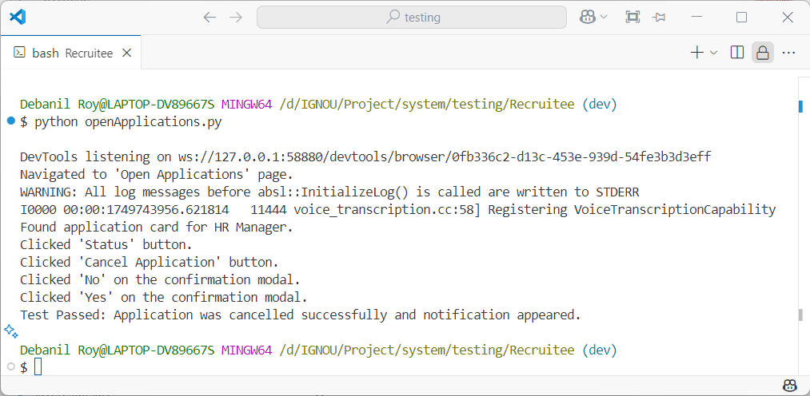**Result**

**Open Offer – Accept**

**Test Case 1: Navigate to Open Offers**

* **Purpose**: To ensure that users can access the Open Offers section from the sidebar.
* **Action**: Click "Open Offers" link
* **Expected Result**: Page loads with all available appointment cards

**Test Case 2: Locate Appointment Card**

* **Purpose**: To verify that the correct appointment card is displayed for the relevant post.
* **Criteria**: Post title = "HR Manager"
* **Expected Result**: Corresponding appointment card is found

**Test Case 3: Confirm Acceptance via Modal**

* **Purpose**: To test the confirmation modal behavior for accepting a job offer.
* **Steps**:
  1. Click "Accept" → click "No" in modal (cancel action)
  2. Click "Accept" again → click "Yes" to confirm
* **Expected Result**: Modal interaction is handled correctly, and user decision is respected

**Test Case 4: Validate Notification**

* **Purpose**: To confirm that successful acceptance triggers a proper notification.
* **Check**: Notification displays "OFFER ACCEPTED"
* **Expected Result**: Confirms that the acceptance was processed and acknowledged

**Result**

It was found during testing that the accept/reject button triggers the API call immediately, even before the confirmation modal response is received. This indicates a logical flaw in modal-handling behavior that may bypass user intent. The issue was fixed by minor code refactoring.

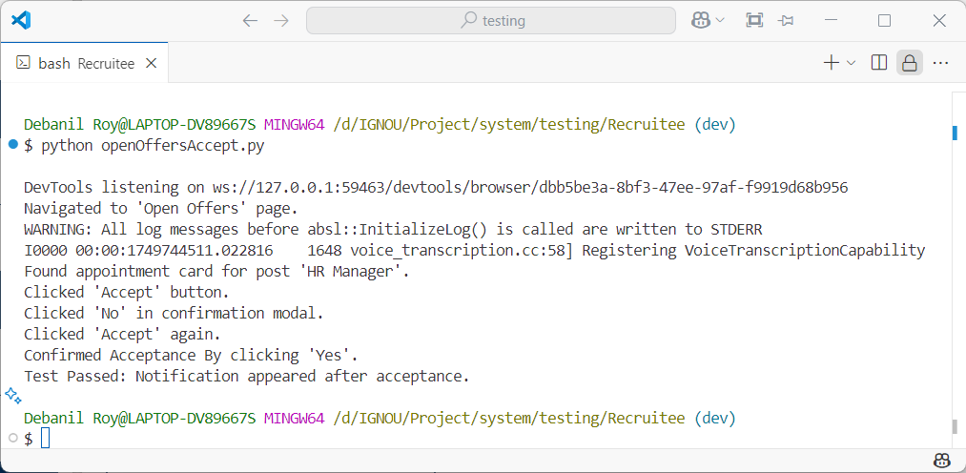

**Open Offers - Reject**

**Test Case 1: Navigate to Open Offers**

* **Purpose**: To ensure that users can access the Open Offers section through the sidebar.
* **Action**: Click "Open Offers" link in sidebar
* **Expected Result**: Page displays list of current offers

**Test Case 2: Locate Appointment Card**

* **Purpose**: To verify that the appointment card for the targeted post is present and interactable.
* **Target Post**: "HR Manager"
* **Expected Result**: Card is correctly found and clickable

**Test Case 3: Reject via Modal**

* **Purpose**: To test modal handling for rejecting an offer and ensure the confirmation respects user input.
* **Steps**:
  1. Click "Reject" → click "No" in confirmation modal (abort rejection)
  2. Click "Reject" again → click "Yes" to confirm
* **Expected Result**: Confirmation modal respects user's input before final action

**Test Case 4: Notification Confirmation**

* **Purpose**: To confirm that rejecting an offer results in a visible success notification.
* **Check**: "OFFER REJECTED" message appears in a notification
* **Expected Result**: Visual confirmation that the action was processed

**Result**

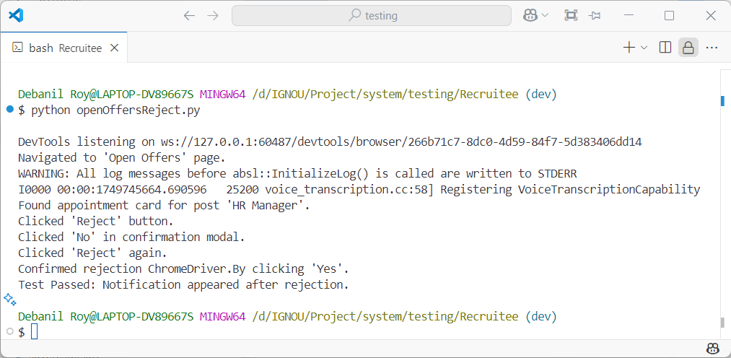

**Create Recruitments**

**Test Case 1: Partial Form Completion**

* **Purpose**: To verify that the submit button remains disabled when only a few required fields are filled.
* **Action**: Fills only post name, salary, and location fields.
* **Expected Output**: Submit button is disabled.
* **Test Result**: Submit correctly blocked.

**Test Case 2: Incorrect Vacancy Distribution**

* **Purpose**: To ensure the form detects mismatch between total vacancies and the sum of category-wise vacancies.
* **Action**: Fills all fields but sets total vacancies to 10 and category-wise sum to 9.
* **Expected Output**: Submit button remains disabled due to mismatch.
* **Test Result**: Validation check for vacancy mismatch passes.

**Test Case 3: Correct Vacancy Distribution**

* **Purpose**: To confirm that the form enables submission only when the total vacancies match the sum of category-wise entries.
* **Action**: Adjusts OBC count to correct the sum (10).
* **Expected Output**: Submit button becomes enabled.
* **Test Result**: Validation allows submission.

**Test Case 4: Modal Confirmation – Cancel**

* **Purpose**: To verify the recruiter can back out of submission by clicking "No" in the confirmation modal.
* **Action**: Clicks submit, then clicks "No" in modal.
* **Expected Output**: Modal closes without submitting.
* **Test Result**: Action is canceled and form remains editable.

**Test Case 5: Modal Confirmation – Confirm**

* **Purpose**: To validate that confirming the modal with "Yes" proceeds with form submission.
* **Action**: Clicks submit again, then confirms with "Yes".
* **Expected Output**: Form is submitted and system proceeds to confirmation state.
* **Test Result**: Form submission is triggered.

**Test Case 6: Notification Confirmation**

* **Purpose**: To check that the system shows a success notification after creating a recruitment.
* **Action**: Waits for and reads the notification element.
* **Expected Output**: Notification text contains "RECRUITMENT CREATED"
* **Test Result**: Success message is correctly displayed.

**Result**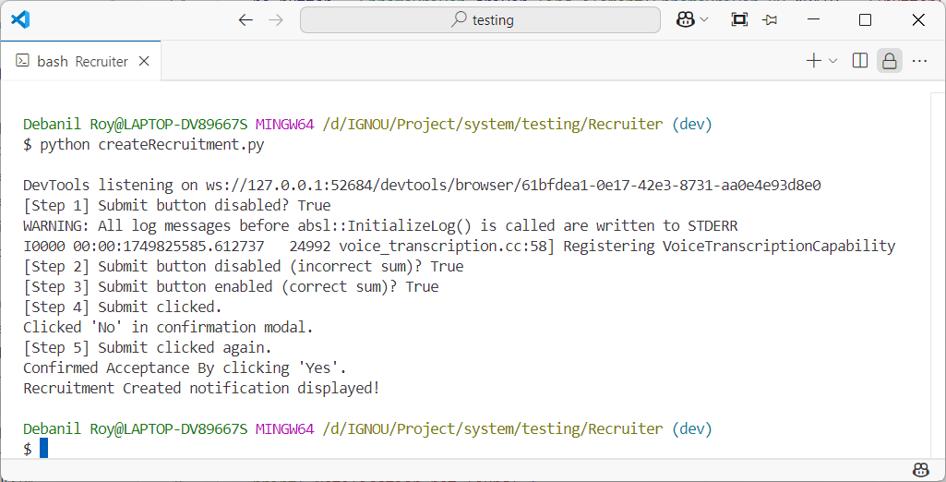

**Add Subjects**

**Test Case 1: Navigate to Add/Modify Subjects**

* **Purpose**: To confirm that the recruiter can access the Add/Modify Subjects page via the sidebar.
* **Action**: Clicks the link "Add/Modify Subjects".
* **Expected Output**: Page loads and recruitment selection dropdown becomes visible.
* **Test Result**: Navigation works as expected.

**Test Case 2: Select a Recruitment (R006)**

* **Purpose**: To validate that a specific recruitment ID can be selected from the dropdown.
* **Action**: Selects R006 from the recruitment dropdown and clicks submit.
* **Expected Output**: Subject input fields appear.
* **Test Result**: Recruitment ID selection and form load succeed.

**Test Case 3: Add Subjects Dynamically**

* **Purpose**: To test that entering a subject name auto-generates the next input field.
* **Action**: Enters "Math" in the first field, "Science" in the second, "History" in the third.
* **Expected Output**: New input appears with each entry; total of 3 subjects entered.
* **Test Result**: Dynamic field addition works correctly.

**Test Case 4: Remove a Subject**

* **Purpose**: To check whether clearing a subject name and tabbing out removes that field.
* **Action**: Clears the first input and presses Tab.
* **Expected Output**: Subject field is removed or ignored from submission.
* **Test Result**: UI behavior allows subject removal.

**Test Case 5: Submit Subject List**

* **Purpose**: To verify that subject entries are successfully submitted and saved.
* **Action**: Clicks the "Save" button after entering subjects.
* **Expected Output**: Notification appears with text "SUBJECTS SAVED".
* **Test Result**: Success notification confirms save.

**Result**

During testing, it was observed that the dynamic addition/deletion of subject input boxes did **not trigger** correctly when the user switched fields using the Tab key instead of typing directly or clicking outside the input box. This issue was resolved with **minor code refactoring** that ensured input field generation was also triggered on blur and keydown events, making the form more responsive to varied user behaviors.

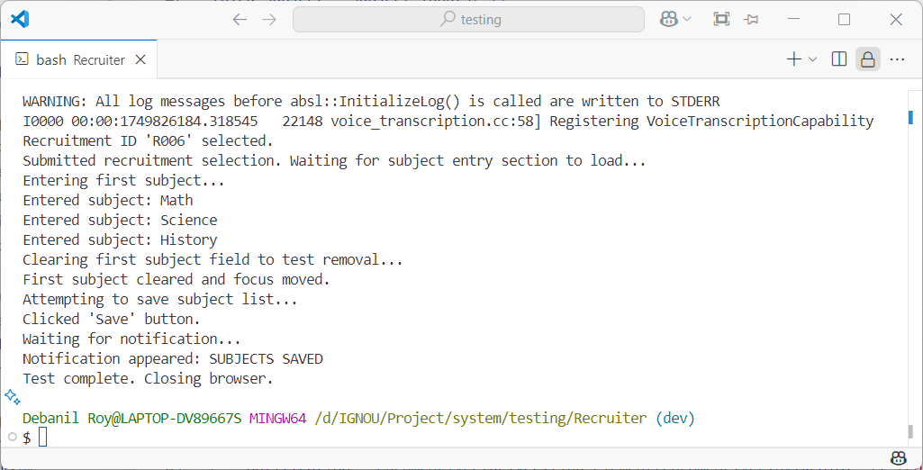

**Manage Recruitment**

**Test Case 1: Navigate to Manage Recruitments**

* **Purpose**: To ensure the recruiter can access the Manage Recruitments module from the sidebar.
* **Action**: Clicks "Manage Recruitments" link.
* **Expected Output**: Page loads and recruitment cards are visible.
* **Test Result**: Page loaded and cards listed successfully.

**Test Case 2: Locate Recruitment Card for R006**

* **Purpose**: To validate that the system can locate a specific recruitment ID among the listed cards.
* **Action**: Iterates through cards and finds the one with "R006" text.
* **Expected Output**: Target card is identified.
* **Test Result**: Card found for recruitment ID R006.

**Test Case 3: Open Edit Panel**

* **Purpose**: To confirm that the recruiter can open the editable panel for a recruitment card.
* **Action**: Scrolls to the target card and clicks "Edit".
* **Expected Output**: Edit panel expands or becomes visible.
* **Test Result**: Edit button clicked successfully.

**Test Case 4: Modify Vacancy Fields**

* **Purpose**: To verify that the recruiter can update vacancy values.
* **Action**: Clears and updates GEN = 4 and Total = 8.
* **Expected Output**: Input fields accept new values.
* **Test Result**: Input accepted and updated.

**Test Case 5: Save Changes**

* **Purpose**: To confirm that modified recruitment info can be saved and acknowledged.
* **Action**: Clicks "Save" button.
* **Expected Output**: Success notification appears with "RECRUITMENT INFO SAVED".
* **Test Result**: Save operation succeeded.

**Result**

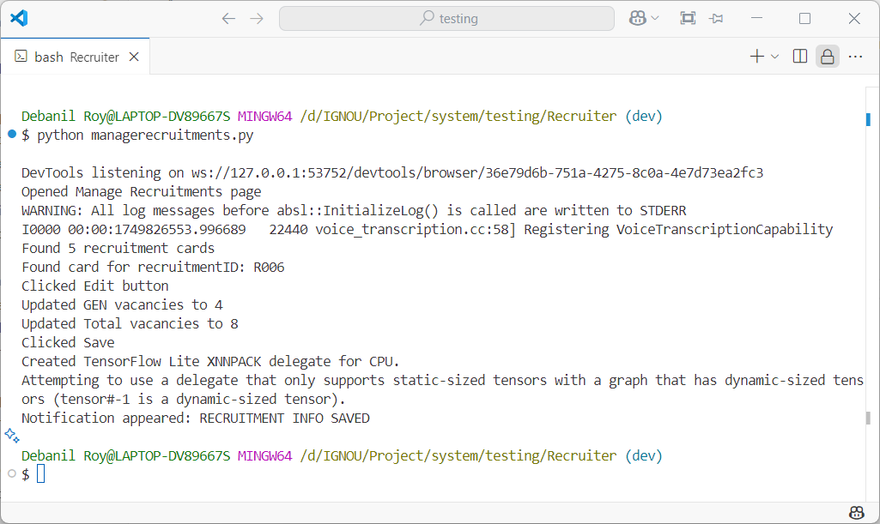

**Submit Results**

**Test Case 1: Navigate to Submit Results**

* **Purpose**: To confirm the recruiter can access the Submit Results page.
* **Action**: Clicks the "Submit Results" link from the sidebar.
* **Expected Output**: Page loads and recruitment selection dropdown is visible.
* **Test Result**: Navigation successful.

**Test Case 2: Select Recruitment ID R005**

* **Purpose**: To validate that a specific recruitment ID can be selected from the dropdown.
* **Action**: Selects "R006" and clicks submit.
* **Expected Output**: Result entry form becomes visible.
* **Test Result**: Recruitment selected and result section displayed.

**Test Case 3: Enter First Result Row**

* **Purpose**: To test if entering results for one applicant correctly populates the first row.
* **Action**: Fills in "MNO005" with three random subject marks.
* **Expected Output**: Inputs are filled and a new row appears.
* **Test Result**: Row inputs handled correctly.

**Test Case 4: Enter Second Result Row**

* **Purpose**: To verify dynamic addition of a new row after the first is filled.
* **Action**: Waits for and fills the next row with "ABC001".
* **Expected Output**: Row appears and inputs accept values.
* **Test Result**: Second row filled successfully.

**Test Case 5: Save Results**

* **Purpose**: To ensure results can be submitted and saved.
* **Action**: Clicks "Save" button after entering both rows.
* **Expected Output**: Notification appears with "RESULTS SAVED" message.
* **Test Result**: Submission confirmed with success notification.
* **Result**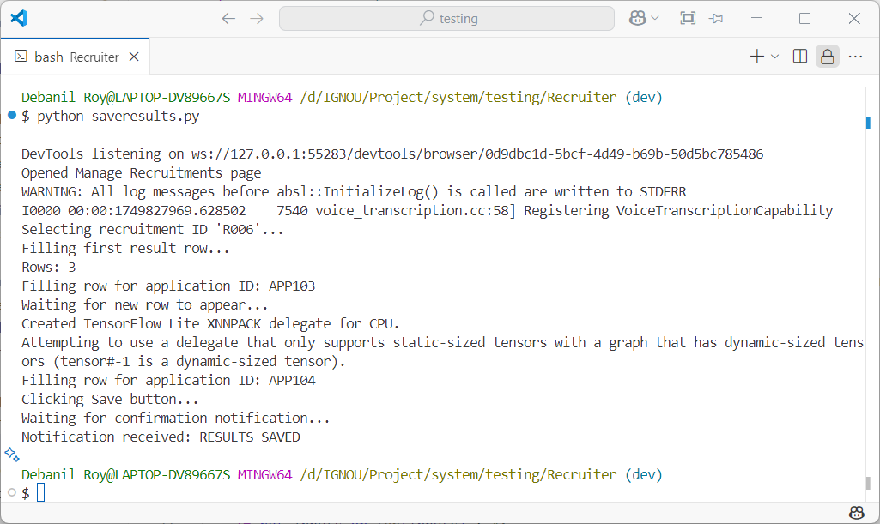

**Create Rank List**

**Test Case 1: Navigate to Create Rank List**

* **Purpose**: To ensure the recruiter can access the rank list module via the sidebar.
* **Action**: Clicks "Create Rank List" link.
* **Expected Output**: Recruitment selection dropdown appears.
* **Test Result**: Page opened successfully.

**Test Case 2: Select Recruitment ID R006**

* **Purpose**: To confirm that a recruiter can target the correct recruitment for ranking.
* **Action**: Selects "R006" from dropdown and submits.
* **Expected Output**: Rank list interface for R006 is shown.
* **Test Result**: Recruitment selected and list loaded.

**Test Case 3: Freeze Rank List**

* **Purpose**: To validate that the recruiter can freeze the rank list and confirm via modal.
* **Action**: Clicks "Freeze Rank List" button, then clicks "Yes" in the confirmation modal.
* **Expected Output**: Rank list is locked from further edits.
* **Test Result**: Freeze action confirmed.

**Test Case 4: Refresh and Verify Frozen State**

* **Purpose**: To ensure that after freezing, the page no longer shows the freeze button and displays a locked state.
* **Action**: Reloads the page, reselects "R006", and submits.
* **Expected Output**: "Rank List Frozen" text is visible and the button is hidden.
* **Test Result**: Freeze state is persisted and shown correctly.

**Result**

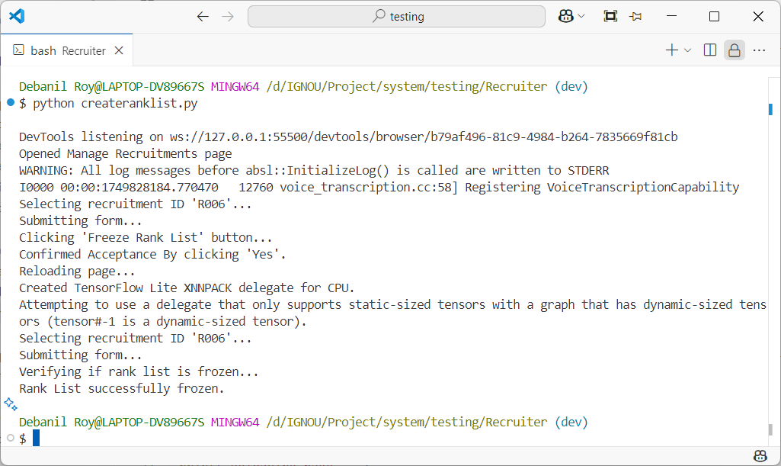

**Verify Applications**

**Test Case 1: Navigate to Verify Applications**

* **Purpose**: To verify the recruiter can access the application verification module from the sidebar.
* **Action**: Clicks "Verify Applications" in the navigation menu.
* **Expected Output**: Page loads and recruitment dropdown becomes accessible.
* **Test Result**: Sidebar navigation works as intended.

**Test Case 2: Select Recruitment ID R006**

* **Purpose**: To confirm that recruiters can select a specific recruitment ID to load applications.
* **Action**: Selects "R006" from dropdown and submits.
* **Expected Output**: Applications table is populated.
* **Test Result**: Recruitment selection triggers the table load.

**Test Case 3: Select Target Applications**

* **Purpose**: To check whether the recruiter can locate and mark specific applications (APP103, APP104).
* **Action**: Locates the rows for the target application IDs and clicks their checkboxes.
* **Expected Output**: Target applications are selected for verification.
* **Test Result**: Checkboxes function correctly and rows are located.

**Test Case 4: Confirm Verification**

* **Purpose**: To validate that the recruiter can proceed with verifying selected applications via a modal dialog.
* **Action**: Clicks "Verify" button and confirms with "Yes".
* **Expected Output**: Verification process is triggered.
* **Test Result**: Modal action confirms verification.

**Test Case 5: Success Notification**

* **Purpose**: To confirm visual feedback is displayed after successful verification.
* **Action**: Waits for "APPLICATIONS VERIFIED" text in the page source.
* **Expected Output**: Notification confirms success.
* **Test Result**: Confirmation message is detected.

**Result**

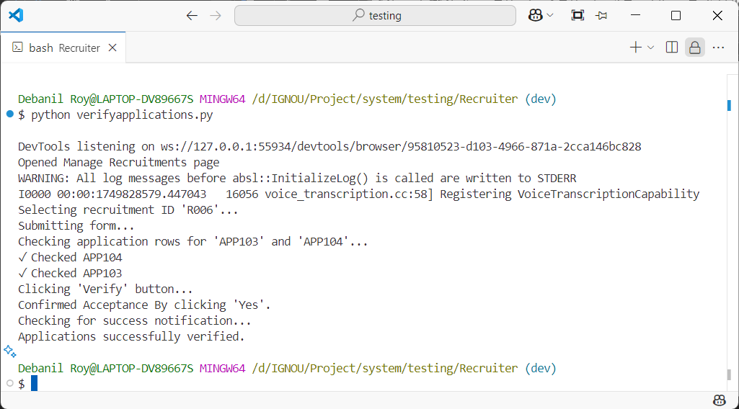

**Send Appointments**

**Test Case 1: Navigate to Send Appointments**

* **Purpose**: To ensure the recruiter can access the Send Appointments module from the sidebar.
* **Action**: Clicks "Send Appointments" link.
* **Expected Output**: Page loads with recruitment selection dropdown.
* **Test Result**: Navigation successful.

**Test Case 2: Select Recruitment ID R006**

* **Purpose**: To validate recruitment selection functionality.
* **Action**: Selects "R006" from the dropdown and submits.
* **Expected Output**: Table of eligible applications appears.
* **Test Result**: Recruitment form loads correctly.

**Test Case 3: Select Applications and Upload Files**

* **Purpose**: To confirm that specific application IDs can be selected and documents uploaded.
* **Action**: Selects "APP103" and "APP104", and uploads offer PDFs.
* **Expected Output**: Checkboxes are ticked and file paths are accepted in input fields.
* **Test Result**: Applications prepared for appointment dispatch.

**Test Case 4: Confirm Appointment Sending**

* **Purpose**: To test that clicking the "Send Appointment" button followed by "Yes" in modal sends the appointments.
* **Action**: Clicks send, confirms modal.
* **Expected Output**: Appointment sending process is triggered.
* **Test Result**: Modal interaction works correctly.

**Test Case 5: Verify Success Notification**

* **Purpose**: To ensure visual confirmation is shown after sending appointments.
* **Action**: Waits for "APPOINTMENT SENT" text in the page.
* **Expected Output**: Success message is visible.
* **Test Result**: Notification confirms operation success.

**Result**

During testing, it was discovered that the logic for processing vacancy counts and disabling application rows was flawed on the **frontend**. This led to incorrect row disabling, inaccurate selection availability, and ultimately, improper appointment dispatching. The issue originated from how application attributes were being interpreted and how remaining vacancies were calculated in the client-side logic. It was resolved through a **major refactoring of the frontend code**, ensuring accurate vacancy tracking and correct enforcement of application selection constraints.

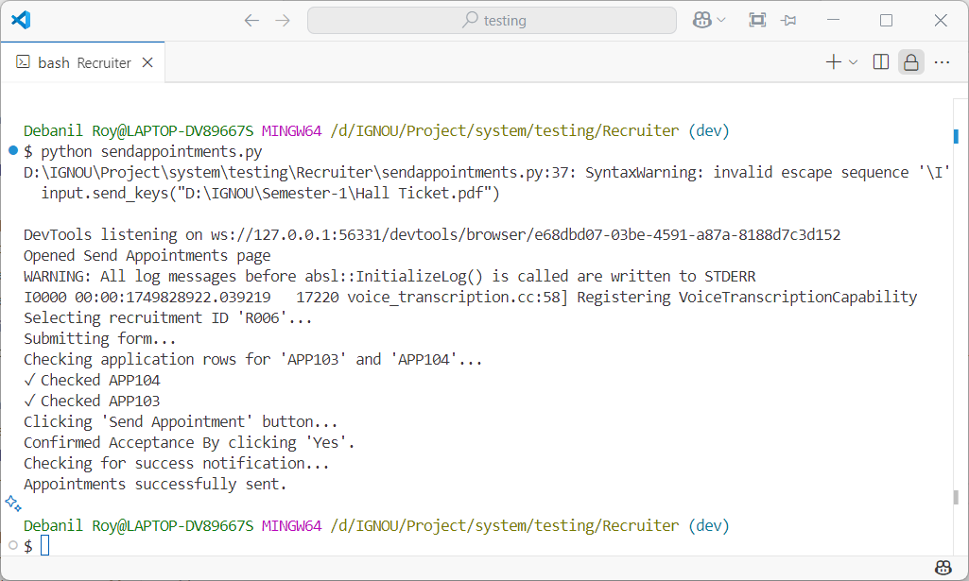

# INPUT / OUTPUT SCREENS

**Login**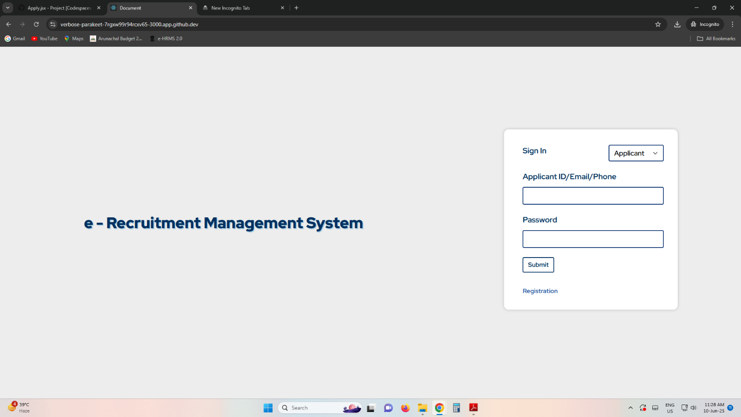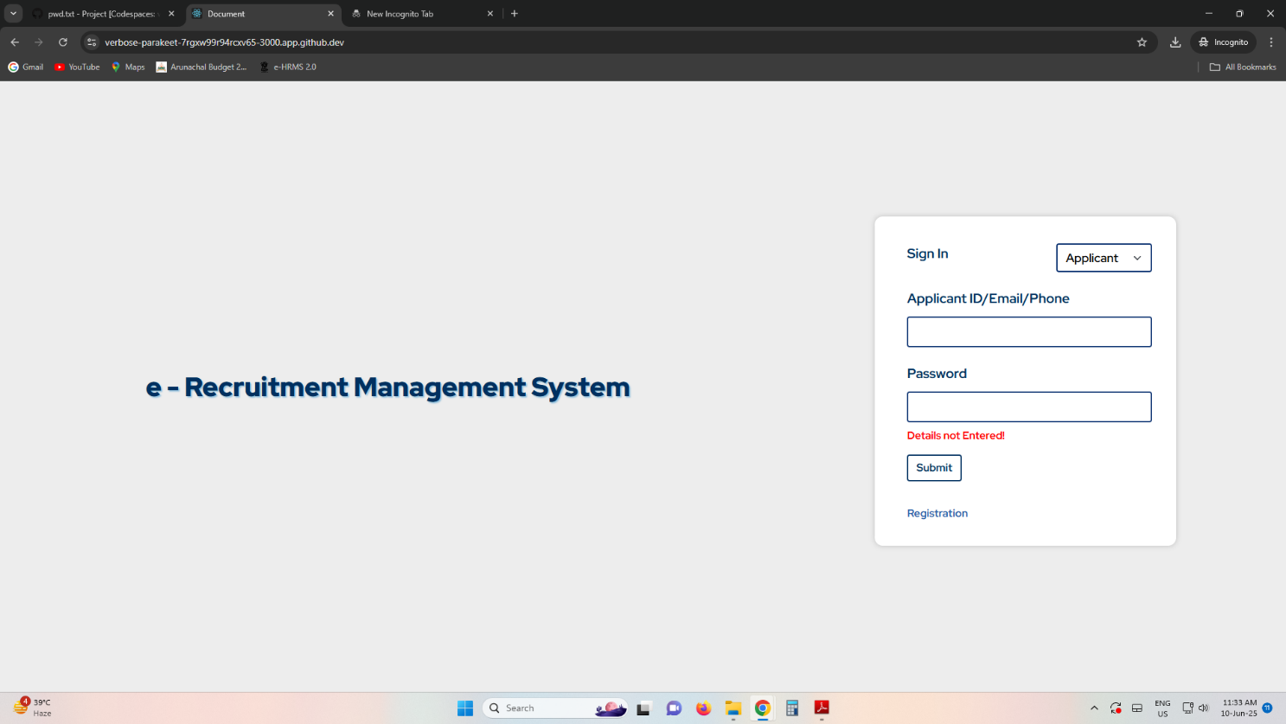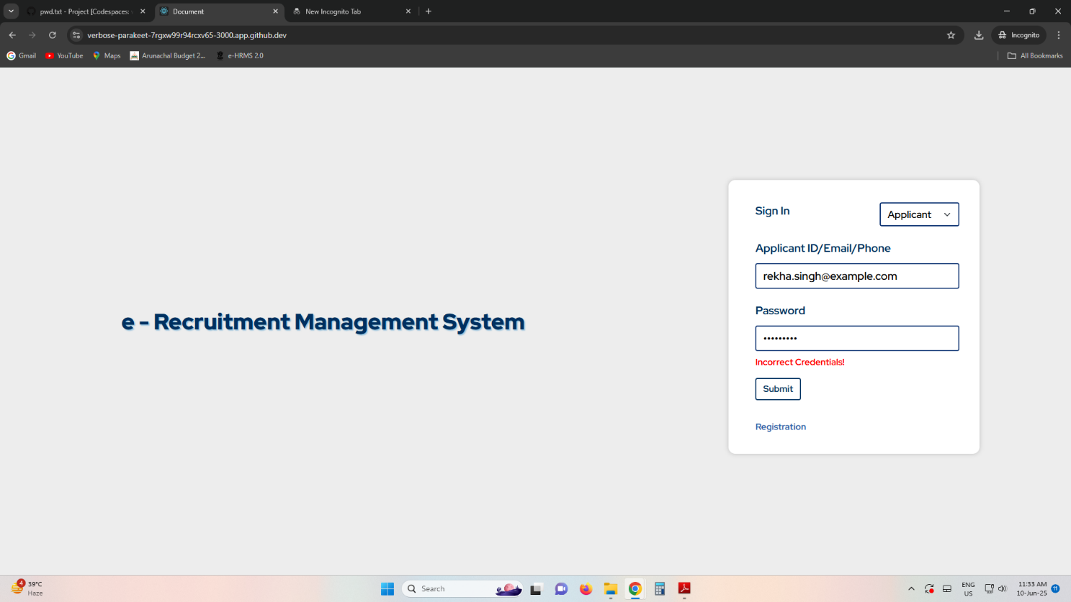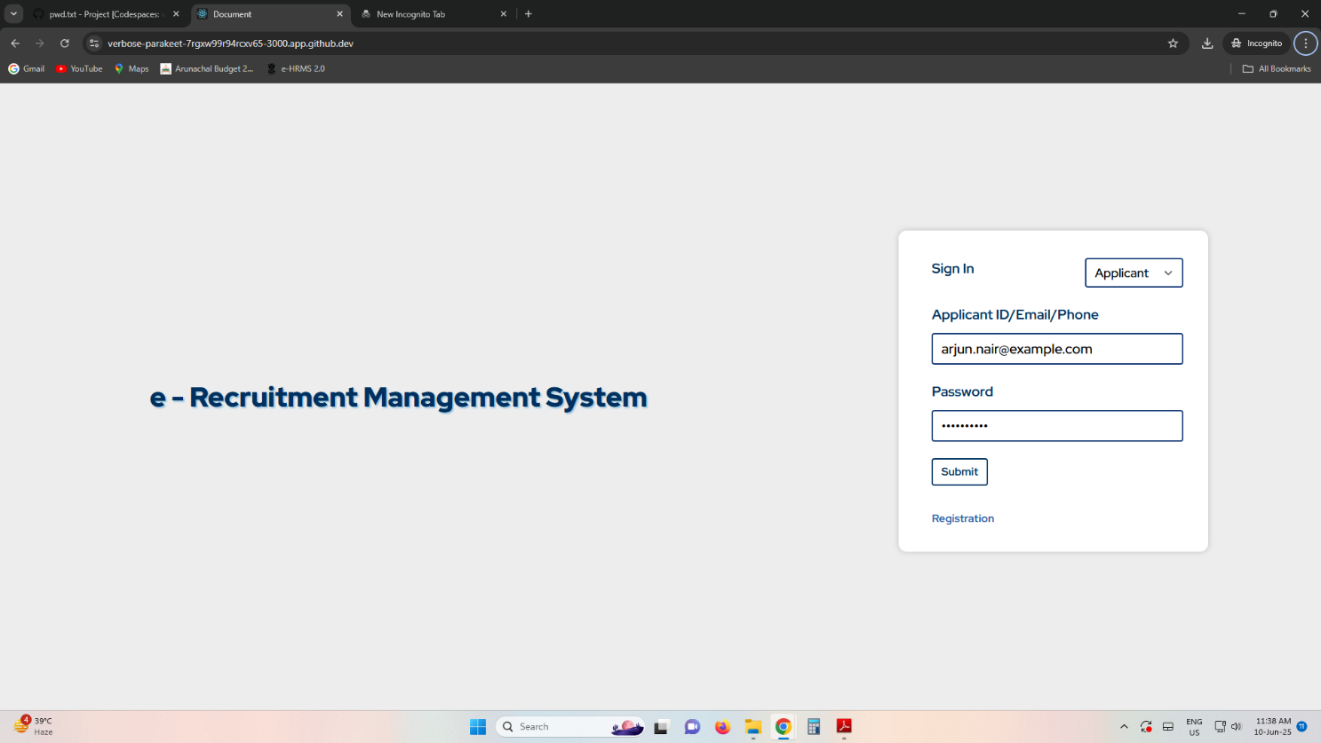

**Open Recruitments**

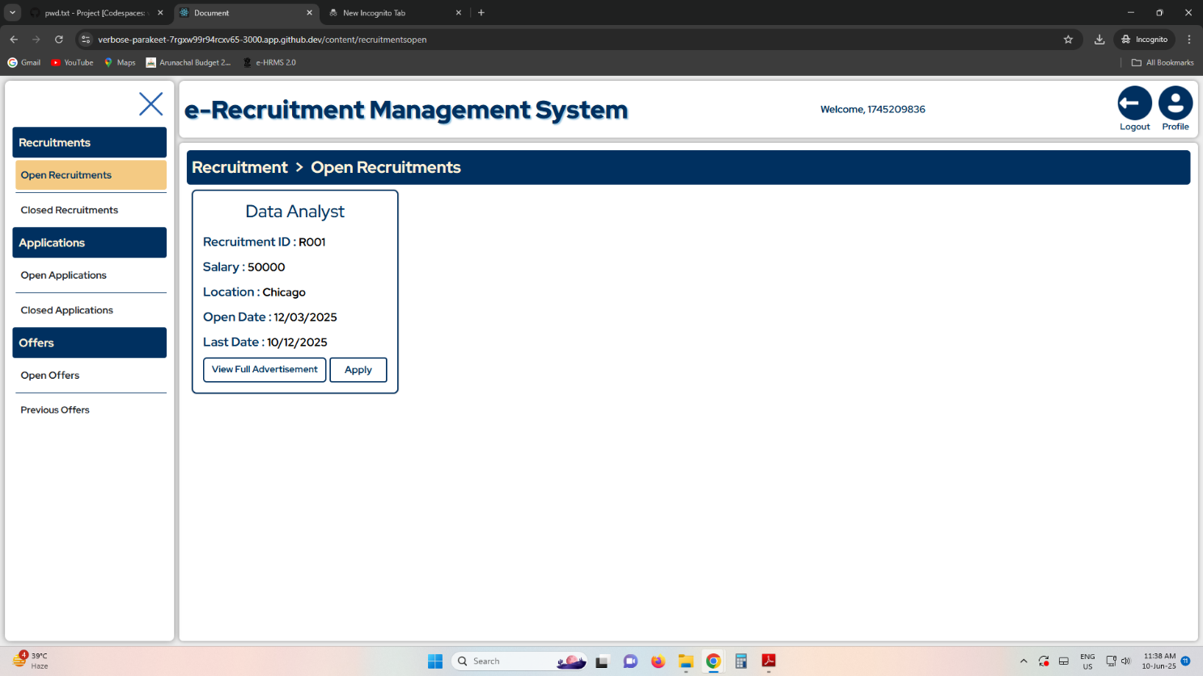

**Apply**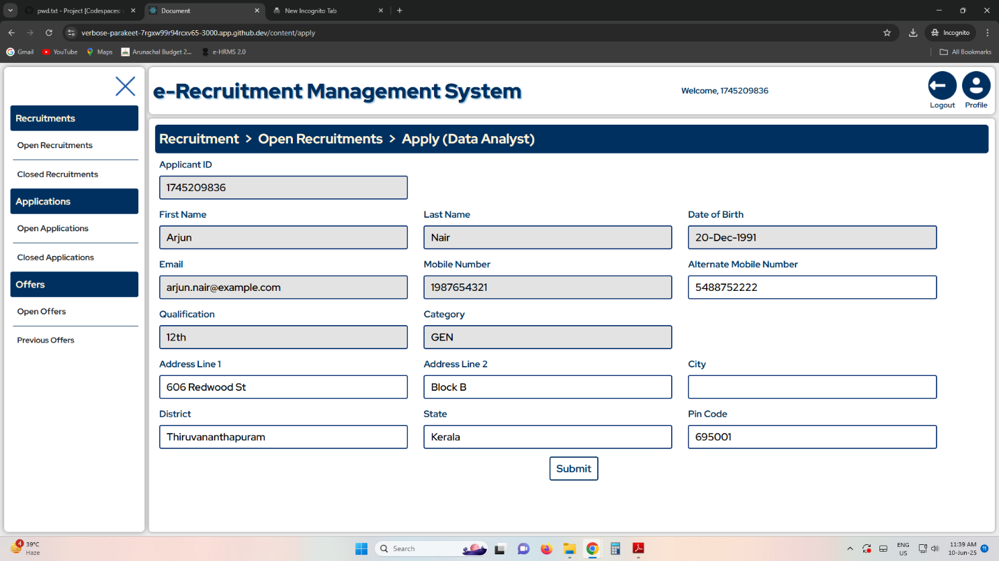

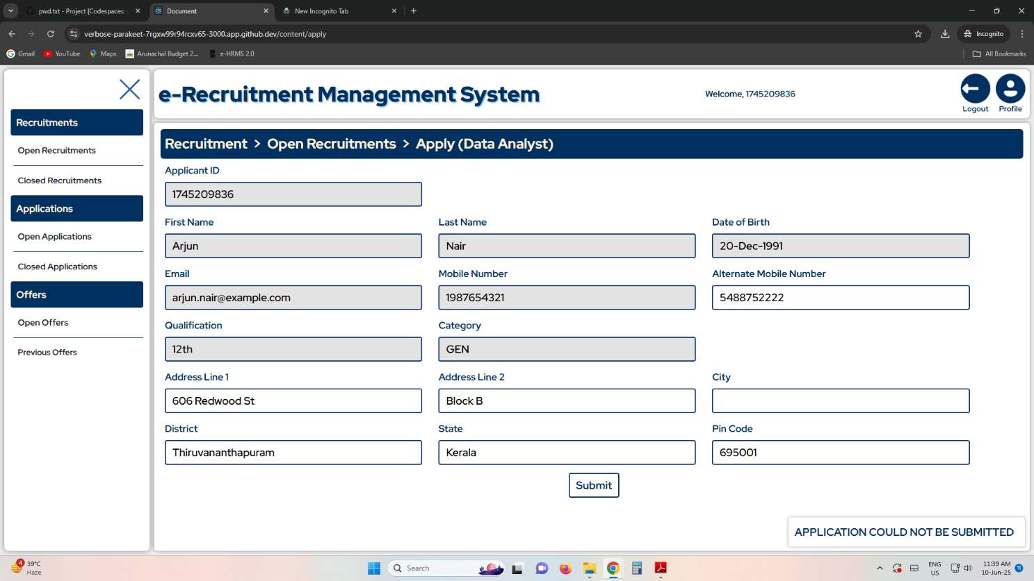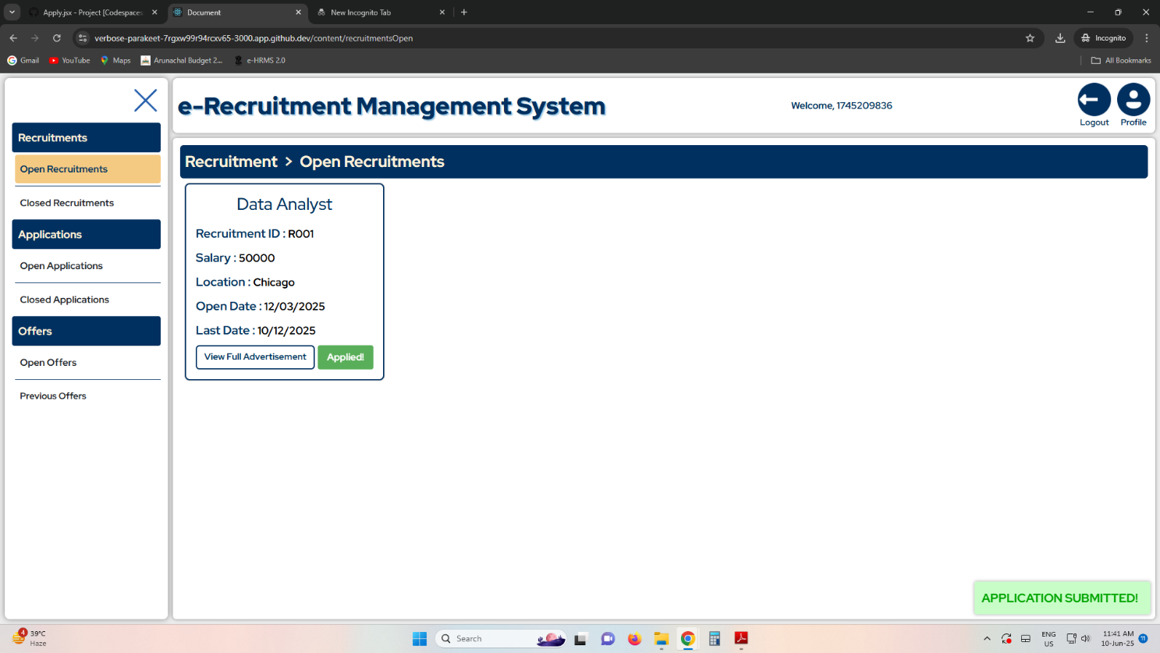

**Profile**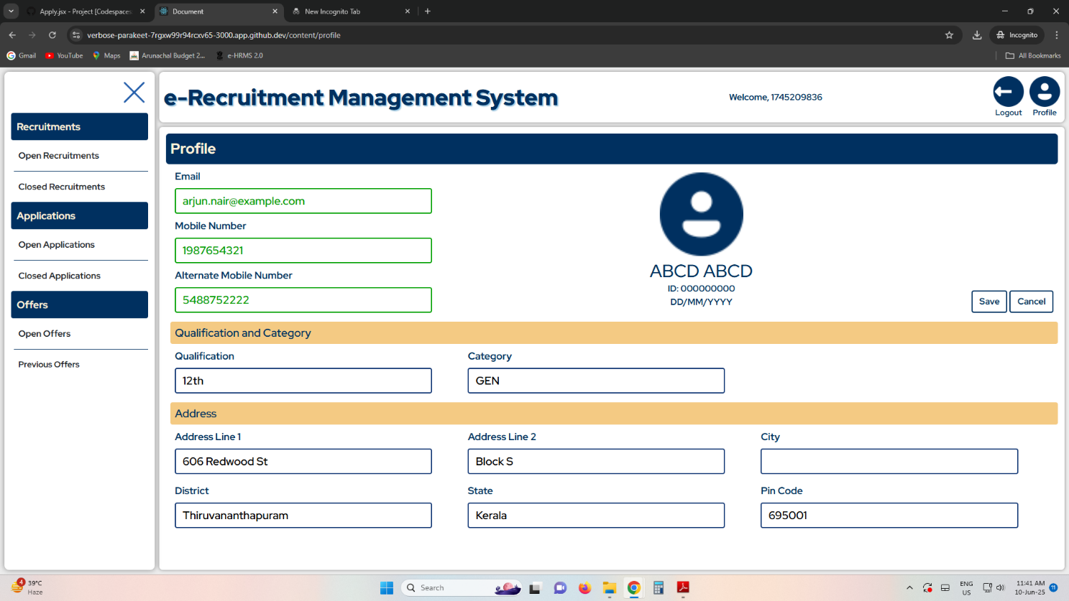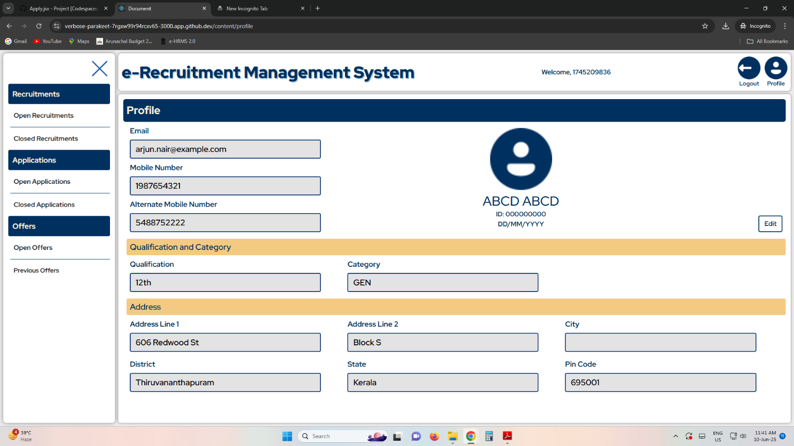

**Open Applications**

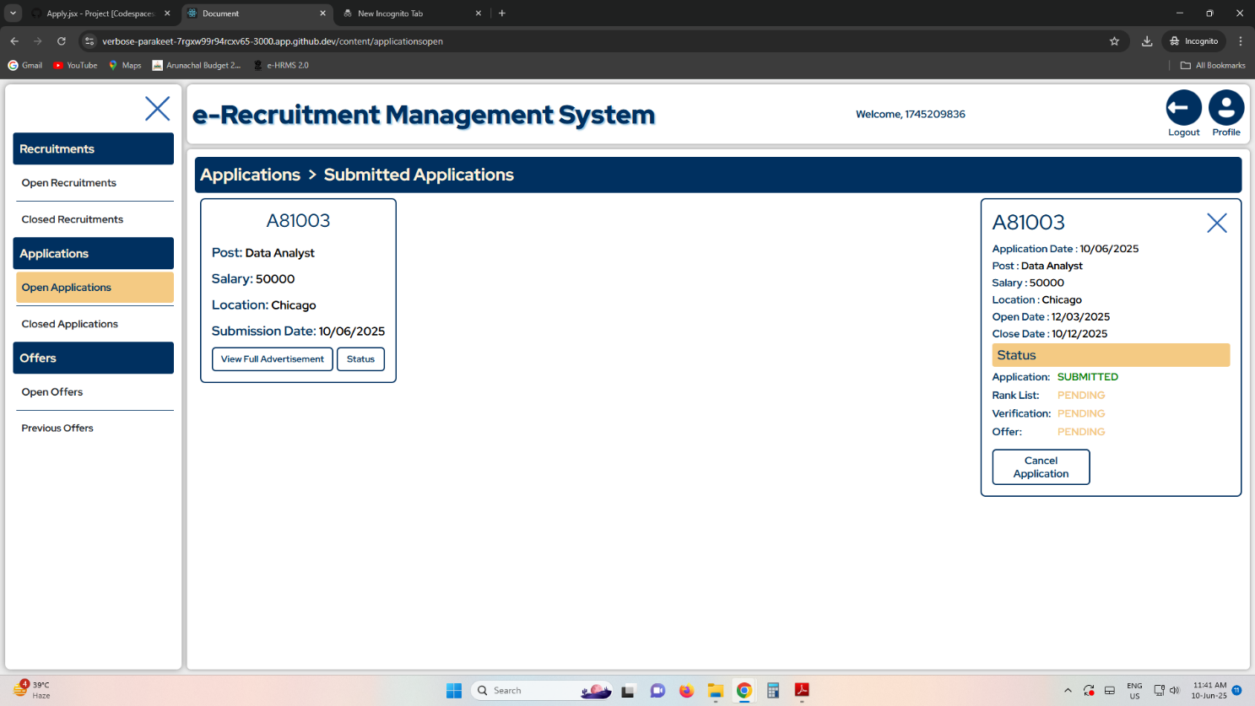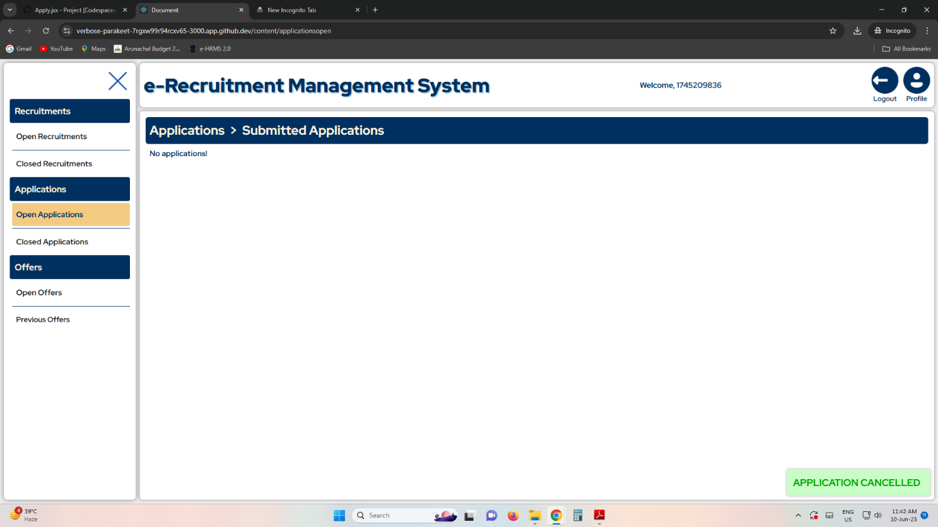

**Create Recruitment**

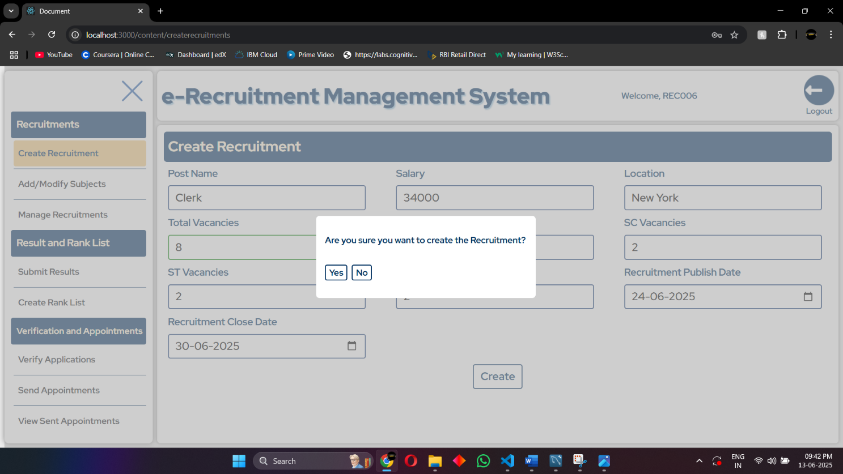

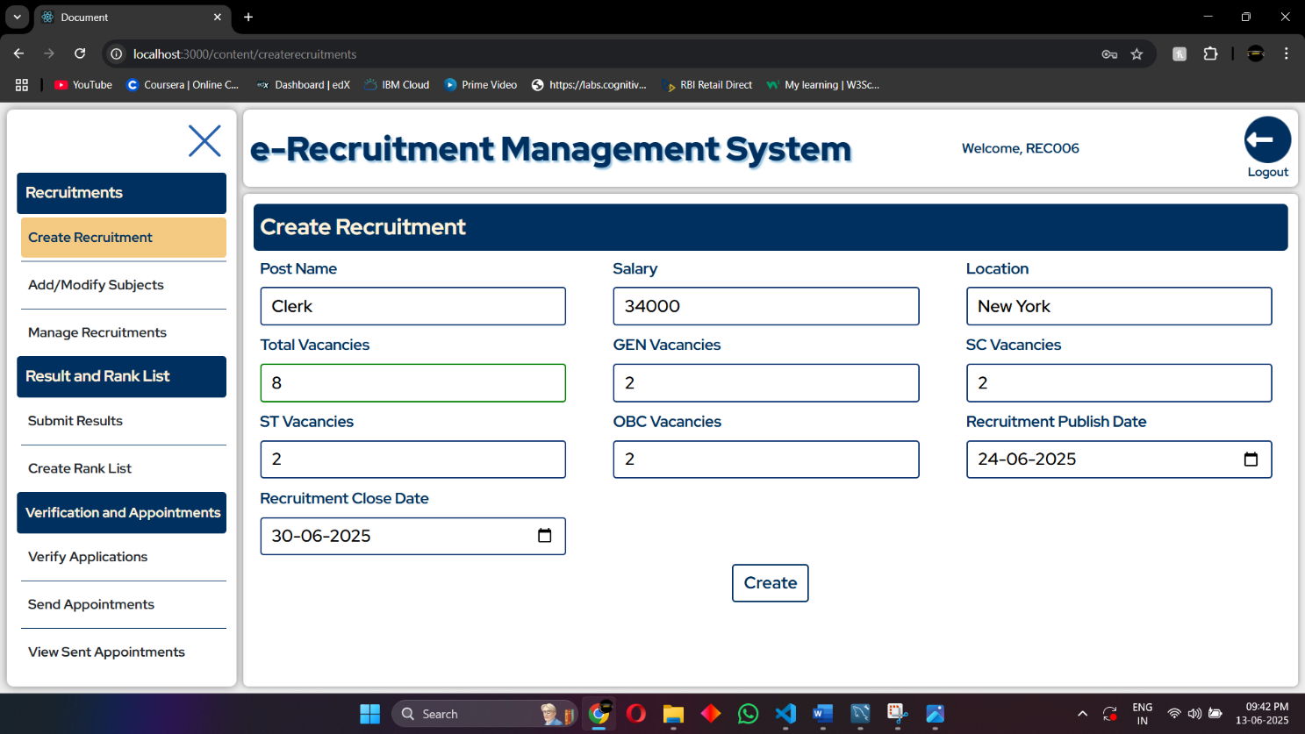

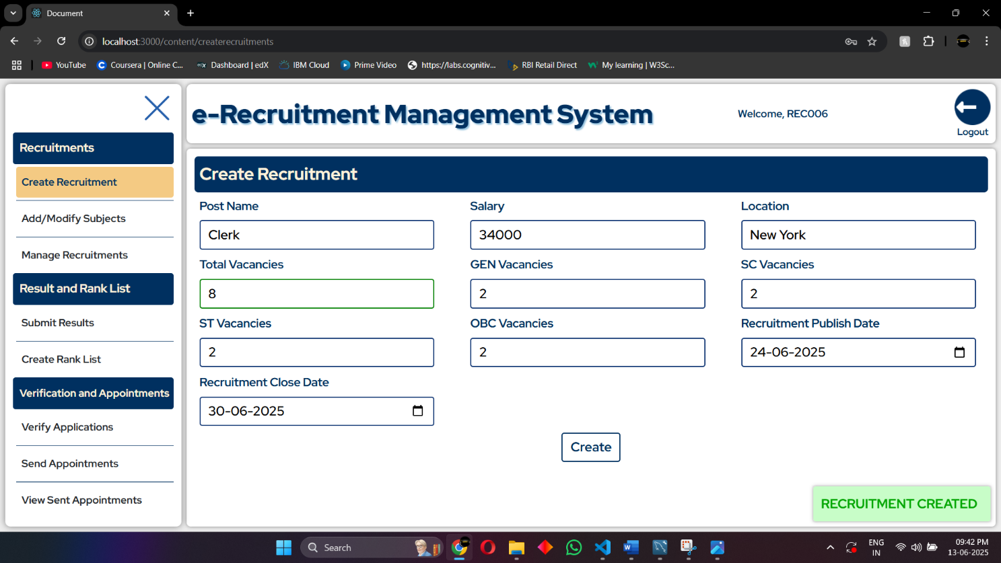

**Add Subjects**

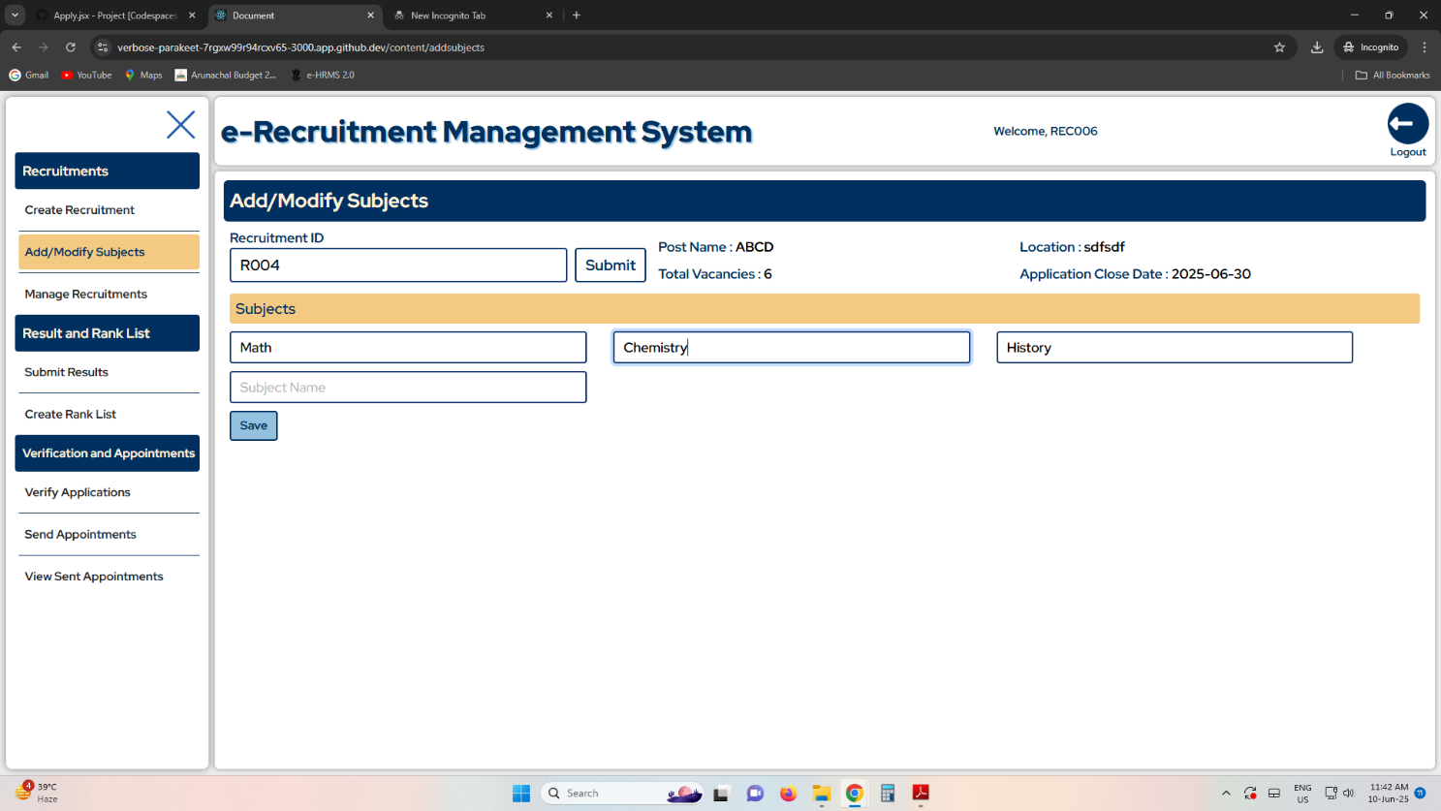

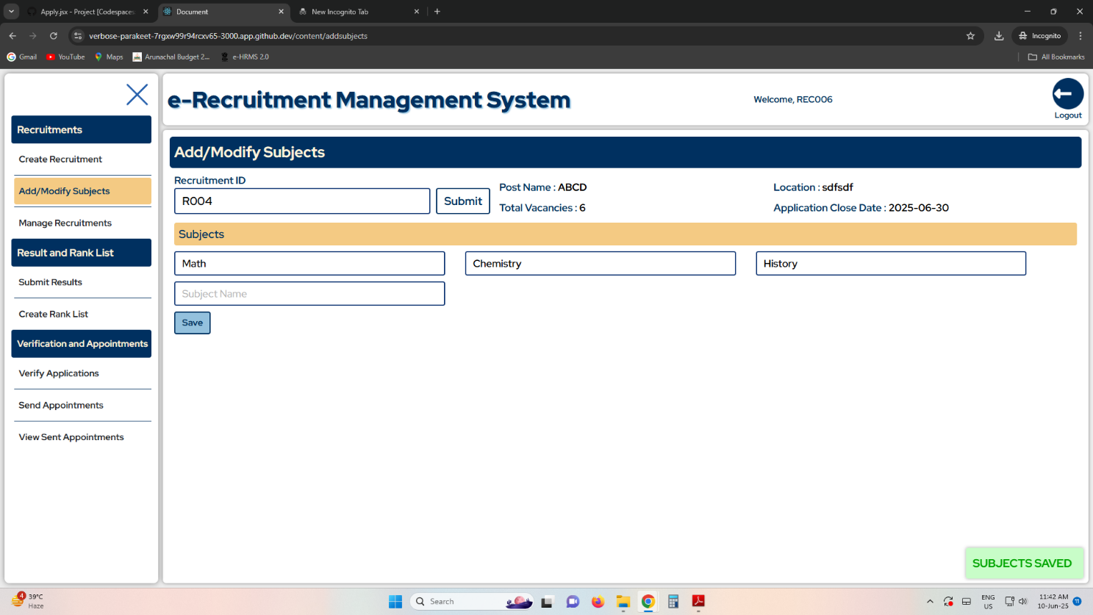

**Edit Recruitment**

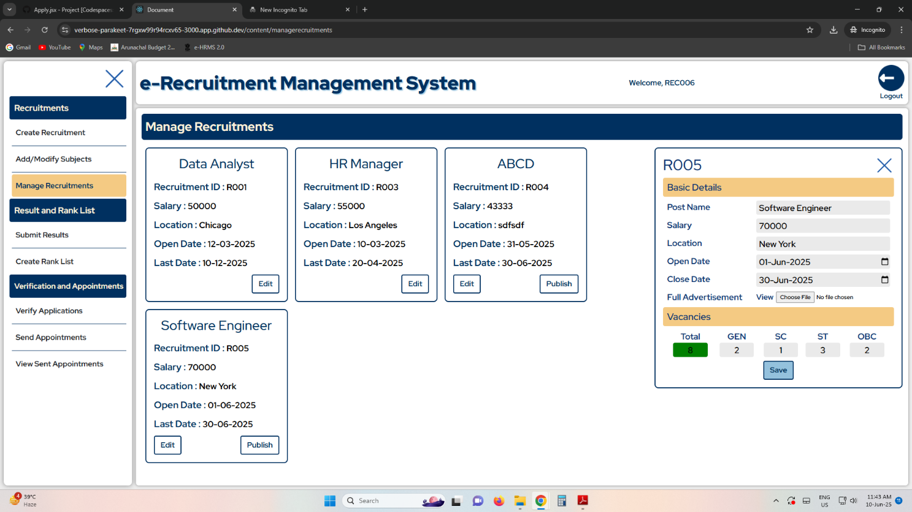

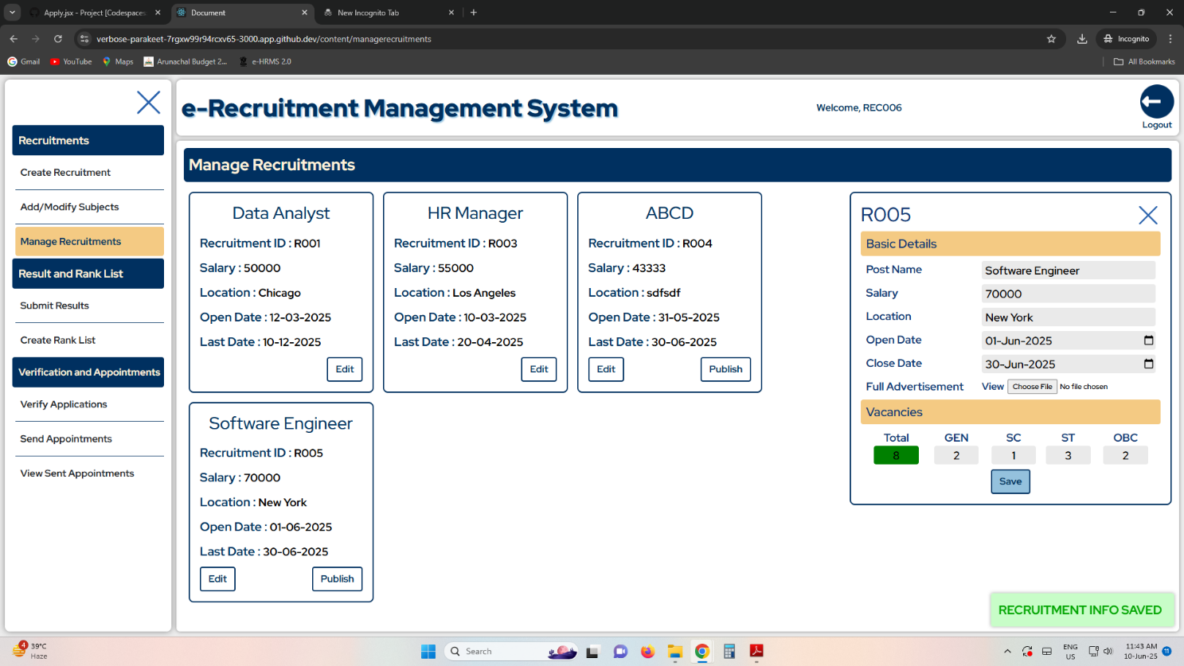

**Submit Results**

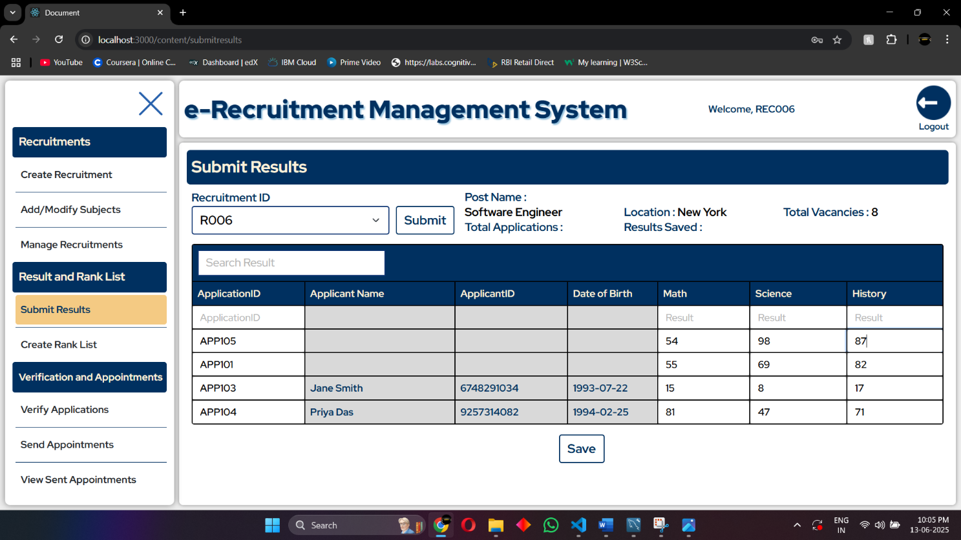

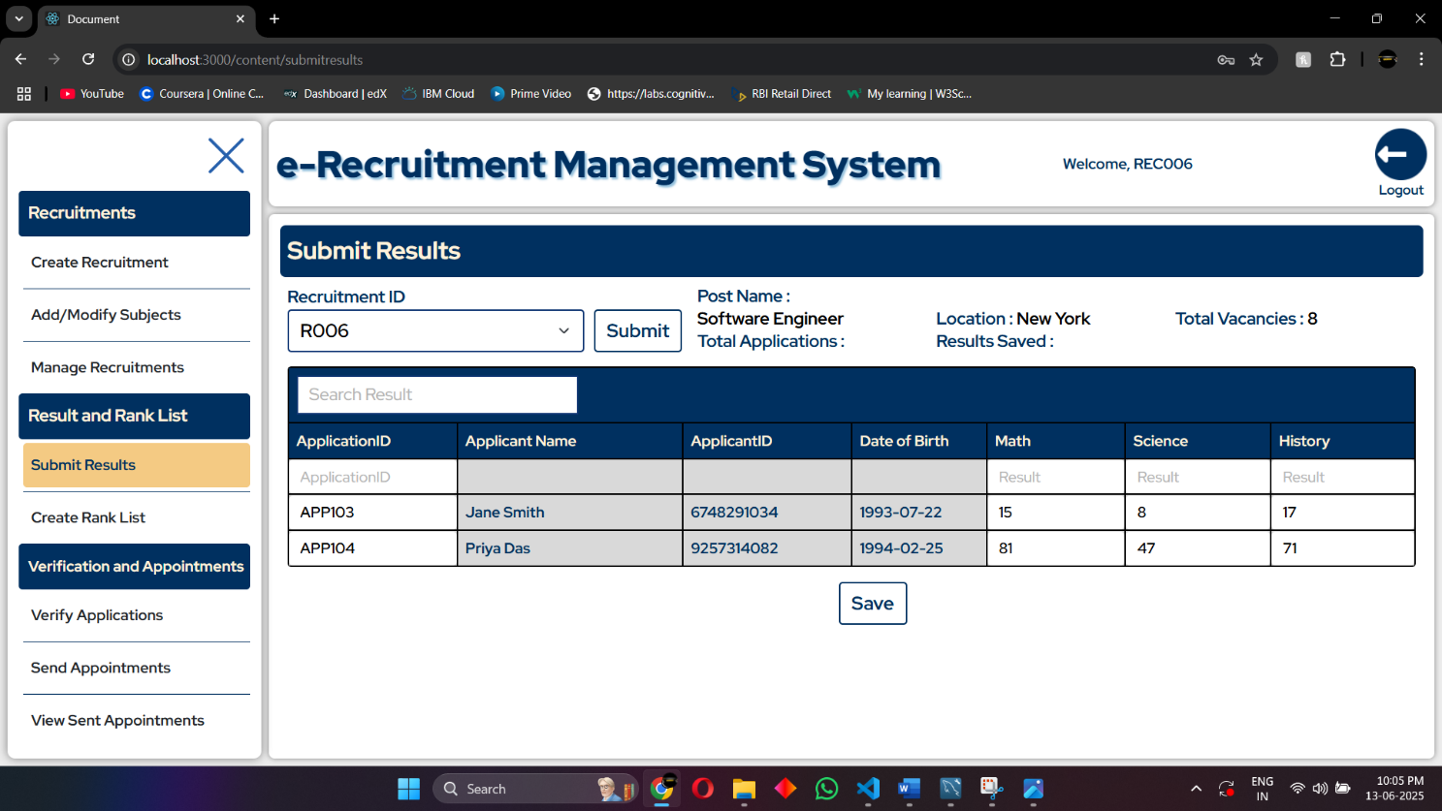

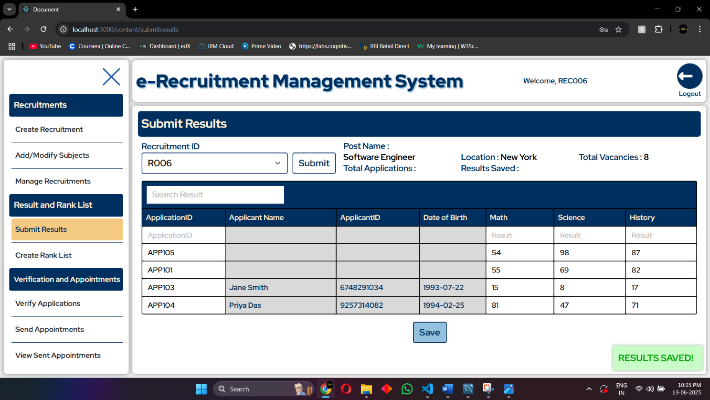

**Verify Application**

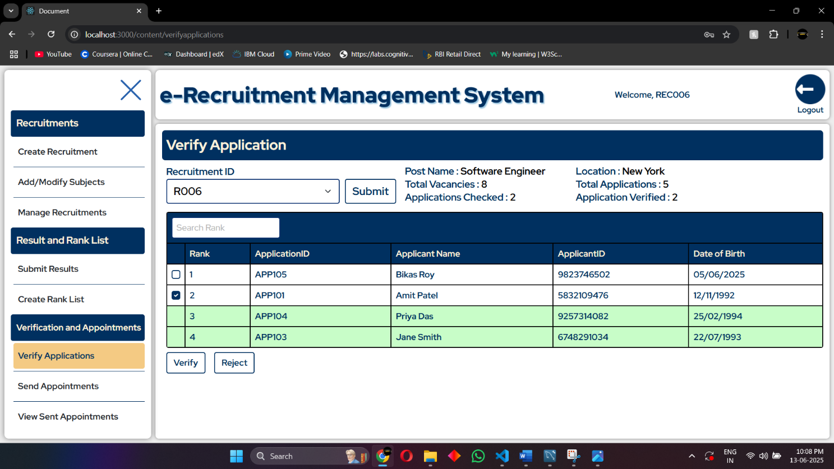

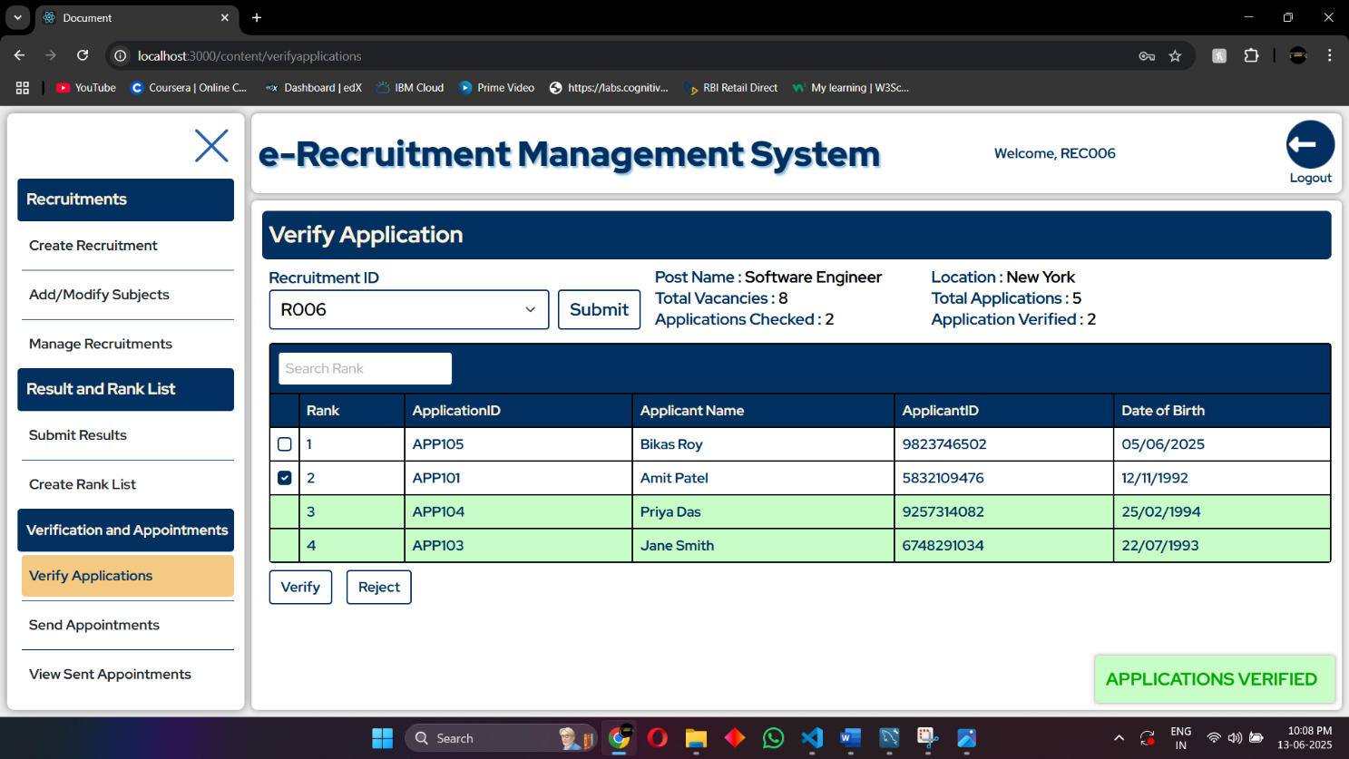

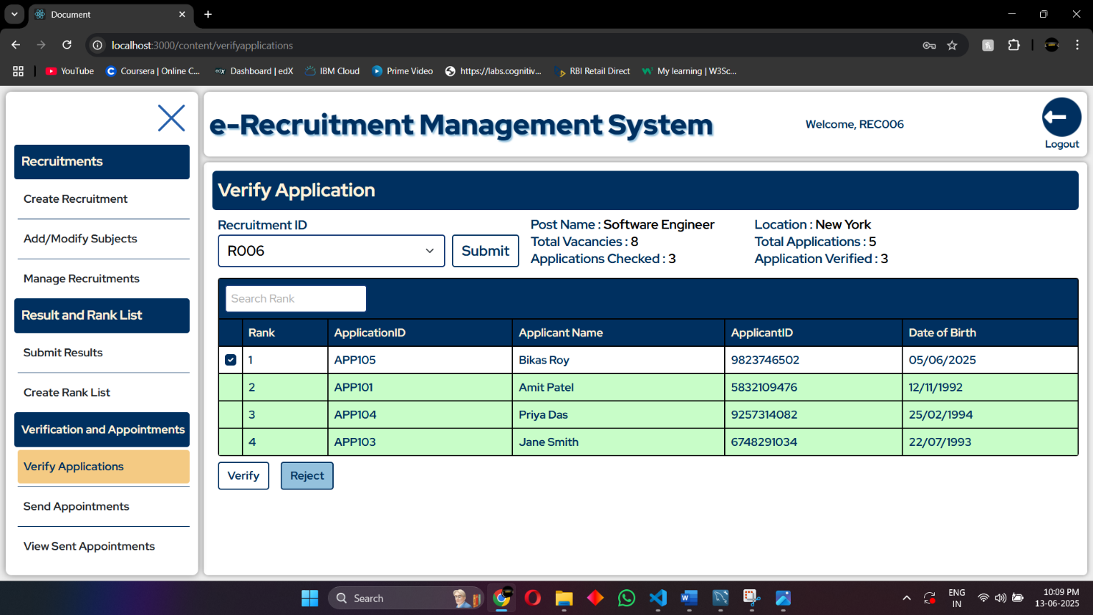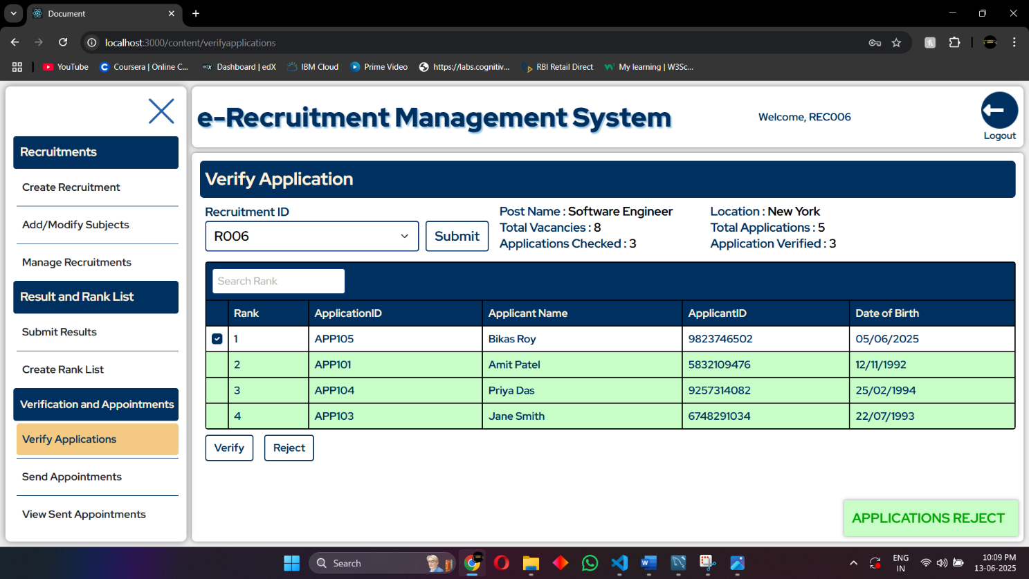

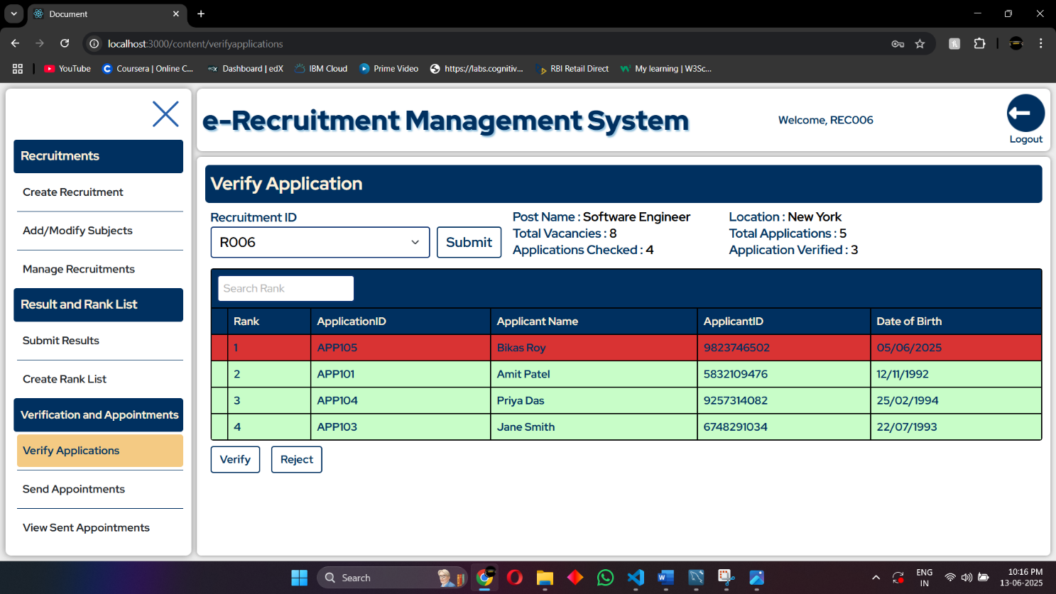

**Create Rank List**

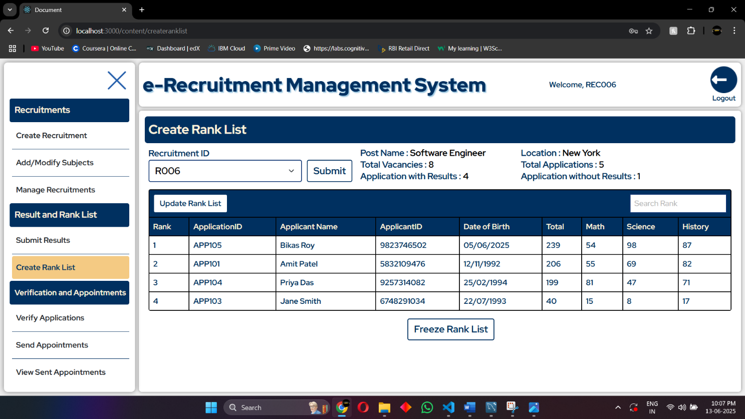

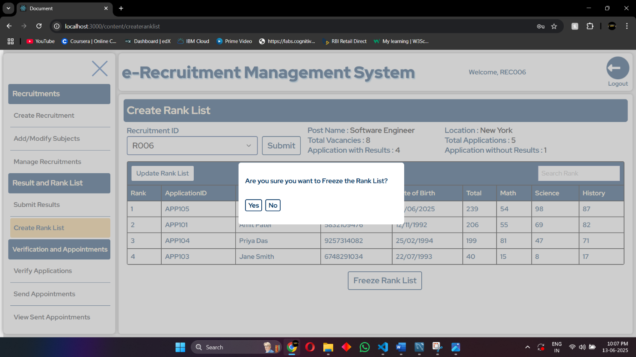

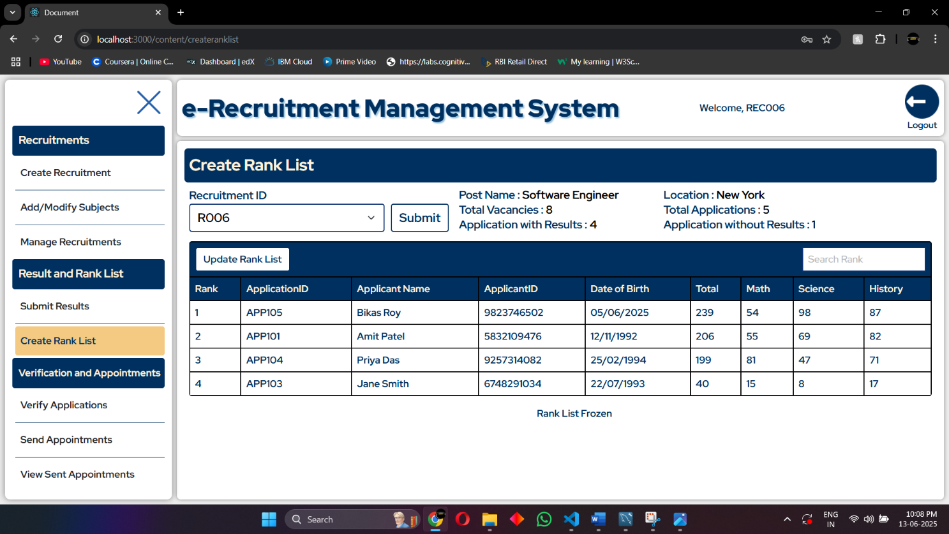

**Send Appointment**

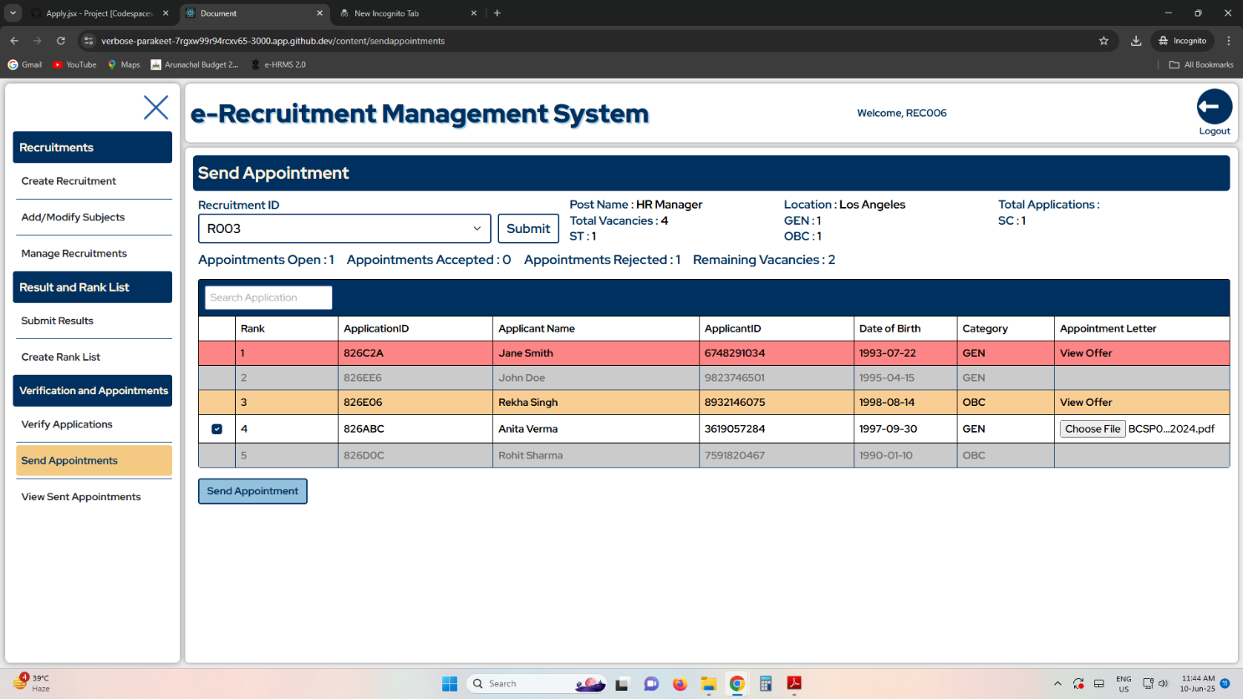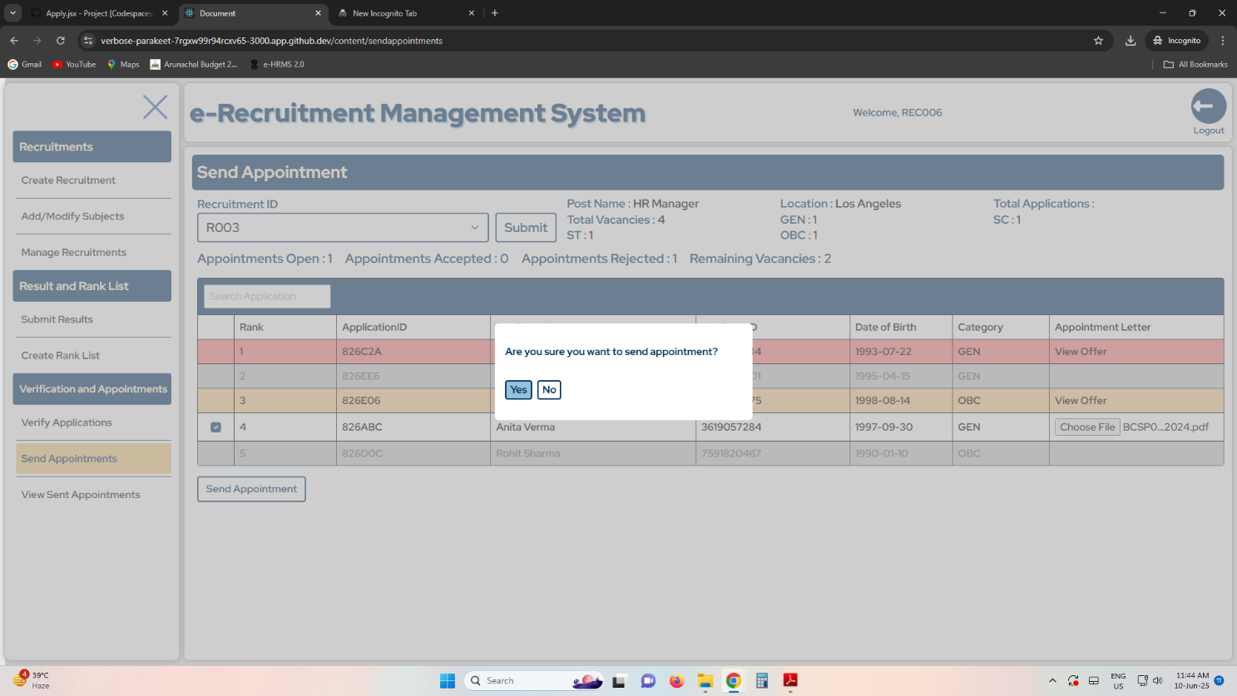

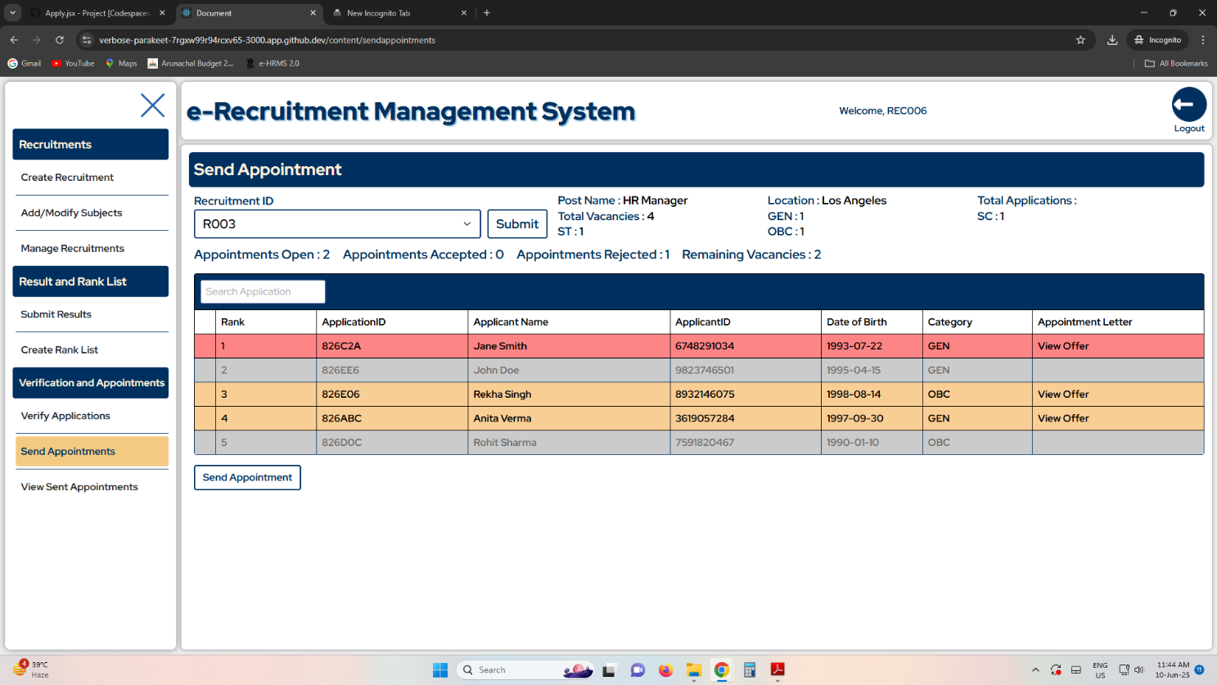

# SECURITY

**1. Hashed Password Storage:**

* Passwords are **never stored in plain text**.
* They are hashed on the server side using a secure hashing algorithm like SHA-256 (ideally with salt if using SHA).
* This ensures that even if the database is compromised, raw passwords are not retrievable.

**2. Client-Side Validation + Server-Side Verification:**

* Input fields like usernames, passwords, emails, etc., are validated on the frontend to reduce garbage or malformed input.
* All data is re-validated on the server to prevent client-side bypass and **injection attacks**.

**3. Prepared Statements via PDO:**

* All interactions with MySQL are done using **PDO with prepared statements**, eliminating the risk of **SQL injection**.
* Parameters are bound securely, and user inputs are not directly inserted into SQL queries.

**4. Session-based Authentication (PHP Sessions):**

* On successful login, a secure PHP session is initiated to track the user instead of transmitting credentials with every request.
* Session IDs are regenerated upon login and stored securely in cookies.

**5. MIME Type and Extension Validation for File Uploads:**

* File uploads (e.g., documents) are strictly validated by MIME type and extension.
* This prevents malicious files from being uploaded (e.g., disguised scripts or executables).

**6. Access Control Logic:**

* Frontend and backend routes are protected by checking user type and session state (Account type, User ID, etc.).
* Users are redirected or denied access if unauthorized actions are attempted.

**7. Secure File Storage by Hash Name:**

* Uploaded files are renamed using **hashed filenames (documentID)** to prevent predictable URL access.
* The frontend only submits a reference hash and type (like 'appointment', 'recruitment'), and the backend resolves the path securely.

**8. Password Strength Enforcement:**

* Password fields are validated to ensure a minimum complexity (uppercase, lowercase, digit, special character, and minimum length).
* This mitigates **brute-force** and **dictionary attacks**.

# LIMITATIONS

**1. Dependency on Electronic Devices and Internet Connectivity**

The system requires users (both applicants and recruiters) to have access to a digital device (PC, smartphone, tablet, etc.) with a stable internet connection and a modern web browser. This may limit accessibility in rural or low-connectivity areas.

**2. No Offline Application Support**

The system does not support offline or physical application submission, which may exclude individuals who are not digitally literate or lack access to digital infrastructure.

**3. No Support for Multi-Language Interfaces *(Current Version)***

The current implementation supports only English. Applicants not fluent in English may face difficulties navigating the system. Future versions may include regional language support.

**4. Limited Role Hierarchy and Delegation *(Current Version)***

Only a single recruiter role is currently supported. Hierarchical permissions, role-based task delegation, and third-party recruitment agency integration are scoped for future versions but are not implemented in the current release.

**5. Lack of Real-time Notification System *(Current Version)***

The current version lacks real-time notifications (e.g., SMS, push, or in-app notifications) for updates like rank publication or appointment issuance, which may delay user response.

**6. Limited Location Handling *(Current Version)***

Although future versions are planned to support multiple office locations and location preferences in application forms, this functionality is not present in the current version.

**7. Browser Compatibility Constraints *(Current Version)***

The system is optimized for modern web browsers like Google Chrome and Firefox. Legacy browsers or unsupported devices may not render the UI or run client-side logic properly.

**8. No External Identity Verification *(Current Version)***

The system does not integrate with external identity verification systems (e.g., Aadhaar, PAN). It relies on self-reported data, which must be verified manually by recruiters.

**9. Scalability Testing Pending**

While the system is designed for large-scale usage (millions of applicants), stress testing and performance benchmarking under peak load are yet to be conducted in a production-like environment.

**10. Security Features Still Evolving**

Though fundamental measures like password hashing, secure sessions, and input validation are in place, advanced security features like CAPTCHA, two-factor authentication (2FA), and login attempt rate-limiting are planned for future versions.

# FUTURE APPLICATION OF THE PROJECT

The e-Recruitment Management System has strong potential for future expansion and large-scale deployment across various government departments, educational institutions, and public sector organizations. In its future iterations, the system can incorporate support for multi-location recruitments, hierarchical recruiter roles, and third-party recruitment agencies, making it adaptable for centralized recruitment bodies such as the Staff Selection Commission (SSC) or state-level public service commissions. Integration with e-signature services, real-time vacancy analytics and mobile app access can further enhance accessibility, automation, and transparency. Additionally, by extending the platform's support to create structured waiting lists and automated reallocation of lapsed vacancies, the system could significantly reduce the number of unfilled posts and streamline workforce placement across the country.

# REFERENCES

1. "RRB NTPC Admit Card 2025 Out @rrbcdg.gov.in Today: Get Direct Links & Steps to Download RRB NTPC CBT 1 Hall Ticket & City Intimation." *IndiaTimes*, June 1, 2025. [indiatimes.com](https://indiatimes.com/news/education/rrb-ntpc-admit-card-2025-out-at-rrbcdggovin-today-get-direct-links-steps-to-download-rrb-ntpc-cbt-1-hall-ticket-city-intimation-660058.html?utm_source=chatgpt.com)
2. "SSC GD Constable Result 2025: Results Expected Soon for Over 53,000 Vacancies, All You Need to Know." *Economic Times*, June 3, 2025. [economictimes.indiatimes.com+1timesofindia.indiatimes.com+1](https://economictimes.indiatimes.com/news/new-updates/ssc-gd-constable-result-2025-results-expected-soon-for-over-53000-vacancies-all-you-need-to-know/articleshow/121611108.cms?utm_source=chatgpt.com)
3. "35 Candidates to Compete for Each Teacher Post Under DSC in Andhra Pradesh." *Times of India*, June 3, 2025. [timesofindia.indiatimes.com](https://timesofindia.indiatimes.com/city/vijayawada/35-candidates-to-compete-for-each-teacher-post-under-dsc-in-andhra-pradesh/articleshow/121577443.cms?utm_source=chatgpt.com)